**Scotland Deanery Newsletter**

Issue 48 | February 2025

**Content**

1. Foreword
2. My Journey Through Medical Training in NHS Scotland
3. Scottish Intensive Care Society Prize
4. Medicine in Madagascar
5. Everything You Wanted To Know About Broad Based Training (but Were Afraid To Ask!)
6. Trainer Development Collaborative
7. Resident Doctors Working in Medical Education
8. Women in Leadership: Developing Tomorrow's Leaders
9. Knowledge Services – Current Awareness Bulletins
10. NES Conference 2025
11. Valuing Diversity and Promoting Inclusivity
12. Please Contact Us
13. NES Websites
14. **Foreword**

**Welcome to the first edition of your Deanery newsletter for 2025.**

The days are beginning to stretch out and we can all look forward to Spring. I am a keen gardener and love this time of year when seeds start to germinate, and new growth appears in the garden!

In this newsletter we are able to spotlight the experiences and successes of resident doctors! It is great to read about positive experiences and to celebrate successes and to reflect on the amazing impact you all make.

The first item tells of a story of the challenges and rewards of a journey through medical training in NHSScotland. A highly illuminating article of a resident doctor’s experiences. Thank you for sharing and thank you for choosing Scotland!

A Scottish Graduate Entry Medicine (ScotGEM) graduate, in her first year of foundation, recently won a national prize at the Scottish Intensive Care Society Resident Doctors meeting for her undergraduate final year Healthcare Improvement project. This article discusses this excellent achievement further. It is also a reminder to us that we can recognise opportunities for improvement in patient care throughout our careers.

The third focus on resident doctors is a story about the opportunity to undertake an out of programme experience. One of our doctors volunteered with the charity Mercy Ships in Madagascar. This item discusses this exciting and developmental experience.

We then move to focus on support for educators. The Trainer Development Collaborative (TDC) has responsibility for the development and delivery of training for trainers in both primary and secondary care. This section has updates for trainers especially GP trainers and an item on Trainer Development Conversations.

Are you a doctor currently working in medical education? Is this your first formal role teaching health professionals/students? Do you know or work with a doctor who is?

If you answered “yes”, there is information in the next item on a study that you may well want to participate in. There is an invitation to join a study aimed at supporting the development of future medical educators. In collaboration with the Academy of Medical Educators, the Association for the Study of Medical Educators and the General Medical Council, this research focuses on the experiences of doctors in Entry-Level Medical Education Roles (ELMERs).

We are delighted to help to promote Women in Leadership: Developing Tomorrow's Leaders, a hybrid conference in association Royal College Physicians Edinburgh in June. The programme includes a variety of talks, live interviews, and workshops. Please see the article for further details.

The Current Awareness section of The Knowledge Network has been refreshed. This is provided by NHS Librarians across Scotland and these bulletins offer recent literature which has been reviewed and curated to identify important, high-quality evidence. The next item discusses this further.

Following on the growing success of the 2024 conference, NES is delighted to confirm that it will once again be hosting the conference online over two days in April 2025: Thursday 24 and Friday 25.

For any queries please contact <nes.conference@nhs.scot> or visit [Events](https://www.nes.scot.nhs.uk/events/)

Remember to keep submitting articles or suggestions for content, take care and take breaks.

I hope you enjoy this edition. 

If you have work you would like to highlight in this newsletter, contact [**Scotland Deanery**](https://www.scotlanddeanery.nhs.scot/contact/).



**Professor Emma Watson**Executive Medical Director, NHS Education for Scotland

1. **My Journey Through Medical Training in NHS Scotland**



My journey in NHS Scotland has been an incredible mix of challenges and rewards. As an International Medical Graduate (IMG) from Pakistan, I took my first step in the UK in May 2022, starting in Stockport. Before long, I moved to Kirkcaldy, Fife, for a clinical fellow post in internal medicine, covering acute medicine and geriatrics. From the very first day, I was met with warmth and support. My colleagues would teach me a "Fife word of the day" to help me understand local slang—small gestures that made me feel right at home. Outside of work, I fell in love with Scotland’s rich history, exploring castles and hiking Munros whenever I had the chance.

Adapting to the NHS system was tough at first, but the incredible team around me made all the difference. Their guidance helped me develop my skills quickly, and before I knew it, I had the confidence to apply for national training. I was thrilled to secure a spot in Aberdeen, where I’ve continued to grow, thanks to exceptional supervisors and supportive departments. The emphasis on trainee well-being here is reassuring, from structured work breaks to professional development programs. One of the standout moments of my first year was the IMT training boot camp—an experience that not only honed my clinical skills but also strengthened my communication and teamwork.

What stands out most in my journey is the sense of camaraderie. The teamwork, the mentorship, and the shared commitment to patient care make NHS Scotland special. The diversity of cases I’ve encountered has shaped my clinical expertise, and the challenges have only made me more resilient. Looking back, I feel incredibly grateful for the opportunities and the people who have supported me along the way. I can’t wait to see where this journey takes me next.



**Umer Farooq**  
IMT-1 trainee   
Infectious Diseases



1. **Scottish Intensive Care Society Prize**

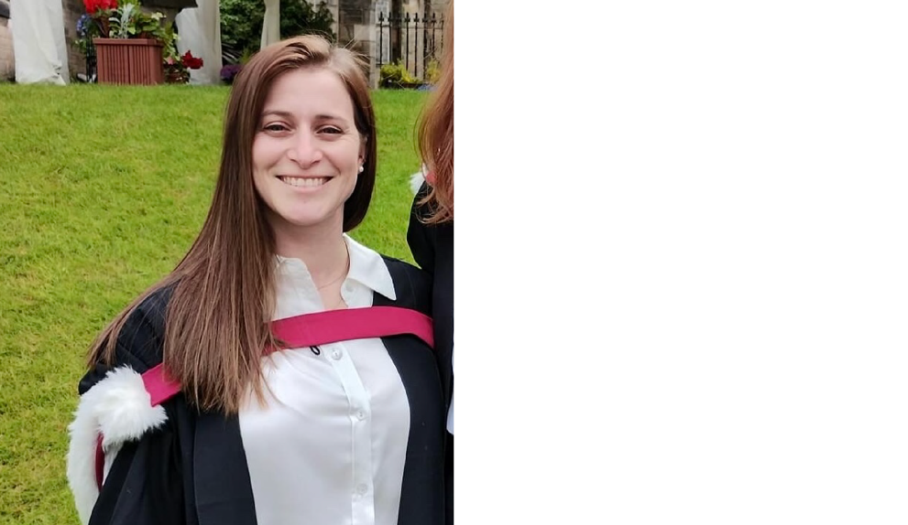

A Scottish Graduate Entry Medicine (ScotGEM) graduate, in her first year of foundation, recently won a national prize at the Scottish Intensive Care Society Resident Doctors meeting for her undergraduate final year Healthcare Improvement project. Dr Lydia Arthur's project, undertaken in the Critical Care Unit of Dumfries and Galloway Royal Infirmary, looked at the 'daily bloods' taken on the unit.

Through a process of stakeholder surveys and conversations, and through the use of driver diagrams, Lydia developed an algorithm to help staff to decide which patients needed a Coagulation test each day. After devising this intervention, she then implemented it though staff education sessions and posters and then assessed the change.

The result a significant drop in daily clotting screens done (from 87% to 40%), as well as a large increase in the choice to exclude them (from 12% to 59%). This ensured that the aim of the project was met, with a reduction of 46% of inappropriate clotting screening tests in the Critical Care Unit.

Lydia said 'ScotGEM's teaching regarding QI was invaluable in improving my HCI skills. With projects running from first year with increasing difficulty and both solo and group projects, together with repeated exposure to tools and techniques meant that I was, and still am, very comfortable with the QI tools available'.

ScotGEM aims to produce skilled clinicians who are also 'Agents of Change'. Lydia's project and her ability to influence and bring about positive change in healthcare settings embodies these ambitions.

1. **Medicine in Madagascar**

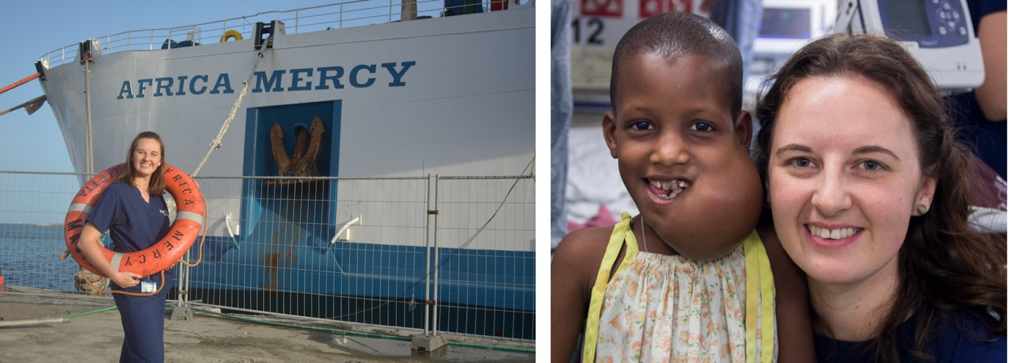

After completing ST5 in Acute Medicine, I had the opportunity to undertake an out of programme experience. I volunteered with the charity Mercy Ships in Madagascar. Mercy Ships is a faith-based international development organisation that deploys hospital ships to some of the poorest countries in the world. They deliver vital, free surgical care to people in desperate need, as healthcare is simply not available.

Madagascar is a beautiful country with welcoming people, stunning coastlines and fascinating wildlife. Did you know there are over 100 different species of lemur? Or that 80% of the flora and fauna in Madagascar is endemic to the island? However, life on the island is hard. Most people live in extreme poverty with limited access to fresh water, poor infrastructure and frequent cyclones that destroys what progress has been made. Therefore, assistance from medical organisations, like Mercy Ships, is very gratefully received.

My main role as Hospital Physician was to optimise the health of patients to enable surgery to proceed safely. I also had a role in protocol development and providing education for local professionals to ensure that the impact is long-lasting. This involved reviewing adult and paediatric patients, many of whom had never seen a health care professional before, diagnosing and treating both acute and chronic conditions. This ranged from familiar conditions such as asthma, seizures, URTI, UTI, thyroid disease, arrhythmias, malignancies and diabetes; to conditions which are much more common in tropical countries such as malaria, schistosomiasis, HIV, TB, tungiasis, parasitic worms and severe malnutrition. The job also included managing the small ICU, rounding on both pre and post-operative patients with surgical colleagues, and working closely with the wound care and rehabilitation teams.

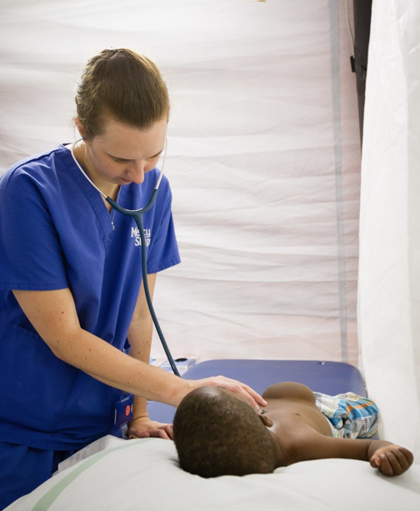

This experience exposed me to working in a different culture with very different health beliefs including traditional healing methods, strong spiritual factors, and fear of curses which cause ill health. All of these had a huge impact on the way my patients viewed their own health conditions and therefore became a part of the clinical consultation, allowing me to develop a fresh perspective into patient centred care.

One of my favourite things about the organisation is their commitment to providing education to, and learning from, local practitioners. There is a real awareness that this is the way to achieve true, long-lasting change. Therefore, local nurses are invited to work on the wards on the ship and a local surgeon participates in every operation. Partnerships are formed with the local hospitals to ensure MDT learning. It was a privilege to be involved in providing education and mentorship for local professionals, including giving feedback and learning of culturally appropriate ways to do this.

This was my third trip to volunteer with the organisation, having previously spent time in Benin (post FY2) and in Senegal (after completion of ACCS). One of the main things that continues to draw me back, is the opportunity to work with people from all over the world with vastly different experiences. At any one time, there are people from over 40 different countries volunteering on the ship. This rich diversity encourages me to view situations from a new perspective and has allowed me to develop my own communication skills to ensure that the whole team is communicating effectively. Working in an environment where the resources can be limited, forces you to enhance your problem-solving skills and discover that often there is often more than one correct solution to a problem. Working alongside local people assisting as translators on a daily basis also allowed me to develop friendships and become more enveloped in the local community. I was able to visit their homes and families and enjoy meals together. This was a true joy.

I am grateful that I have been able to use my medical training and experience to help the people of Madagascar in a small way. I am also aware that I have gained so much more from the experience. I am confident that the skills that I have gained and developed will allow me to be a better practitioner and colleague as I return to the NHS to complete my acute medicine training programme and thus I am thankful for the OOPE opportunity.

1. **Everything You Wanted To Know About Broad Based Training (But Were Afraid To Ask!)**

**What is it?**

Broad Based Training (or BBT) is a two year programme for doctors who have successfully completed foundation training. It aims to develop doctors who are comfortable managing complexity as the population ages and medical complexity becomes the norm. In addition, it seeks to promote integration and understanding within the specialties involved for both resident doctors and their trainers.

Finally, it also allows doctors to be more certain about their choice of career pathway.



**How does it do this?**

BBT resident doctors rotate through 4 six-month posts in General Practice, Paediatrics, Psychiatry and Medicine. In each of these rotations they are considered to be the same as any of the core trainees in this specialty, with the same access to educational programmes.

At the successful completion of BBT, these doctors will choose one of these specialties and  enter the second year of training in this specialty.



**Sounds pretty interesting…**

You’re right! And in addition to this, broad based training incorporates “10% time”.



**10 per cent time? What’s that?**

It’s unique to BBT. It gives resident doctors in BBT the opportunity to do something which interests them and meets their own educational needs. Essentially, BBT doctors spend 90% of their time in their current placement, but for the other 10% of that time (12-13 days) they arrange to spend time in one of the other 3 BBT specialties. They must spend their 10% time in a different specialty each time, so they by the end of BBT they will have spent 100% of time in each specialty



**Sounds confusing…**

It does a bit! It’s easier to use an example. If a BBT doctor starts in psychiatry, they can spend their 10% time in either GP, medicine or paediatrics and so on. They will have completed 10% time in each of the 4 BBT specialties by the end of BBT.



**So it’s study leave?**

No, this time is in addition to study leave and annual leave. It is an integral part of the programme.



**What have people chosen to do with their 10% time?**

All sorts of things! We’ve had doctors spend time in teenage and young adult cancer teams, in sexual health clinics, with community midwifes and in peripheral clinics. One doctor spent a day with a funeral director as part of this time. Essentially we’re happy to discuss anything you might find educational.



**Who would BBT suit?**

All sorts of doctors! It’s particularly suited to those who might be struggling to choose between any of the BBT specialties, for those who are considering and “FY3” year, or for those who are thinking about working in rural areas.



**Sounds great…what’s the catch?**

Ha! Well, the main one is it’s an extra year in training, as you would spend 2 years in broad-based training before exiting into the second year of training in the BBT specialty of your choice – but as I’ve said above, many doctors aren’t ready to commit to a particular specialty and might be considering taking time out of training after the foundation programme. BBT is a way to get that extra time whilst remaining in training and gaining experience in a number of specialties. Our BBT doctors tend to enjoy their time in the programme!



**You would say that…**

I agree I’m a little biased! But I don’t expect you just to take my word for it, we have a number of testimonies from BBT doctors past and present for you to read!

If after reading them you would like to know more, please contact Neil Shepherd, our training programme director ([**neil.shepherd@nhs.scot**](mailto:neil.shepherd@nhs.scot)) or me ([**allan.macdonald@nhs.scot**](mailto:allan.macdonald@nhs.scot)) to discuss it further!



## ****BBT - Resident Doctor Testimonials****

*“Broad Based Training provides a breadth of experiences and the time to further develop as a clinician. For me, this time allowed me to learn more about myself as a doctor and I ended up choosing a speciality I had not been considering at all, but which I am very happy working in now! My experience in Grampian was always very well supported and gave me realistic insight into what working as a junior speciality trainee was like. The 10% time allowed me to explore areas of medicine which I had never been exposed to before. It sparked my curiosity for learning, reminding me of one of the reasons I chose medicine in the first place and how exciting and interesting it can be! “*

**Ryen Crabb**



*“I did BBT in Inverness straight after foundation. I found it was a great way to gain more experience before deciding on a further training pathway. I particularly enjoyed the way the BBT program tries to parallel the training of each specialty you are in for each job (for example joining in with the deanery teaching days and GP training days in GP). The 10% time was also really great and gave the opportunity to explore an area that you wouldn't usually get to see in the 'normal' jobs of training.”*

**Amy**



*“I was in the first group back in 2018 and originally applied as when I entered FY2 I didn't know what training programme I wanted to go into however had always liked adult medicine, paediatrics and psych - I actually thought that GP was going to be the training programme for me therefore when BBT came up it was the perfect combination of rotations.*

*As I was in the first intake there were certainly a lot of teething issues mostly with rotas and getting the 10% time however after some education about the programme I never had any issues. I loved the 10% time for getting to explore my own interests although it did require a lot of admin! For example I spent some time with the eating disorders team, perinatal mental health team, under 12s inpatient psychiatry unit, teenage cancer trust and specialist ID teams.   
  
I think it was the perfect programme for me - it is very different doing the job as a junior registrar rather than a foundation doctor and gave me a good insight into how training and future consultant jobs work in each speciality. As I was in Lanarkshire I did a spilt paediatric rotation of 3 months in neonates and paediatrics giving me a different experience to some other locations - this was crucial experience when I had chosen paediatrics as my speciality at the end as I had some experience in both areas. Although I thought I would want to do GP after my rotation I quickly realised that this was not the job for me and did not enjoy the rotation.   
  
I chose paediatrics and I am currently a ST6 in GGC. I still maintain that BBT was the best programme for me at that stage in training as I don't think I would've entered another programme at the end of FY2. I found being able to experience each rotation as a junior reg was invaluable experience and definitely helped me solidify my love for paediatrics (and perhaps my dislike for other specialities). I think if I hadn't done BBT and ended up going straight to paediatrics (probably after some years of locuming/fellow jobs) on those hard runs of on-calls shifts and unwell patients I would have always thought I would have had GP to fall back on and considering changing specialities - however that would have been a terrible idea for me! I also think it is invaluable time that you get to experience other specialities and actually go into your future speciality more prepared than others.  
  
I think the only negative would be the understanding of the programme and the aims that other people had. I chose to go into paediatric and did find when I entered training that people thought I had taken the 'back door' entry rather than going through the application process. I definitely felt I had to defend my training and process of entering into paediatrics.  
  
Broad based training so far has been really enjoyable. It feels like a training job and not just service provision! With the 10% time you have the chance to explore your interests whatever they may be - from remote and rural medicine to sexual health to palliative care. The study budget and study day allowance gives you the chance to complete courses and attend conferences to further build your portfolio.   
  
The four rotations gives a strong foundation which will be useful in whichever training programme you then choose to enter. The programme gives a real focus on holsitic care and realistic medicine.   
  
My colleagues in NHS Highland have been fantastic and working with the mountains on your doorstep helps encourage that ever important work-life balance! I would strongly recommend this programme to anyone who is considering a career in any of the four rotations as to date I can only say positive things.”*

**Maddie**



*“I switched into BBT from an other training program, with a plan to go back to it if I did not enjoy the other specialties. I found that I enjoyed the two other specialties more than my original specialty. BBT also gave me the time and flexibility to try niche shadow niche subspecialties and clinics I had interest in. Ultimately, BBT changed the trajectory of my career in a good way.”*

**Bader**

1. **Trainer Development Collaborative**

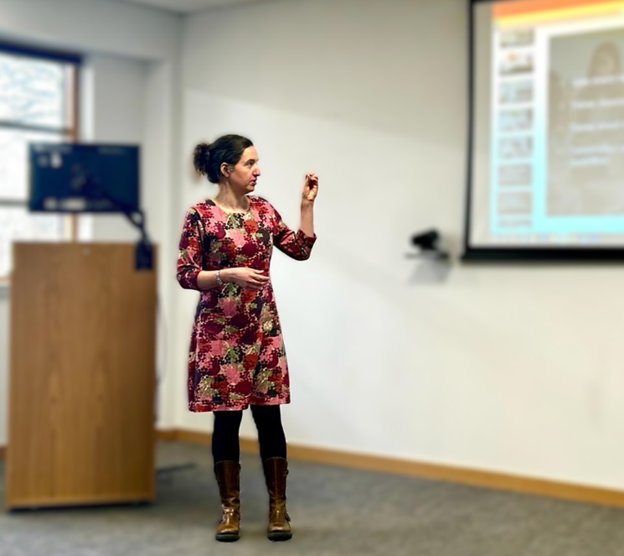

The Trainer Development Collaborative (TDC) has responsibility for the development and delivery of training for trainers in both primary and secondary care

**Courses**

Alongside our entry-level courses (Trainer Workshop and the GP Trainer Entry Course), the TDC offers a number of CPD opportunities, mapped to the Academy of Medical Educators (AoME) framework, which are designed to help you develop in your trainer role.

Our CPD courses:

* expand on themes first introduced in the Trainer Workshop
* consider the importance and influence of the learning environment
* explore the practicalities of delivering effective training and
* how the additional support needs of some trainees can be recognised and managed



**Modules**

In addition to the courses on offer, a number of modules have been developed with the specific aim of raising awareness among postgraduate medical trainers of the work undertaken by the Trainee Development and Wellbeing Service (TDWS).

There is an intention to develop a number of similar modules covering different topics relevant to training which you might find useful, therefore we would encourage you to look out for new these new resources.  



**Trainer Development Conversation Videos…**

The TDC are producing a number of ‘Trainer Development Conversation’ videos featuring our Associate Postgraduate Dean Dr Daniel Bennett and guests, discussing a variety of topics relevant to postgraduate medical education.  New videos will continue to be published regularly so please check the TDC page on TURAS Learn to keep up to date with the latest videos.

You can find more information about the TDC and the resources we provide on the [**Scotland Deanery website**](https://www.scotlanddeanery.nhs.scot/your-development/trainer-development-collaborative/resources-for-new-trainers/gptec/), on [**TURAS Learn**](https://learn.nes.nhs.scot/58659/trainer-development-collaborative-tdc), or by contacting us at [**nes.TDC.Admin@nes.scot.nhs.uk**](mailto:nes.TDC.Admin@nes.scot.nhs.uk).



**Update on TDC courses for GP trainers**

* GP Trainer Entry Course (GP TEC) is designed for GPs who wish to become GP Educational Supervisors in Scotland and is now in its second year.
* GP Trainer Entry Course (GP TEC) is designed for GPs who wish to become GP Educational Supervisors in Scotland and is now in its second year.

The course uses a blended learning approach, combining online modules with virtual and in-person meetings. In 2024, the TDC increased the course capacity to 96 spaces per year, which has positively impacted GP training capacity. Waiting lists are still managed on a priority basis. GPs who wish to become an Educational Supervisor are advised to contact their local TPD to ensure they can attend a course at the appropriate time. A list of General Practice TPDs can be found on the deanery website

[**https://www.scotlanddeanery.nhs.scot/trainee-information/gp-specialty-training/meet-our-teams/**](https://www.scotlanddeanery.nhs.scot/trainee-information/gp-specialty-training/meet-our-teams/)

2025 sees the addition of a new course, the **GP Trainer Development Course**. This is a one-day face to face course designed for newly approved GP Educational Supervisors (ES) who have had 1 -2 trainees. The aim is to build confidence and expand learning now that the ES has some experience in carrying out their new roles. There will be six courses a year in various locations throughout Scotland. This course takes place in a friendly non-judgemental environment allowing the participant to practice their new skills and discuss any concerns. Dates for the year will be on TURAS soon [**GP Trainer Development Course | Turas | Learn**](https://learn.nes.nhs.scot/79272) If you are interested, please keep an eye on the link.



**Trainer Development Conversations**

We are delighted to be able to launch our short resources “Trainer Development Conversations”.

These will be available on the Trainer Development Collaborative area of TURAS Learn [**Resources for recognised and approved trainers | Turas | Learn**](https://learn.nes.nhs.scot/67716/faculty-development-alliance-fda/developing-your-educational-role).  These are short interviews on educational topics with each being around 20 to 30 minutes in length and have been developed in response to trainer feedback.  We have acknowledged from the feedback that trainers are keen to know the key issues on a topic and to be able to fit this in to busy clinical and educational schedules.  A reflection form is also provided on the page and can then be added to a trainers continuing professional development log.

The initial resources feature the senior leaders within the Medical Directorate of NES who will introduce who they are and their areas of responsibility and interest.

Further videos are in production on other educational aspects of the trainer role.  It is hoped that these will be useful and stimulate further interest in these topics.

As with all of the aspects of the Trainer Development Collaborative we are keen to receive your feedback and your suggestions for topics which would be of benefit to trainers.  If you have any suggestions for future conversations please send them in to [**nes.tdc.admin@nes.scot.nhs.uk**](mailto:nes.tdc.admin@nes.scot.nhs.uk)

1. **Resident Doctors Working in Medical Education**



* **Are you a doctor currently working in medical education?**
* **Is this your first formal role teaching health professionals/students?**
* **Do you know or work with a doctor who is?**

If you answered “yes”, we are interested in hearing from you! We are inviting you to join a study aimed at supporting the development of future medical educators. In collaboration with the Academy of Medical Educators, the Association for the Study of Medical Educators and the General Medical Council, this research focuses on the experiences of doctors in Entry-Level Medical Education Roles (ELMERs).



**What's Involved?**

You will be asked to fill out an [**anonymous survey**](https://eur01.safelinks.protection.outlook.com/?url=https%3A%2F%2Fbit.ly%2Felmerstudy&data=05%7C02%7Cniall.macintosh%40nhs.scot%7C73331adc6c384a1b80c108dd36de97fa%7C10efe0bda0304bca809cb5e6745e499a%7C0%7C0%7C638727051849409454%7CUnknown%7CTWFpbGZsb3d8eyJFbXB0eU1hcGkiOnRydWUsIlYiOiIwLjAuMDAwMCIsIlAiOiJXaW4zMiIsIkFOIjoiTWFpbCIsIldUIjoyfQ%3D%3D%7C0%7C%7C%7C&sdata=fxDiYmjSIKATSLEtWLHRMiSm9lqPjD5A%2Fv1TUyiPw9I%3D&reserved=0) about your current role and your thoughts on pursuing a career in medical education. At the end of the survey, you can indicate if you would like to participate in an interview for further discussion. **If you complete both the survey and interview components of the study, you will receive a £25 Amazon voucher**. Your input will help us better understand the challenges and opportunities in medical education posts to support future educators.



**Next Steps?**

If you are interested, please [**click here**](https://eur01.safelinks.protection.outlook.com/?url=https%3A%2F%2Fbit.ly%2Felmerstudy&data=05%7C02%7Cniall.macintosh%40nhs.scot%7C73331adc6c384a1b80c108dd36de97fa%7C10efe0bda0304bca809cb5e6745e499a%7C0%7C0%7C638727051849441520%7CUnknown%7CTWFpbGZsb3d8eyJFbXB0eU1hcGkiOnRydWUsIlYiOiIwLjAuMDAwMCIsIlAiOiJXaW4zMiIsIkFOIjoiTWFpbCIsIldUIjoyfQ%3D%3D%7C0%7C%7C%7C&sdata=9igvWSumWmX0ZIKb86%2BTT4uJrT3Jg4t5nKeDdIFNQM8%3D&reserved=0) for more details about the study and how to take part in the survey. Your perspectives are incredibly valuable for shaping how we support medical educators in the future. We hope you will consider taking part. Furthermore, we are keen to gather as many perspectives and experiences as possible, so **please share this with relevant and interested colleagues**.



**Questions?**

If you have any questions about the study or if you would like any more information, please contact the study’s Principal Investigator [**Dr LJ Edwards**](mailto:%20l.edwards4@aston.ac.uk) directly.

1. **Women in Leadership: Developing Tomorrow’s Leaders**

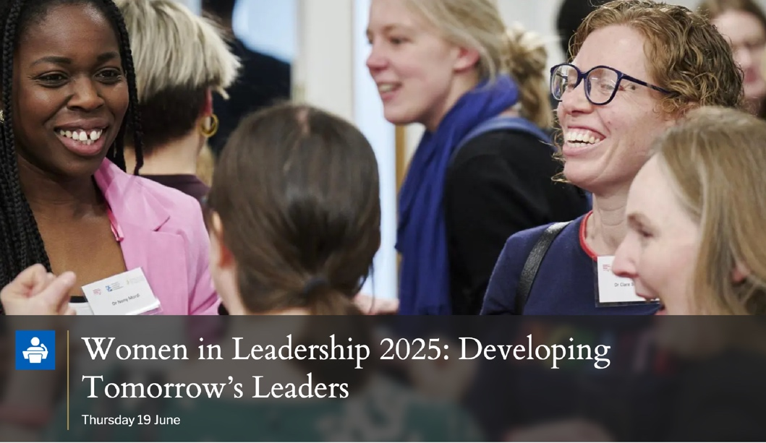

We are delighted to present Women in Leadership: Developing Tomorrow's Leaders, a hybrid conference in association Royal College Physicians Edinburgh.  This exciting event draws together an international collection of experts, inspiring role models and disruptors, celebrating and supporting not only the leaders of today but also those who follow in their footsteps as the leaders of tomorrow across all healthcare sectors and beyond.  The conference is for everyone – not just women!

The programme includes a variety of talks, live interviews and workshops with topics including learning across sectors, intersectionality, active bystander training, how to get into leadership, and a session to help male leaders support women colleagues, mentees and employees with allyship, advocacy and coaching.



[**Women in Leadership 2025: Developing Tomorrow’s Leaders | Royal College of Physicians of Edinburgh**](https://eur01.safelinks.protection.outlook.com/?url=https%3A%2F%2Fwww.rcpe.ac.uk%2Fevents%2Fwomen-leadership-2025-developing-tomorrows-leaders&data=05%7C02%7CNiall.MacIntosh%40nhs.scot%7Cd13f83f6b80546cd2d1308dd4794809e%7C10efe0bda0304bca809cb5e6745e499a%7C0%7C0%7C638745425305968053%7CUnknown%7CTWFpbGZsb3d8eyJFbXB0eU1hcGkiOnRydWUsIlYiOiIwLjAuMDAwMCIsIlAiOiJXaW4zMiIsIkFOIjoiTWFpbCIsIldUIjoyfQ%3D%3D%7C0%7C%7C%7C&sdata=6JYjb2asPIz9B0PwaoDuhSwmY0e9LCZ7wuRUVhNR0c0%3D&reserved=0)

1. **Knowledge Services – Current Awareness Bulletins**

## ****The Current Awareness section of The Knowledge Network has been refreshed!****



Provided by NHS Librarians across Scotland these bulletins offer recent literature which has been reviewed and curated to identify important, high-quality evidence.

There are a wide range of topics including:

* AI in healthcare
* Cancer – supportive care
* Realistic medicine
* Social prescribing
* Vaping and Tobacco control
* Climate change

Subscribe to have bulletins delivered straight to your inbox –so you can keep pace with updates.

**The full list, library contacts and most recent issues are available on The Knowledge Network Current Awareness pages.**

To hear about new bulletins and other resources, subscribe to our monthly [**Knowledge Nuggets newsletter**](https://mailchi.mp/nes/nuggets).

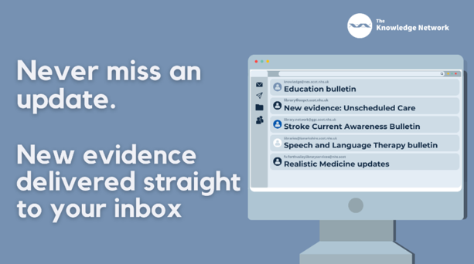



If you have any questions, please contact our [**Knowledge Services Help Desk**](https://www.knowledge.scot.nhs.uk/about/contact-us/). 

**10. NES Conference 2025**

## ****Learning for Change: Tackling Health Inequity through Education and Workplace Learning****

## ****24 & 25 April 2025****



## ****NES Annual Conference 2025 - Learning for Change: Tackling Health Inequity through Education and Workplace Learning****

**Thursday 24 and Friday 25 April 2025**

Following on the growing success of the 2024 conference, NES is delighted to confirm that it will once again be hosting the conference online over two days in April 2025. This conference is for colleagues from all professional disciplines across health and social care with an interest in education and training, workforce development and digital solutions. There will be a number of plenary and parallel sessions run by all professional groups and an opportunity for joint sessions highlighting interprofessional learning. NHS Education for Scotland sponsor the conference, and there will be no charge for participation.



Further details on the programme and how to register are available here: [**NES Annual Conference 2025**](https://www.nes.scot.nhs.uk/events/nes-annual-conference-2025-learning-for-change-tackling-health-inequity-through-education-and-workplace-learning/)

**11. Valuing Diversity and Promoting Inclusivity**

[**Inclusivity Poster**](https://scottish.sharepoint.com/sites/4nes/SPDS/Communications/Forms/AllItems.aspx?id=%2Fsites%2F4nes%2FSPDS%2FCommunications%2FDeanery%20Newsletter%2F2023%2FJune%202023%2F814870%5FSCT0922830498%2D001%5FInclusivity%5FPoster%5FP2%20%2D%20PRINTED%20VERSION%20%28002%29%2Epdf&parent=%2Fsites%2F4nes%2FSPDS%2FCommunications%2FDeanery%20Newsletter%2F2023%2FJune%202023&p=true&ga=1)

**12. Please Contact Us**

**FAO all trainees**

Please [**contact us**](https://www.scotlanddeanery.nhs.scot/contact/) with information on any initiatives and projects you are involved in that you would like to share with your colleagues across Scotland, or if you have feedback on the Deanery Newsletter or Deanery Websites.

**13. NES Websites**

**The Scotland Deanery Website**

On the [**Scotland Deanery website**](https://www.scotlanddeanery.nhs.scot/) for Scottish medical training there are sections with lots of relevant information for Trainees, Trainers, IMGs, Medical ACT, Quality and the Trainee Development and Wellbeing Service.

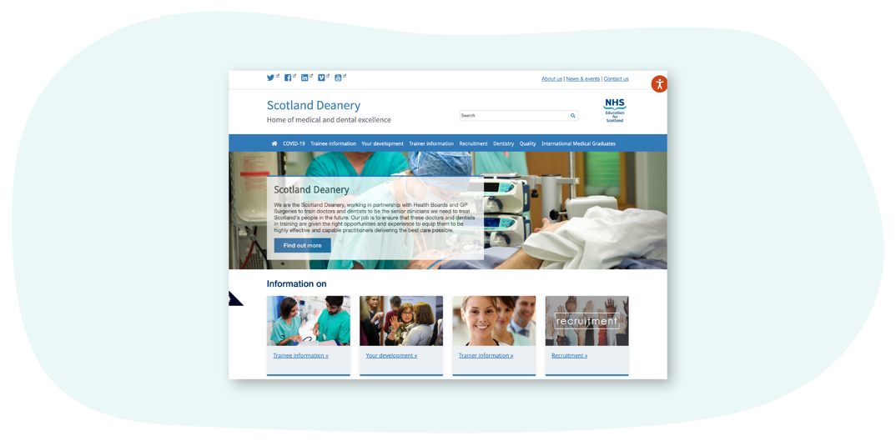



**Scottish Medical Training**

[**This site**](https://www.scotmt.scot.nhs.uk/) is our recruitment site and  is the principal resource to learn more about how to apply for Foundation, Core and Specialty Medical Training in Scotland. Here you’ll find regularly updated information about application windows (how and when to apply), a directory of 50+ GMC-approved medical specialty programmes and first-hand accounts about training from trainees and trainers. There are also useful insights on career direction and what it’s like training and working in Scotland.

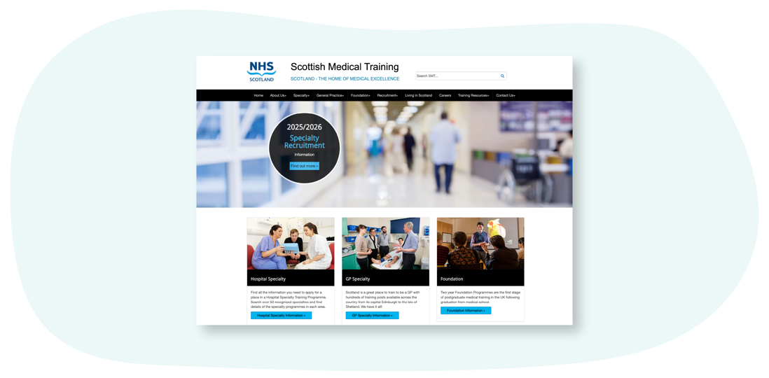

**Scottish Online Appraisal Resource (SOAR)**

Designed for doctors (in both Primary and Secondary Care) working and training in Scotland, for their Appraisal and Revalidation needs. The Scottish Online Appraisal Resource ([**SOAR**](https://www.appraisal.nes.scot.nhs.uk/)) is used by Appraisers and Appraisees to aid the appraisal process, and for Trainees to complete their self-declarations. Here you’ll also find a SOAR user guide, handy FAQ’s and examples of Quality Improvement Activities.

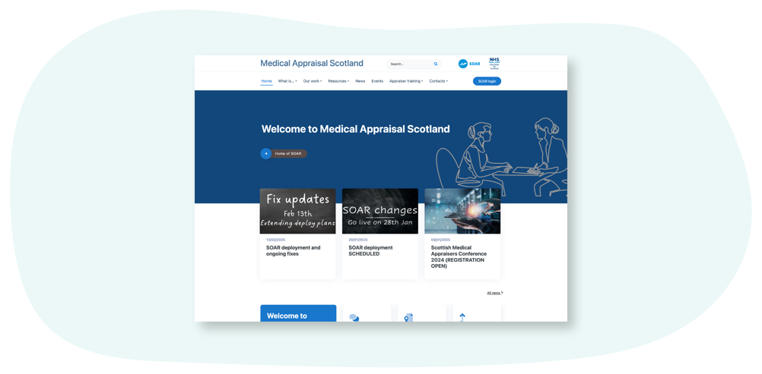



**Clinical Skills Managed Educational Network (CSMEN)**

[**This website**](https://www.csmen.scot.nhs.uk/) provides information and resources relating to the Clinical Skills Managed Educational Network (CSMEN) which was established in 2007 to support excellence in clinical skills education. The focus has been on improving patient safety and clinical outcomes by supporting access to high quality, multi-professional skills training and clinical simulation across all geographical areas of Scotland. CSMEN develops online educational resources**,**manages and deploys a Mobile Skills Unit (MSU) which provides state of the art simulation facilities for remote and rural healthcare practitioners and has built a national network of healthcare educators and practitioners. We connect people and organisations involved in health and social care to enable collaboration for a "Once for Scotland" approach to skills and simulation-based learning.

