Joint NHS Ayrshire & Lanarkshire

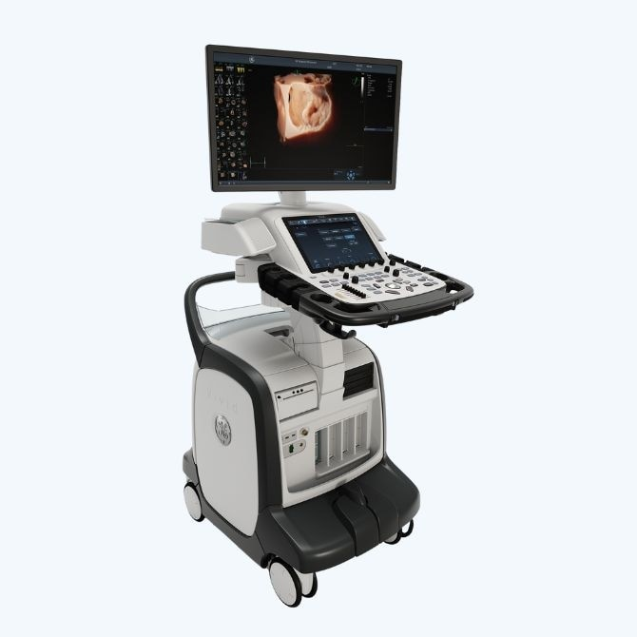

FUSIC Heart Course

**Friday 25th October 2024**

University Hospital Hairmyres

Course cost £230

This course is validated by RCOA/FICM for **5 CPD** points

Teaching from cardiologists, BSE accredited sonographers and FUSIC accredited intensivists

To apply for the course, please email [isobel.kirby@lanarkshire.scot.nhs.uk](mailto:isobel.kirby@lanarkshire.scot.nhs.uk)