PERFORMANCE SUPPORT UNIT (PSU)
FRAMEWORK FOR DOCTORS IN TRAINING IN THE SCOTLAND DEANERY

INDEX

Page Number

1. Introduction 3

2. Purpose 3

3. Professional Support Service 3- 4

4. Who should be referred to PSU? 4 - 6

5. Record keeping 6

6. Resource and Support Services 6

7. Governance of PSU 6

8. Regional Performance Support 6-8

9. Evaluation of the Impact of PSU 8

10. Annex 1 – Referral pathway 9

11. Annex 2 – Roles within Performance Support Unit 10

12. Annex 3 – Management pathway 11

13. Annex 4 – Performance Support Operational Group 12 - 13

14. Annex 5 – Performance regional Group SOP 14

15. Diagram 1 – Governance Structure 15

16. Diagram 2 - Role and Communication Channels for Deanery 16
Performance Support

1. Introduction

1.1 In April 2014 NHS Education for Scotland became a single Deanery with four regions and five regional offices. The purpose of this re-organisation was to ensure consistency of processes and experience in the trainee journey irrespective of specialty and location.

1.2 As a result a Performance Support Unit (PSU)to provide support and guidance for trainees and for those involved in managing and supporting the trainees who require professional support has been developed.

1.3 The strategic vision of the PSU is :

- To promote early identification of trainees who require professional support.
- To provide clinical and educational supervisors with a clear structure for identifying and
addressing any difficulties.
- To ensure clear lines of responsibility for other educators involved in managing trainees requiring professional support.
- To provide a network of support for educators throughout Scotland.
- To establish a group of experts who can deal with specific areas of difficulty and where necessary refer to additional resources and identify opportunities for targeted training.
- To ensure equal access to educational support.

2. Purpose

2.1 The purpose of the PSU guidance is to ensure that doctors who may be experiencing difficulties are identified and supported as early as possible. The work of the PSU is based on the following underlying principles:

- To support trainees in their training with a view to provide them with the tools to progress in their training programme.
- To support trainees during the process of leaving a training programme if support and
remediation are unsuccessful.
- To support Educational Supervisors managing trainees with difficulties in the workplace.
- To provide a culture of support and development
- Processes and decisions will be transparent and understood by all.
- Decisions will be based on best evidence.
- To provide clear criteria for assessment and decision making.
- To ensure consistent application of guidelines across the Scotland Deanery.
- To ensure a responsible use of funding and resources.

3. Professional Support Service

3.1 The PSU can advise on a range of services – examples include

- Case management.
- Careers advice.
- Language and communication skills
- Examination support.
- Signposting to Occupational Health assessment.
- Advice re specific training to meet identified educational needs
- Assessments
- Mentoring support.
- Conflict resolution.
- Management of GMC referrals in relation to key areas of performance (competence), health or conduct (personal/professional).

3.2 Referrals to the PSU will be made by TPDs, FPDs, APGDs, GP Training Leads and DMEs. Self referrals from trainees will not be accepted.

A standard referral form will be used. This can be seen on the Scotland Deanery website at:
http://www.scotlanddeanery.nhs.scot/trainer-information/performance-support-unit/psu-documentation/ The standard referral process is seen at Annex 1.

3.3 The PSU works directly with trainees assessed at level three. When a referral form is received by the PSU the Clinical Lead (PSU) will review the referral and allocate a case manager (consultants and GPs working in medical and educational environments) to the case. They will meet with the trainee and/or identify appropriate action, and refer to relevant support service as required.

3.4 The case manager may meet with the doctor when appropriate to make an assessment and formulate a plan.
This will be implemented and managed in partnership with the Regional Performance management group/TPD/Employer who may already be involved in providing support to the trainee. The Clinical lead (PSU) and the case managers will meet regularly to discuss these cases.

3.5 The PSU case managers will be supported by an administrator who will co-ordinate appointments, support the case managers with preparation of reports, letters and updating of TURAS.

3.6 Details of the role of the Clinical Lead (PSU), Case Manager and administrator are outlined in Annex 2.

3.7 PSU will liaise with the Faculty Development Alliance on appropriate training for educators

4. Who should be referred to the PSU?

4.1 For most doctors in training there are no concerns about their clinical or professional performance during their training. Clinical and educational supervisors will have access to evidence of the performance of trainees via their e-portfolio. This is reviewed routinely as trainees move from post to post.

4.2 For doctors in training where there are concerns they will usually fall into three main areas

(a) Performance (competence)
(b) Conduct (personal/professional)
(c) Health
Each of these concerns can be categorised into three levels.

Level One Support

4.3 Minor concerns which can be managed locally by training team. Concerns which are of low risk to patients, colleagues and self.

- ARCP outcome 5, 7.4
- Concerns raised by educational or clinical supervisor requiring discussion with TPD/FPD but locally remediable.
- Health issues with 10-20 days sickness leave
- Single failed examination

Level Two Support

4.4 Concern which if left unmanaged could pose a significant risk to patients, colleagues or for the trainee of failing to progress or requiring additional training time.

- Unsatisfactory educational supervisor end of placement report.
- More than one examination failure or Failure of examinations which will trigger additional time in training.
- ARCP outcomes 2, 3, 7.2, 7.3.
- Any trainee likely to require extension of training due to lack of satisfactory progress or ill health for any reason.
- Trainees requiring additional support to allow them to continue to cover on call and perform usual work of grade.
- Health problems with sickness leave of more than 20 days.
- Any trainee requiring triggered occupational health referral by LEP.
- Any incident of clinical concerns triggering formal disciplinary investigation.

Level Three Support

4.5 Concern or repeated performance problems that present a high level of risk to patients, colleagues or to progression of trainees in their programme.

- Unsatisfactory educational supervisor end of placement report from more than one placement in that training programme.
- Repeated Failure of examinations which will trigger additional time in training
- ARCP outcome 3,4, 7.3, 7.4
- Any trainee who despite extension of training due to lack of satisfactory progress or ill health is still not meeting training targets.
- Any clinical concern requiring removal from on call duties or usual work of grade
- Any incident of clinical concerns triggering formal disciplinary investigation which triggers suspension from duty.
- Any GMC referral by LEP or trainers
- Combinations of any of above

4.6 Level 3 concerns should be formally referred to the PSU where a case manager would be appointed.

4.7 The PSU will work with the regional Performance Management Groups (PMG) to provide regular reports and follow up information. The Regional PMG/TPD/Employer will have continuing responsibility for working with the trainee and case manager to implement any action plan.

4.8 The different stages of the process are outlined in Annex 3. It is recognised that GMC referral can occur outwith this process.

5. Record Keeping

5.1 Doctors in training are undertaking training programmes under the auspices of Postgraduate Dean and are employees in healthcare organisations. The transfer of educational information is applicable to every doctor in training in accordance with Gold Guide and Data Protection Act (DPA).

5.2 All educational contacts relating to potential poor performance whether it is specific or generic should be contemporaneously recorded and copies given to the doctor. Documentation should commence as soon as performance concerns come to light. Only a small minority of performance difficulties may escalate into a PSU referral, records should nevertheless be kept from the earliest stage to help ensure continuity and avoid duplication effort. Good documentation is an essential part of educational governance.

5.3 Recording forms are found on the Scotland Deanery website at: http://www.scotlanddeanery.nhs.scot/trainer-information/performance-support-unit/psu-documentation/

5.4 There will be a TURAS performance support tab that will show the level of support for required for each trainee and which will indicate any meetings with a case manager. All meetings with PSU and the outcome agreed with trainee will be shared as part of the training record on TURAS.

5.5 More detailed notes on meetings will members of PSU may be held with appropriately restricted access on a site specific to PSU on sharepoint.

6. Resource and Support Services

6.1 The PSU will have a range of services at their disposal. This can be seen on the website at http://www.scotlanddeanery.nhs.scot/trainer-information/performance-support-unit/psu-resources/ Regions will still have access to occupational health and HR support. Referral to Ward simulation and acute care scenarios at Dundee and Larbert respectively will go through the PSU.

7. Governance of PSU

7.1 The Performance Support Unit will be accountable to MDET via the lead Dean/Director. The structures underpinning this will consist of an operational group which will have responsibility for the development and implementation of the NES PSU Framework document as well as overseeing the activity of the Case managers led by the Clinical Lead (Diagram 1).

7.2 The remit and membership of the PSU Operational Group is seen in Annex 4.

7.3 The PSU Case Managers Group will oversee the management of trainees and be responsible for the ongoing development of case managers.

8. Regional Performance Management Group (PMG)

8.1 The Regional PMG will remain the first port of call for Educational Supervisors, TPDs, FPDs and Health Boards who identify trainees in need of extra support.

8.2 The regional structures is required to be robust and consistent and will be the link between the PSU and training supervisors and local education providers.

8.3 The Regional PMG will manage and support trainees categorised as Level 1 or 2. The PMG will also oversee implementation of training plan agreed of level 3 support need agreed with PSU.

8.4 The Regional PMG will meet regularly with the board, HR and specialty leads to review trainee progress. They will refer any trainees considered Level 3 to the PSU and will update PSU on the Level 1 and 2 trainees for data capture and reporting purposes only.

Regional Process

8.5 All trainees will be allocated a level of support on the TURAS Performance support tab.:

No known issues – no extra support required
Level 1 or 2 support
Level 3 support

8.6 Levels 1, 2 and 3 are described elsewhere in the paper. However Level 1 may include a trainee who is not performing as well as usual and on whom the CS or ES may wish to watch more closely.
8.7 Level 2 may include trainees with an exam fail.

8.8 It is recognised that some will move between the levels. Therefore, the local groups should review the trainee cohorts at each meeting.

Composition of the Regional Group

8.10 This would normally be led by the local Associate Dean for performance support.

8.11 Other members to include

- Regional Dean
- GP Director/Assistant Director
- Foundation Associate Dean
- Specialty Associate deans when appropriate
- Relevant Board representatives
- Admin Support

8.12 Depending on size of region, number of Health Boards and trainees the number and format and frequency of meetings can be planned appropriately.

8.13 The Standard operating procedure for the regional Group is outlined in Annex 5

Communication

8.14 Good communication between all members of the regional team, health boards and PSU is essential. This is shown in diagrammatic form in Diagram 2.

9. Evaluation of the Impact of PSU

  - Training outcomes for all level 3 support need trainees will be recorded.

  - It will be important to evaluate the effectiveness of the policy at all three levels of performance. The intention is to strengthen the process for gathering information on the satisfaction of doctors and referrers using the PSU.

  - The PSU operational group will be tasked with significant event reviews both for cases that have gone well and those that have not.

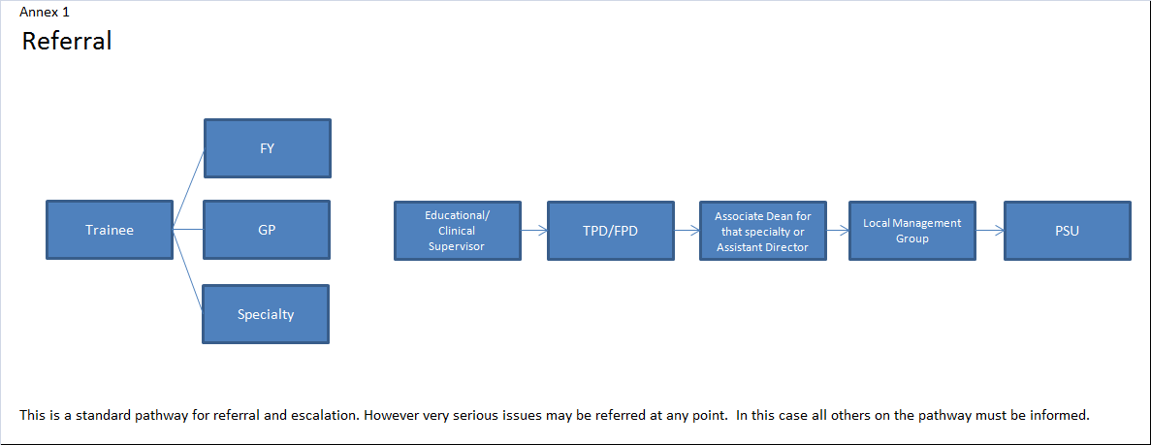

Annex 2

ROLES IN PERFORMANCE SUPPORT UNIT (PSU)

Clinical Lead for Professional Support

- Responsible to MDET via Lead Dean/Director
- Responsible for leading and delivering PSU strategy
- Review PSU referrals and determines appropriate disposal
- Chairs PSU Operational Group
- Supervises, appraises and ensures ongoing professional development of Case Managers
- Manages individuals referred to Level Three
- Attends National and UK Performance Support meetings

Case Managers

- These will be Consultants and GPs who have experience in managing trainees requiring Level 1 and Level 2 support
- Manage individual cases referred as Level Three
- Responsible to Clinical Lead (PSU)
- Participate in case conferences
- Liaise with other support services
- Write reports on meetings to be shared with trainees

Administrator for PSU

- Offer first point of contact for anyone seeking information on PSU
- Responsible for the day to day running of PSU and management of incoming cases
- Provides advice and support to those making referrals, doctors being referred and Case Managers
- Facilitates the triage of case with the Clinical Lead (PSU).
- Updates TURAS
- Arranges operational group meetings, strategy group meetings and case conferences.

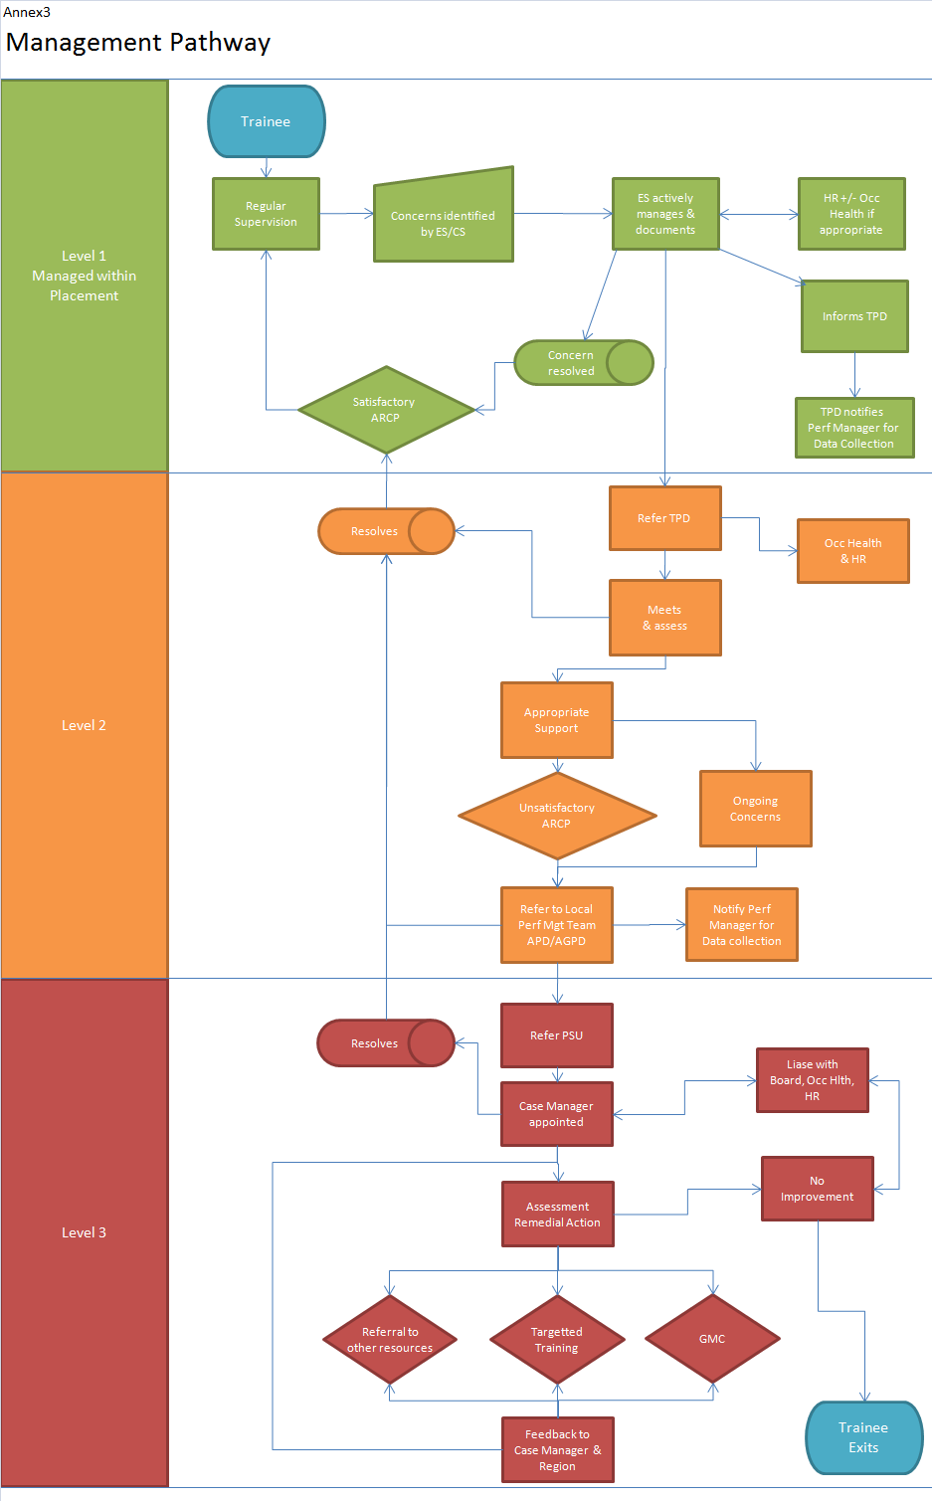
Annex 4
Performance Support Unit Operational Group
Terms of Reference
Aims

This Group will be responsible for overseeing the function of the PSU and the delivery of educational support to trainees whose performance is identified as giving concern.

Remit

- To agree a standardised process of recording and monitoring the progress of trainee doctors requiring support.
- To develop SLAs with providers for additional resources as required
- To monitor the quality, the use and effectiveness of national resources.
- To monitor the budget for performance support
- To provide an annual report for Medical Directorate Executive team (MDET)
- To establish a consistent referral process.
- To establish a consistent management process.
- To facilitate access, when appropriate, to national resources for remediation.
- To identify where additional resources are required.
- To provide informal guidance for regional staff on process when required.
- To liaise with the Faculty Development Alliance in the process of training Clinical supervisors, educational supervisors, training programme directors, associate deans and assistant directors who deal with performance issues.
- To provide input into the learning resources and courses available to those dealing with performance issues.
- To receive regular reports from the local performance management teams on regional activity. To prepare regular reports for the Performance Support Unit steering group.
- To quality manage a consistent referral processes for trainees and equity of access to support services.
- To quality manage the consistency of management of trainees requiring extra support.
- To provide national policy and guidance documents which are fit for purpose, easily accessible and remain updated
- Oversee the process of appointment of case managers.
- To ensure NES website is up to date with relevant information regarding PSU
- To ensure appropriate linkages between the operational group and the regional teams.
- To have links to faculty Development Alliance to ensure training for those supporting struggling trainees meets their needs.
- To establish formal links with the General Medical Council (GMC) and any other relevant bodies.

Membership of the Group

- Chair – Clinical Lead PSU
- Case managers x 4/5 – These may be associate deans, assistant directors or TPDs with particular expertise from across Scotland.
- Admin support.
- Service representative
- Performance management leads from each region
- GMC liaison officer
- HR
- Other members may be co opted as required

Frequency of Meetings

The operational group will meet every two months.

Reporting
The operational group will report to the Lead Dean Director.

Local Performance Management Group Standard Operating Procedure Annex 5

Administrator task
Time | Action | Responsible
3 week before meeting | - Contact training teams (APDs, Foundation consortium leads leads) with list of known level 2-3 trainees in their programs.  - Ask for any level 2-3 trainee not known to the PSU, especially where recent information suggests need for extension to training. | Admin
 | - Contact LEP HR with list of known level2-3 trainees in their employ.  - Ask for any level 2-3 trainee especially to check anyone with sick leave >2 weeks or where new clinical concern causing change in duties. | Admin
1 week before meeting | - Update PRG spreadsheet against returns.  - Check sheet against GMC list.  - Send urgent reminder to any group not returning  Dataset=name, GMC, post, TPD, case manager, previous note from PRG. | Admin
At Meeting | - Compile note on each trainee discussed.  - Assign case manager to all new level 3 trainees via PSU referral | Admin  APD
Post meeting | - Check typed notes  - Inform case managers of new cases  - Send notes to HR/DME and training teams on relevant trainees  - Add note to TURAS PSU section  - Action agreed points from notes | APD  Admin  APD

DIAGRAM 1
MDET

Performance Support Unit
Case manager Group
Level 3 +/- Level 2 Referrals

Regional Performance Groups x 4

Relates to ES/TPD/FPD locally

Performance Support Unit Operational Group

Training Management Workstream Lead
MK (accountable)

Diagram 2

ROLE AND COMMUNICATION CHANNELS
FOR DEANERY and REGIONAL PERFORMANCE SUPPORT

Local Education Provider
Foundation : GP : Specialty Trainee

CS

HR ES

FPD/TPD

APD/AD

A

Moya H Kelly
PSU
Manages Level 3
Data Capture for Level 1 and 2
Level 1 may be managed locally but regional groups should be aware
Manages Level 2
Level 1 when appropriate
Refers level 3
Regional Performance Group

All APD/AD
HR/Service
Admin
APD Performance

j:\gpsecure\jane\psu (performance support unit)\psu - final framework paper\performance support unit_1.docx

