Scotland Deanery Newsletter
Issue 44 | June 2024

Content

- Foreword
- 11th Annual Medical Directorate Awards
- NES Conference 2024
- Need to Report a Concern?
- Latest Guidance on Applying for Acceleration of CCT Date
- Supporting and Understanding Doctors in Training Who Leave a Training Programme
- Changes to the Scottish Training Survey
- Medical Careers Team Evening Webinars
- NES Knowledge Services: The Knowledge Network redesign
- Valuing Diversity and Promoting Inclusivity
- Please Contact Us
- NES Websites

- Foreword

Welcome to the June edition of your Deanery newsletter.

As the bees start buzzing with the summer breeze, or so we can wish, and ARCPs are underway, we hope that you have had a good year in training. For some, this may be your first summer as a doctor, whilst for others, this may be the last one as a trainee. Regardless of the new adventures you are preparing to embark on in August, we wish you an exciting future and bon voyage!

To begin with, we would like to draw your attention to key updates in this issue, which include the latest guidance on the application for accelerated Completion of Clinical Training (CCT) date and the new leaving process for exiting a training programme. Educational opportunities highlighted in this newsletter include Careers Team Evening Webinars aimed to help you with career development, and the updated Knowledge Network for Health and Social Care, which contains many freely available resources.

We first celebrate the successes of all those whose contributions to medical education have been recognised through the 11th Medical Directorate Awards. Through pioneering new training modalities, inspiring new generations of trainees through their commitment, enthusiasm and role modelling, and standing up for important issues like sexual misconduct, the continued hard work of all those who are involved in medical education helps us build a supportive and fruitful environment for learning. A sincere heartfelt congratulations to all the winners and runners-up!

Our next item announces the online availability of the NES Conference session recordings and all of the posters that were successfully submitted.

“Part of creating a nurturing learning environment is to feel empowered to raise concerns when they arise.”

We appreciate that it can be difficult to know how or whom to raise the issue to at times. The article ‘need to report a concern?’ illustrates some of the processes and people who might be available to support you if an issue does arise, whether it is related to patient care or your training.

Next included in this issue is the latest guidance on applying for the acceleration of the CCT date. Most clinical training programmes have an indicative timeframe, and it is recognised that learners can attain skills and knowledge at different rates. With some trainees potentially achieving all the required competencies before the indicative training timeframe, they may be in a position to consider applying for an accelerated CCT date. Links to the latest published guidance and useful practical tips to consider before application are contained in the article.

Starting from June 2024, a new and improved process for leaving a training programme will be also implemented. We recognise this may be a challenging time with difficult decisions to be made and can be associated with anxiety and stress. A recent survey also highlighted the need for a more standardised approach to gain feedback from trainees who leave a programme. Thus, some of the changes include streamlining email notifications to reduce administrative burden, using a Leaver’s questionnaire to gain feedback, and the chance to meet 1:1 with a senior member of the Trainee Development and Wellbeing Service to provide feedback.

Further changes that will be coming into effect from June 2024 is the new updated Scottish Training Survey. Each year, questions are continuously reviewed to allow the most relevant and appropriate questions to be included. This year, new questions on key issues such as discrimination, harassment, sustainability, interactions with Physicians Associate and Anaesthetic Associates, and overall satisfaction with the posts will be included. The results are published yearly to inform the quality management process undertaken by the deanery.

Also included in this issue is information on the Medical Careers Team Evening Webinars that will be running on an approximately monthly basis, from 17:00-18:00, for the remainder of 2024. These sessions are aimed at helping trainees and trainers plan their careers and career development. Flyers for these sessions are attached.

Further educational resources are available on the Knowledge Network for Health and Social Care website, which has also undergone an update! Many services and resources are available, from training material to books and journals, so it is worth exploring! Many books and journals are available for free with your OpenAthens account- details of how to sign in or self-register are included.

As always, feedback on the deanery newsletter and website is always sought after, and we welcome submissions for articles to hear about your experience of training for upcoming newsletters!

If you have work you would like to highlight in this newsletter, contact Scotland Deanery.
Dr Mengye Li (Core Trainee in Anaesthetics) and Dr Xinming Yu (Internal Medical Trainee)
Trainee representatives for the Scotland Deanery Communications Group

- 11th Annual Medical Directorate Awards

Award for Innovative Education and Technology

Winner: Dr David Varghese

Clinical Fellow in Transplant & Mechanical Circulatory Support, Golden Jubilee National Hospital
- Mr David Varghese, who is a Clinical Fellow in Transplant and Mechanical Circulatory Support at the Golden Jubilee National Hospital.
- Mr Varghese has a real passion in training and – after intensive efforts, has successfully pioneered a simulator for training in Cardiac Surgery. This model provides excellent simulation in aortic and mitral valve suturing, using materials that authentically replicate the conditions of suturing valve replacements in human tissue in real time, without the need or cost associated with animal or cadaveric models.
- The whole model is almost identical to a natural aortic valve in continuity with the aortic root and ascending aorta and also allows training in mitral valve annulus suturing.
- Cardiothoracic Trainees and Fellows will have the opportunity to work on their skills on this simulator before they start operating in real patients.

Runner up: Professor Cindy Chew

Director of Imaging & Anatomy, University of Glasgow. Consultant Radiologist, University Hospital Hairmyres

Award for Exceptional Staff Support

Joint Winners: Marion Mackay

Service Manager, Medical Education Directorate, NHS Lothian
- Marion is the Service Manager, Medical Education Directorate, NHS Lothian. Over her working life, Marion has embodied the ethos of NHS Scotland through unwavering dedication, leadership, and a deep commitment to quality healthcare education and patient care. She has consistently demonstrated a "can do" attitude, approaching each challenge with resilience and optimism.
- Marion has fostered a spirit of unity and cooperation that has enabled the effective daily running of Lothian’s programmes. Her ability to inspire and motivate has been crucial in building a cohesive team that works seamlessly towards supporting trainees and medical students. Her contributions have not only advanced medical education but have enhanced the lives of countless individuals.

Angela Haining

Care of the elderly secretary and undergraduate teaching coordinator, Edinburgh
- Angela started working for the NHS 40 years ago as a medical secretary. She has welcomed and nurtured medical students over the years, through a time of more rigid and didactic teaching to the more holistic style we have now. She has been a shoulder to cry on and cared for those with many crises from broken down cars to angry consultants!
- As teaching has evolved, she has understood the need for a multidisciplinary approach and now coordinates a teaching plan which is personalised for small group teaching.
- During her tenure Angela has supported 3 generation of consultants/senior doctors. Her in-depth knowledge of complex systems within the department, has been vital for the delivery of excellent and tailored care and support to patients, their relatives, learners, and her colleagues.

Runner Up: Philip Smith

SAS Programme Officer, NES

Inspirational Role Model

Winner: Professor Morwenna Wood

DME NHS Fife
- Professor Wood became the Director of Medical Education in NHS Fife in 2008. The depth of her impact on medical education in Fife and further afield is extraordinary. She has influenced the careers of innumerable medical students, doctors in training and trainers and continues to influence the careers of many.
- Morwenna brings relentless energy to her education role. Under her guidance, NHS Fife partners with four universities over six programs and provides training opportunities for increasing numbers of trainees from foundation to higher trainees. Despite managing the complex delivery in all these areas, she sustains personal and supportive connections with key educational leads across Scotland and is widely respected for her insights, judgement and clear communication.
- Professor Wood has inspired many to become involved in medical education. She demonstrates a passion for transforming people through education and training opportunities. She has supported and inspired many to pursue medical education careers giving them guidance and confidence.
- Morwenna has a strong sense of inclusion and under her leadership NHS Fife has developed programs for international medical graduates and widening participation in medical careers. She supports doctors who are on non-traditional training pathways and specialty doctors in the organisation.
- A wide range of trainees, undergraduate and postgraduate trainers and locally employed doctors contributed to her nomination for this award. A recurring theme in their contributions is that of Morwenna’s inspirational and supportive approach. There are many examples of how she has championed individuals to be the very best they can be.

Joint Runners up: Dr Wendy Corstorphine

Hospital lead for medical education, NHS Orkney

Dr Dean O’Dwyer

Clinical Development Fellow, NHS Shetland

Equity, Diversity and Inclusion

Winner: Lothian MED Fellows
- This team of talented and enthusiastic Fellows came together in the wake of the Women in Surgery 'Breaking the Silence' report (Sept 2023), determined to stand up against sexual misconduct in the workplace. Through an inclusive and thoughtful approach, their expertise was used to produce a suite of online resources, looking at evidence and support available for those who have experienced sexual misconduct in the workplace, those who have been witness to it, and those who may want to consider their own behaviour and/or may have been accused of misconduct. Their maturity of thought both around the use of language and in ensuring the resources are relevant promotes inclusivity, personal reflection and encourages improvement.
- The team worked at great pace and launched the resource in less than three months. NES was delighted to hear of their work and is collaborating with the Fellows such that the resource can be adapted and shared nationally.
- The energy of the Fellow team has continued since the resource launch 5 months ago. They have presented at conferences, produced toolkits, and are working across professional boundaries to share learning and empower others.

Runner up: Dr Katie Brown & Dr Lynsay Crawford

Clinical University Lecturer and Senior Clinical University Lecturer, University of Glasgow

The awards presentation can be accessed here: Medical Directorate Awards 2024

Professor Alan R Denison

Dean of Postgraduate Medicine and Chair of the Awards Panel

- NES Conference 2024

All the recordings and posters from the NES Virtual Conference 2024 are available here:
https://www.nes.scot.nhs.uk/events/nes-annual-virtual-conference-2024-post-event-recordings-posters/

- Need to Report a Concern?

Most trainees have a positive experience in their placements on their training programme. However, from time to time some of you will encounter a problem or issue that causes concern. This might mean you don't know who to talk to in the department if it relates to a colleague or a safety concern.

Patient safety is everyone's first concern and you should use the clinical governance framework in your Board to highlight a risk as soon as you become aware of it. All Boards will have policies for incident and near miss reporting, risk management and clinical governance. They will also have policies for bullying and harassment, and staff conduct and capability so there will be a mechanism and staff who can advise you.

As a first step to raising a concern about the quality of your training out with the normal feedback routes such as surveys, ask your clinical or educational supervisor for advice, and use the policies of the NHS board where you are employed to try to resolve the problem. Management staff in the Clinical Directorates will work within these policies and can take forward some solutions. All Boards have a Director of Medical Education and their department should also be able to help you with a concern about training and advise on the appropriate Board person to speak to. Feedback about the quality of training is not whistleblowing, and each Board has its own policy around what to do in relation to whistleblowing. Should the concern fall under the scope of whistleblowing rather than as feedback about the quality of training advice on how to proceed should be sought from the placement Board’s Director of Medical Education.

If you feel you need further support, contact your Training/Foundation Programme Director or your programme administrator at the Deanery. We want to help you resolve your problem and we are here to make sure you get the right training to an appropriate standard, so we can assist you if you don't know who to ask.

Further information to access support from the Medical Directorate’s Quality team can be found on our webpage - https://www.scotlanddeanery.nhs.scot/trainee-information/report-a-concern/

- Latest Guidance on Applying for Acceleration of CCT Date

Most postgraduate medical curricula are set out with an indicative timeframe. This allows understanding of the likely time required to complete the curricular requirements and attain a Certificate of Completion of Training (CCT). The reality is that the majority of trainees take longer than the indicative time for multiple reasons including less than full time working, statutory leave, periods out of programme and extensions of training to allow completion of competencies.
A small number of trainees may however acquire their competencies at a faster pace and in agreement with their trainers, feel that it is in their interests to apply for an early CCT date. There are many factors to consider when deciding if this is the correct move. There may be a strong desire to move on to a consultant or GP role or post CCT fellowship training but this should only happen when the trainee and trainers can be absolutely confident that a trainee is ready to do so. Being in a training programme should provide many advantages such as close supervision and support which may not be as readily accessible after exiting training. The opportunity to develop further skills or knowledge, or funding to do so, out with a training programme can be limited and relies upon the priorities of employers. It should also be remembered that curricular competencies should be seen as the minimum required for CCT and many people benefit from more experience prior to taking up consultant or GP posts.
The Scotland Deanery has recently published updated guidance on the process for applying to accelerate a CCT date. It can be found via this link: Scotland Deanery page on acceleration of CCT
The broad principles of the process are that a trainee requires the support of their educational supervisor and TPD. It is essential that this support is sought more than a month prior to the ARCP to allow time for careful consideration. The ARCP panel will then decide, based upon the evidence in the trainee’ portfolio if an early CCT is appropriate. This recommendation will then be passed to the Postgraduate Dean who will make the final decision. In order to avoid unacceptable disruption to programmes and fellow trainees, a CCT date will not normally be brought forward to less than 6 months after the ARCP. This allows time to plan for replacing the trainee. It would also be extremely unusual for a CCT date to be brought forward by more than 12 months’ whole time equivalent. This is because any competencies attained prior to joining the programme should have been taken into account at the trainee’s first ARCP with any appropriate adjustment made to their CCT at that, early stage, in their training programme. The process, outlined in the link above, refers to adjusting a CCT date to recognise competencies gained during the training programme. This would almost never be so rapid as to reduce training time by more than 12 months in a 4-6 year specialty programme. Similarly, accelerating CCT dates in short, core programmes is a consideration that can only be made at the ARCP at the end of year one. Requests for ad hoc ARCPs to be held to consider applications for early CCTs will not usually be facilitated so trainees should base plans for requesting early CCTs around the standard ARCP calendar.
This process helps trainees to move on to the next stage of their careers at the correct point and avoid remaining in a training programme if that is no longer needed. This is consistent with training to a competency-based curriculum which recognises that learners attain knowledge and skills at different rates and allows a more bespoke approach to meeting training needs.
Mr Alastair Murray, Deputy Postgraduate Dean

- Supporting and Understanding Doctors in Training Who Leave a Training Programme

Until now, there has been no formal opportunity for doctors leaving a training programme to provide feedback to NES about their experience and reasons for leaving. Recent feedback gathered from a small cohort of doctors on training contracts who resigned described a varied experience with respect to support and information, highlighting the need for a more standardised approach to the leavers’ process, ensuring that we learn from those who leave training and offer appropriate support and careers guidance.

We understand that there are a wide range of reasons that doctors may not complete their training programme. We acknowledge that for most, this decision will not be undertaken lightly, and may be associated with challenging circumstances. We want to ensure we offer appropriate wellbeing and careers support to doctors in training during their leaving experience. We hope that our new leavers process, starting June 2024, will provide an opportunity to help us understand what factors lead doctors to leave a training programme and allow us to consider ways to improve the training experience and retention of doctors in training.

What is new to the doctors in training leavers process?

1. Website update
We have updated the website to provide more information and support to doctors in training who are considering leaving, and a link to this can be found here. The new leaving process starting June 2024 is described in detail, and resources are also offered to support and guide both doctors on training contracts and their trainers in the period before a decision has been taken to resign.
2. Streamlined email notification
We have reduced the number of emails a doctor on a training contract will need to send to give notice of resignation – the doctor in training will now only need to send a single resignation notification email to both the NES training management team at training.management@nes.scot.nhs.uk, and also to their employing health boards’ HR department. NES training management team will then cascade the information to the doctor’s training team, including their Training Programme Director, Associate Postgraduate Dean and Lead Dean Director/Postgraduate Dean on behalf of the doctor to reduce the administrative burden.
3. Leaver’s questionnaire and supportive Trainee Development and Wellbeing Service (TDWS) meeting
As part of the resignation process, NES would like to understand the reasons behind decisions to leave and ensure that leavers are offered comprehensive support and guidance where appropriate. With that in mind, we have developed an online leaver’s questionnaire to be sent to all doctors on training contracts who leave training, to gather initial information and feedback. Leavers will also be offered the opportunity of a 1:1 meeting with a senior member of the TDWS team to ensure the doctor has appropriate support in place. Themes around reasons for leaving will be collected confidentially to ensure NES can improve training and support for doctors on training contracts.
4. How we plan to use this feedback
Responses to the online questionnaire and themes covered within the TDWS leavers' meetings will be treated in confidence. However, where necessary and with consent where possible, appropriate action may be taken in response to any issues raised. The exception to this would be in the case of a significant patient safety concern, in which case we may need to break this confidentiality to seek further guidance. To encourage learning and response to feedback, anonymous collated themes will be shared at organisational level and regularly reviewed to help us identify any specific interventions or improvements we might wish to consider in future.

Further support available
The Trainee Development and Wellbeing Service (TDWS) offers a range of independent advice and guidance, including careers advice, health, and wellbeing support.

Click here for more information.
Further information and resources are also available in the doctors in training support section of the Scotland Deanery website here.
Additional career support resources are available here.

- Changes to the Scottish Training Survey
The Scottish Training Survey (STS) began in 2013 and has seen many changes over the years. The driving aim of the survey is to produce robust indicators of training across Scotland to inform quality management of posts and programmes. An additional benefit of the STS is that is allows us to capture data for each training post undertaken by a trainee across a year rather than at one point during the training year. As the survey has developed additional questions have been included to gather information on trainee wellbeing and equality, diversity and inclusion. We continue to review the questions and this year we are adding a number of new questions that will appear from June onwards. They cover areas such as discrimination, sexual harassment, sustainability, interactions with physician associates or anaesthetic assistants and overall satisfaction with your training post. We’ve also introduced some additional guidance related to the freetext comments process and how we investigate them. The main purpose of the STS is to inform the quality management process undertaken by the Deanery and all our STS results are published on an annual basis on our website, https://www.scotlanddeanery.nhs.scot/quality/survey-reports/.
Please be assured that we value and appreciate the time taken to complete the survey and are grateful to receive the information we do so please continue to do so.
Further articles will appear in the newsletter highlighting actions taken following feedback in the coming issues.
- Medical Careers Team Evening Webinars

For the remainder of 2024 the Trainee Development and Wellbeing Service, Medical Careers Team will be running a series of evening webinars aimed at helping both trainees and trainers plan their Careers, and also to support their professional development.

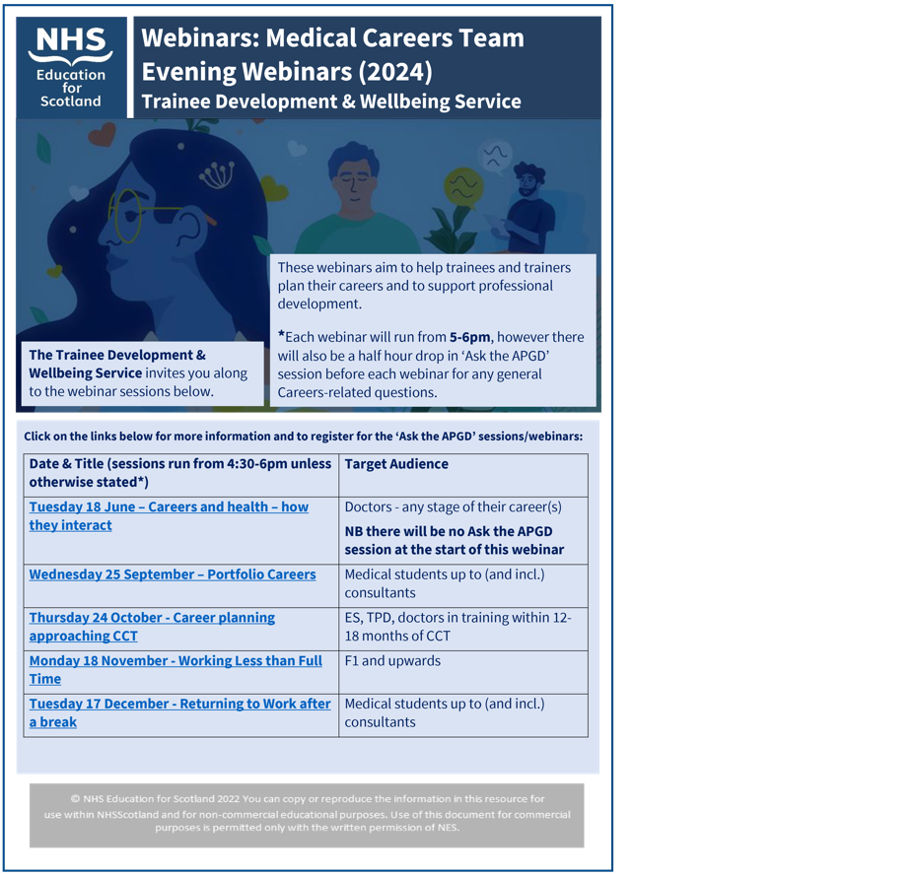

https://www.scotlanddeanery.nhs.scot/media/722451/medical-careers-team-evening-webinars-2024-flyer.pdf

You can find out more about the content of each session, and also register for the webinars, by clicking the links in the attached flyer. These will run approximately once a month from 5pm – 6pm and while we have indicated the most relevant target audience, all are welcome. Please note that some webinars will have a 30 minute drop in ‘Ask the APGD” session before the webinar starts so if you have any general Careers questions, please use this time to get in touch.

We hope you see you there!

If you have any questions, please contact the Medical Careers Team at TDWS@nes.scot.nhs.uk

- NES Knowledge Services: The Knowledge Network Redesign

The Knowledge Network for health and social care: new look and feel – same great content

The Knowledge Network has had a refresh!

NES Knowledge Services have updated the site to be more up to date and easy to use. Sign up for an Introduction to The Knowledge Network via Turas Learn, to help you find your way around and remind you of the many services available to you: Book now

Things may look different but you will still find the same excellent collections of books, journals and articles to support practice and learning from the Library Search. All available for free to health and social care staff in Scotland with an OpenAthens account – NHSScotland staff can choose to sign in with an NHSS email address and password when prompted and all other eligible users can self-register for an account.

We will be updating all of our training materials to support health and social care staff over the coming months. Visit our Help and Training page to see what’s available.

All health and social care staff can keep up to date with library news by joining our Knowledge Nuggets mailing list.

If you need any help or would like to request training for yourself, your colleagues or as part of your own training programmes, please contact our Knowledge Services Help Desk.

10. Valuing Diversity and Promoting Inclusivity

Inclusivity Poster

11. Please Contact Us

FAO all trainees
Please contact us with information on any initiatives and projects you are involved in that you would like to share with your colleagues across Scotland, or if you have feedback on the Deanery Newsletter or Deanery Websites.

12. NES Websites

The Scotland Deanery Website
The Scotland Deanery, along with our Local Education Providers, is responsible for managing Medical Training and Training Programmes across the four Scottish regions. Here you’ll also find details of the Deanery’s Quality Management activities, its key staff and locations plus information on Professional Development for doctors.

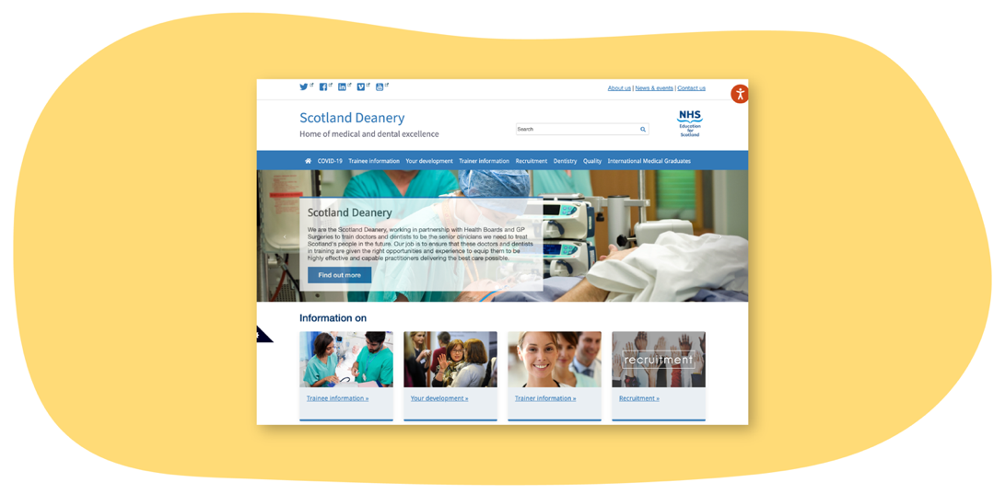
Scottish Medical Training
This site is the principal resource to learn more about how to apply for Foundation, Core and Specialty Medical Training in Scotland. Here you’ll find regularly updated information about application windows (how and when to apply), a directory of 50+ GMC-approved medical specialty programmes and first-hand accounts about training from trainees and trainers. There are also useful insights on career direction and what it’s like training and working in Scotland.

Scottish Online Appraisal Resource (SOAR)
Designed for doctors (in both Primary and Secondary Care) working and training in Scotland, for their Appraisal and Revalidation needs. SOAR is used by Appraisers and Appraisees to aid the appraisal process, and for Trainees to complete their self-declarations. Here you’ll also find a SOAR user guide, handy FAQ’s and examples of Quality Improvement Activities.

