Scotland Deanery Newsletter
Issue 43 | April 2024

Content

- Foreword
- International Medical Graduate Update
- GMC National Training Survey
- What Happens at NHS Education for Scotland (NES) Medical Senior Leadership Meetings?
- Experience of Being a Clinical Research Fellow
- Royal College of Obstetrics and Gynaecology Award
- What is NES Doing to Tackle Sexual Harassment in Healthcare?
- Technology Enhanced Learning Update
- Rural and Remote Placement Opportunities
- NES Conference 2024
- Study Leave Update
- Welcome to the Trainer Development Collaborative
- Medical Certificate Cause of Death Webinar
- Valuing Diversity and Promoting Inclusivity
- Please Contact Us
- NES Websites

- Foreword

Welcome to the April edition of your Deanery newsletter.

Spring has well and truly sprung and with it comes a very busy time of year for doctors in training. New rotations, upcoming ARCP’s and many of you will be planning what’s next come August. Our paths as doctors in training are becoming increasingly non-linear with expanding opportunities for alternative career paths and more flexible working, which I think is something to be celebrated and embraced. This is highlighted in this months edition by the reflections of our colleague Dr Alexandria Chung who is currently a Clinical Research Fellow. Whichever path you choose to take, the Scotland deanery has support for you and I fully encourage you to take advantage of this where needed.

Firstly, I just wanted to highlight two important dates included in this newsletter.

If you haven’t already done so, please remember to complete the GMC national training survey by the 2nd of May; your feedback is so important in driving improvement in training.

Secondly, the NES Annual Virtual Conference 2024 is taking place on the 25th and 26th of April.
This multi-disciplinary event is jam-packed with a huge range plenaries and workshops to suit all interests – and it’s free! Registration is now closed, but don't worry if you missed it, recordings and resources will be available following the event on the NES website.

The newsletter opens with an important update on the fantastic work that the deanery and its partners are undertaking to optimise the experience and support for International Medical Graduates (IMG’s) in Scotland. The article highlights that we all have a vital role to play in this journey and seeks to raise awareness of the valuable resources available.

“Undertaking the Scottish Clinical Leadership Fellowship (SCLF) with NES this year has really opened my eyes to the sheer breadth and depth of the ongoing work within the medical directorate, all in support of training and supporting Scotland’s’ current and future medical workforce.”

Included is an article on what really goes on at the deanery senior leadership meetings – aiming to answer all your burning questions like; who attends these meetings? What is discussed? The deanery encourages trainee input in all of its work, so please reach out if you have any suggestions or wish to get involved.

With all the current challenges the NHS is facing, it can be difficult to remain positive and optimistic in our day-to-day work. It is therefore more important than ever to celebrate success when it comes and recognise our colleagues who are going above and beyond to support others. I am therefore delighted that this months edition includes a celebration of our colleague Dr Alexandra Rice, who was recently awarded the prestigious title of National Trainer of the Year from the Royal College of Obstetricians and Gynaecologists. Congratulations Alex – very well deserved!

This month, we include an update on the imperative ongoing work that the Deanery is undertaking to address sexual misconduct in healthcare. There have already been some very positive steps made, but there is still much work to do to address the issue that is unfortunately so deeply engrained in our healthcare culture. We have included links to both supportive and educational resources, please utilise these as required and reach out to us with any feedback or suggestions you may have.

We have also included informative updates on the ongoing work of the NES Technology Enhanced Learning Team, Rural and Remote Placement Opportunities and recent changes to the study leave application process – be sure to keep yourself updated on these important topics!

Last but certainly not least, the newsletter rounds up with an introduction to the exciting new Trainer Development Collaborative (TDC), which is a fantastic upgraded online platform for delivering high quality courses and resources for trainers in medical education.

I hope the longer spring days and warmer weather brings a much-needed wellbeing boost to you all. Whichever path you are choosing to take, be sure to take the time to enjoy the journey along the way!

If you have work you would like to highlight in this newsletter, contact Scotland Deanery.
Dr Alice Main
Scottish Clinical Leadership Fellow
NHS Education for Scotland & Scottish Government Obstetrics and Gynaecology Registrar

- International Medical Graduate Update

Dear Colleagues,

As we welcome new colleagues and International Medical Graduates (IMGs) into the heart of our NHS family in Scotland, we must shine a light on the strides we're making together to ensure their smooth transition into the wider team. This commitment not only enriches our workforce but ensures the highest quality of patient care and innovation within our health services.

A Warm Scottish Welcome to Our International Colleagues

ਜੀ ਆਇਆਂ ਨੂੰ, خوش آمدید, સ્વાગત છે, أهلاً وسهلاً, Witamy

The strength and diversity of our NHS lie in the vibrant mix of skills and perspectives that IMGs bring. From leadership roles to frontline services, their contribution is invaluable. However, adapting to a new medical and cultural environment poses challenges, and it's our goal and responsibility to ease this transition.

Spotlight on Current Induction and Pastoral Support Initiatives

We're proud to highlight a range of initiatives aimed at supporting our IMG colleagues:

Welcome to UK Practice (WtUKP)

Adapting to UK medical practice can be hard for any doctor, regardless of where you’re from or how experienced you are. This free workshop is designed to help doctors new to the UK, by offering practical guidance about ethical scenarios you may encounter, and the chance to connect with other internationally qualified doctors. Every IMG new to NHS Scotland can access this workshop.

NES IMG support

IMG support activities are coordinated by our associate postgraduate dean for International Medical Graduates. The team have introduced and developed a wide range of resources and initiatives aimed at supporting IMGs in Scotland.

A significant effort in supporting medical professionals, developed by NES in partnership with Directors of Medical Education (DMEs) across health boards, is the Softer Landing Safer Care (SLSC) program. This is a framework for a 2-week shadowing period for IMGs at the start of their post, so they have sufficient time to acclimatise to working in the NHS whilst an individualised action plan is agreed between them and their Educational Supervisor. During this time, this aim is that the trainee should be supernumerary to the rota, or otherwise without any lone on-call commitments. This initiative provides a recommended framework that health boards are encouraged to adopt to ensure that doctors only work within their competence level.

Scotland Deanery also offers a range of enhanced support options for International Medical Graduates (IMGs) in Scotland with a dedicated webpage on the Scotland Deanery site. The webpage offers resources on training pathways, living in Scotland, and understanding roles within the NHS, along with links to a buddy scheme, a Facebook support group, and details about the orientation activities. The pre-induction webinars, held biannually in June and January, serve as interactive Q&A sessions, while the orientation events, conducted in August and February, provide a platform for IMGs to establish support networks. These initiatives aim to integrate with existing health board inductions and cover important topics like e-portfolios, curriculum, and cultural intelligence.

The Scottish Trainee Enhanced Programme (STEP) is an induction initiative started in 2015, specifically designed for General Practice (GP) trainees in Scotland who gained their primary medical qualifications outside the UK. STEP offers a comprehensive two-day induction, blending in-person and virtual sessions within the first six weeks of a trainee's program. It emphasises establishing a supportive relationship between trainees and their educational supervisors (ES), who also attend, enhancing their understanding of the trainees' unique challenges and needs.

The program has benefited over 400 international medical graduate (IMG) GP trainees and 300 GP educational supervisors by addressing specific challenges IMGs face through sessions on cultural competence, communication skills, exam preparation, and wellbeing among others.

Importantly, STEP reflects the significant role of IMGs in Scotland's primary care sector, with a notably high proportion of GP trainees being IMGs in recent years. Following its success in GP training, the program expanded to psychiatry in 2018 and is now extending across all specialities in Scotland. This expansion is led by speciality training boards, aiming to ensure equitable access to induction and support for all trainees.

Commencing in August 2024 is the new WINS (Welcoming IMGs New to Scotland) programme. This all-day face-to-face event will be offered regionally and hopes to capture the content and feedback from our STEP and orientation programmes. WINS will be offered to all speciality trainees, SAS and locally employed colleagues new to NHS Scotland.

From dedicated web resources to orientation events and the Softer Landing Safer Care framework, NES is at the forefront of providing a structured welcome and ongoing support to our IMG colleagues in Scotland.

Local Innovations

Across NHS Boards, initiatives such as boot camps, simulation sessions, and enhanced induction programmes exemplify our commitment to a supportive, inclusive environment. Scottish IMG support Network links all health board IMG leads and champions who co-ordinate these activities.

Centre for Workforce Supply (CWS)

The Centre for Workforce Supply recently completed a review of all IMG support activities within NHS Scotland and has established a National IMG Induction Working Group, involving key figures from NES and health boards, to enhance the support framework for International Medical Graduates (IMGs) in Scotland. This group has laid out several strategies aimed at improving the integration, support, and induction processes for IMGs. The group's recommendations focus on improving the coordination between various IMG support networks to ensure a unified approach, refining the process for accurately identifying IMGs in need of support and helping to ensure IMGs can participate in crucial "Welcome to UK Practice" programs. They also emphasise the importance of creating and disseminating visual resources to raise awareness of the support available, making better use of existing communication channels, and evaluating feedback from recent induction events to enhance future offerings. Additionally, the group suggests potentially exploring induction options for IMGs while they are still in their home countries, thus preparing them for a softer landing within their work environments. These recommendations aim to create a more supportive, integrated, and effective environment for IMGs transitioning into Scotland's healthcare system.

Facing Challenges Head-On

Despite these efforts, we recognise hurdles such as varying levels of engagement and the need for more streamlined identification and support mechanisms for IMGs. Addressing these challenges is not just about maintaining standards but about nurturing a workforce that feels valued, understood, and supported.

Call to Action: Recommendations for a Brighter Future

We stand at a crossroads, with the opportunity to further enhance our support for IMGs. Recommendations include better integration of support networks, increasing awareness of available resources, and exploring innovative induction methods, including pre-arrival training.

Your Role in This Vital Journey

Every member of our NHS Scotland team plays a crucial role in this journey. Whether by participating in mentorship programs, attending workshops to better understand the needs of IMGs, or simply extending a warm welcome to your international colleagues, your actions make a difference. If you’re interested in making a difference, please sign up to the CWS Medical Network for more information on recruiting and supporting IMGs, including a series of learning sessions you can join virtually.

Looking Ahead

As we move forward, let's keep the conversation going. Engage with the initiatives, provide feedback, and share your experiences. Together, we can ensure that every IMG feels at home in Scotland, ready to contribute to our shared mission of excellence in healthcare.

Warm regards,
Scotland Deanery Contributors:
  - Greg Logan Scottish Clinical Leadership Fellow
  - Andrea Kwek, Head of programme- workforce, Centre for workforce supply.
  - Nitin Gambhir, Lead Dean Director

- GMC National Training Survey

The annual national training survey is open until Thursday May 2, 2024.
Every year the survey provides a comprehensive picture of the experiences of doctors in training and trainers in Scotland. It is a core part of the NES Quality workstream’s work to monitor and report on the quality of postgraduate medical education and training. Your engagement with the survey is very much appreciated.

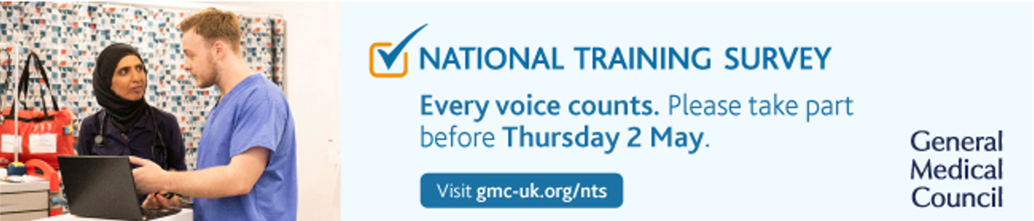

- What Happens at NHS Education for Scotland (NES) Medical Senior Leadership Meetings?

Have you ever wondered what really goes on in the senior leadership meetings within NES? Or even just how the senior leadership team works? Prior to starting the Scottish Clinical Leadership Fellowship (SCLF) within NES medical I must admit I had no idea, and speaking to peers this seems to be common! Over the last 8 months we have had the opportunity to attend all senior leadership meetings in NES to observe, contribute our opinions and get involved with the work of the medical directorate. I thought I would therefore aim to shed some light for newsletter readers on these meetings, including who attends them and what is discussed.

The overall purpose of the Medical Directorate is the organisation and provision of education and training of Doctors in Scotland. Along with their partners they support delivery of first-class training programmes for Scotland to ensure safe and effective care for patients both now and in the future. They ensure that training meets the regulatory requirements set by the GMC and that Doctors in Training (DiTs) have the right support to make the right progress in their ongoing education. They also provide support and training initiatives for consultants, GPs and SAS Doctors which in turn, supports them to provide high quality training.

The overall purpose of the senior leadership meetings is to ensure ongoing active governance of the medical directorate. They ensure the organisation is focussing on the right thing, considering the right evidence and responding in the best way. All of these meetings are organised and run by a fantastic support team within NES. Prior to the meetings, the agenda, previous minutes, and associated papers are all sent out to attendees.

There are four key medical directorate meetings that happen on a regular basis:

Medical Directorate Apex Group (MDAG)
A weekly senior team meeting chaired by the Executive Medical Director and attended by the Deputy Medical Director, Lead Dean Directors, and senior members of the management team. The agenda is variable depending on current issues arising in medical education and training and the matters that require final decisions or input by the senior leadership team. Examples of agenda items include:
  - Changes in leadership and governance structures within NES
  - National recruitment numbers, their allocation and specialty fill rates
  - Medical education reform and the shape of training matters
  - NES response to sexual misconduct reports.
Medical Directorate Reference Group (MDRG)
A monthly meeting chaired by the Executive Medical Director which involves the senior leadership team as for MDAG as well as wider partners in medical education including the Deans of medical education (DME’s), Specialty Training Board (STB) chairs and members of the NHS Scotland Academy. The theme of the agenda changes monthly and is regularly led by the DME’s group and STB chairs to ensure a variety of issues are discussed. Examples of recent agenda items include:
  - Medical education supervision – NES Mission statement
  - Foundation Doctors induction and shadowing arrangements
  - Study leave, travel & subsistence framework – update on ongoing work
  - NES Simulation programme
  - Specialty and Specialist (SAS) doctors update
Medical Directorate Quality and Safety Group (MDQ&S)
A monthly meeting chaired by the Deputy Medical Director which is relatively new within NES medical. It’s a governance group that aims to have oversight of the quality and safety processes and activity within the directorate. There is also a focus on human factors and patient safety. It aims to highlight any arising issues or concerning trends early and acts as an assurance to the processes in place. Regular items on the agenda include:
  - Doctors in training resignations – by region, specialty and reasons leaving
  - Inter-deanery and inter-regional transfers
  - ARCP outcomes and appeals
  - Quality; survey results, site visits and enhanced monitoring sites
Medical Directorate Management Group meeting
A monthly meeting chaired by the Associate Director discussing all the management and supporting activity within the directorate. Includes management representatives from the training programme management team, quality team, digital team, medical HR and the finance team. Agenda items include:
  - Finance update and forward planning
  - Recruitment and vacancies within the directorate
  - Equality, diversity, and inclusion activities
  - NES Website updates
I hope this has been a helpful insight into what goes within the NES medical directorate senior meetings. I am happy to answer any questions on alice.main2@nhs.scot.

- Experience of Being a Clinical Research Fellow
Dr Alexandria (Alex) Chung is a Clinical Research Fellow in Infectious Diseases. Alex has a keen interest in Public Health and Research. She is currently working with the Regional Infectious Diseases Unit (RIDU). She was kind enough to share her experiences of the Clinical Research Fellow role.
What is your day-to-day like?
The core part of my role can be summarised as having clinical oversight of the clinical Infectious Diseases trials conducted in NHS Lothian. However, the overall job is quite flexible and I've been able to make what I want out of it. My schedule can be varied as a result of this. For example, on a typical day, this could include writing research papers, consenting patients for clinical trials and reviewing patients for adverse events. A particularly interesting area of research that I am involved in is the use of broadly neutralising antibodies (BNAbs) in the treatment of HIV of which there are promising results from the stage I clinical trial, RIO.
The role also suits me a lot as it allows me to develop my project management skills. There are opportunities such as taking on the role of a Sub-Investigator with existing clinical trials, setting up initiatives in RIDU and supervising medical students on research and quality improvement projects. With my interest in Public Health, I also have scope to contribute to wider projects such as being a board member in the Young World Federation of Public Health Associations (Young WFPHA) working group and subsequently organising an event with them for Global Public Health Week. I also have scope to continue working with colleagues from the University of Edinburgh and the US Centres for Disease Control (US CDC) on Verbal Autopsy projects.
Lastly, the role is quite flexible in terms of clinical time. Personally, I've chosen to not have regular clinical time in my schedule. Previous fellows have, however, made arrangements to do part-time clinical work. In addition to clinical commitments, fellows are expected to contribute to the department's medical student teaching. Along with another Clinical Research Fellow, we organise and deliver weekly teaching to Year 4 medical students.
How did you apply for the role?
I previously worked in the RIDU as an FY2 and I really enjoyed working with the department. I spoke to one of the consultants, who has oversight of the role, and expressed my interest. I was fortunate to get the role.
Any take-home messages?
If clinical medicine isn't quite what you're looking for but you're still keen to stay in the field of healthcare, I'd recommend considering a research fellowship. If you have an interest in Public Health, Global Health and promoting health equity, I’d recommend having a look at the Scottish Public Health Conference on 1st May in Glasgow and linking in with trainees from the field.
This article was written by Dr Xinming Yu (Internal Medicine year 2 doctor) and Dr Mengye Li (Anaesthetics CT3 doctor)

- Royal College of Obstetrics and Gynaecology Award

Dr Alexandra Rice, a Consultant Gynaecologist at the Royal Infirmary of Edinburgh, recently received the prestigious National Trainer of the Year award from the Royal College of Obstetricians and Gynaecologists in London.

This award recognises trainers who go above and beyond to support and educate trainees within the speciality beyond that required by any formal role the trainer holds.

Having won the South East Scotland Trainer of the year award, Dr Rice was nominated for the National award as a ‘champion of trainees’ and ‘exemplary role model who is changing culture’.

She graduated from the University of Glasgow and undertook speciality training in O&G in South-East Scotland, where she displayed an early penchant for medical leadership. During her training she undertook a Scottish Clinical Leadership Fellowship which provided her with invaluable insights into management and NHS leadership and encouraged her involvement in leadership as a process of motivating people to work together to accomplish great things. She is involved in not only training others but mentoring them with her ability to inspire, be empathetic to trainees and encourage collaboration in teams.

In 2022, Dr. Rice embraced the role of RCOG College Tutor, a position that highlighted her pivotal role in addressing concerns flagged through Deanery feedback. She has facilitated positive institutional changes. Notably, she stands out as an exceptional trainer, with her dedication to nurturing professional development exemplified through her open-door policy.

Dr. Rice confronts challenges with an empathetic and compassionate approach. Her influential contributions to education, training, and compassionate healthcare continue to leave a positive impact on colleagues and patients.

- What is NES Doing to Tackle Sexual Harassment in Healthcare?
As part of my Scottish Clinical Leadership Fellow position with NES, I have been involved in establishing a Shadow Leadership Board. Here, trainees can raise important issues which affect their personal, professional lives and training experiences and contribute to active change. We recently discussed the repulsive findings of the Working Party into Sexual Misconduct in Surgery. At a recent Medical Directorate Reference Group meeting, current work in this area by senior leadership, was discussed. We as a shadow board, feel that it is pertinent that trainees are informed of the current position of NES and what is being done to address the findings of this appalling report. Below is an update written by Mr Alastair Murray, Consultant Orthopaedic Surgeon and Deputy Postgraduate Dean, who is currently leading on some of this work. Support links are also attached at the end of this letter.
Few should now be unaware of the shocking findings of the Working Party into Sexual Misconduct in Surgery (WPSMS) which were published in September last year. Based on survey findings from over 1,400 respondents, they reported that two thirds of women and a quarter of men had experienced sexual harassment at work. More than 80% had witnessed sexual misconduct with 10% feeling that they had been coerced into inappropriate interactions. Tragically 30% of women and 7% of men had been victims of sexual assault.
This report was not the first to highlight this issue and perhaps the most upsetting aspect of its impact was that many, mostly female, colleagues expressed little surprise and indicated that the findings were consistent with their lived experiences working in our healthcare system. Many others, mostly male, were shocked by the findings having felt unaware of these behaviours evidently prevalent around them. This apparent diversity of experience and awareness highlights another major finding from the WPSMS that most people who are subject to sexual misconduct chose not to report their experiences. For the few that did, most felt that the result was inadequate.
While the WPSMS focussed on the surgical workforce in England, it would be disingenuous to hope that their findings are not relevant to the entire healthcare workforce across the UK. Not only is it abhorrent that many colleagues feel unsafe at work but it is well understood that these behaviours impact on patient safety as they impair our abilities to perform our roles to the best of our abilities.
The WPSMS made a number of recommendations which were endorsed by the statutory education bodies (including NES), unions, Colleges and NHS employers.

NES has developed the following work streams to contribute to delivering on these recommendations in Scotland:
1. Policies and procedures
All Scottish Health Boards, including NES, operate with a “Once for Scotland” set of policies. These include a policy on Bullying and Harassment (B&H) which is intended to cover sexual harassment. Some concern was expressed that this policy may not have offered sufficient guidance on handling disclosures of sexual harassment where a different, trauma informed approach was required. NES has been involved in discussions with partners including HR directors and the Scottish Government to seek enhancement of this policy with provision of additional material specific to sexual harassment and this work is now underway.
NES has also been promoting exploration of guidance around asymmetric relationships at work. Many industries have policies in place to mitigate against such relationships as they are seen as a potential for conflict of interest or coercive behaviours. The WPSMS report would seem to support that such coercive activity is one of the enablers of sexual misconduct in healthcare. NES has taken the independent step of issuing guidance to its medical staff requiring disclosure to line managers of any intimate relationships which could be perceived as asymmetric to allow appropriate safeguards to be put in place. Whether this is adopted more widely by NHS Scotland is subject to discussion.
2. Support
One of the most harrowing aspects of the WPSMS report’s findings was that most people don’t disclose what has happened to them and therefore do not access support. NES wanted to ensure that healthcare staff in training were able to see the Trainee Development and Wellbeing Service (TDWS) as somewhere that they could come to seek independent help. The TDWS has invested in training for its team to enhance their skills at supporting those affected. It has also been working on developing supportive material and links on its web pages and to promote self-referral to the TDWS when help and advice is needed.
3. Education
This is always a fundamental part of changing culture. Recent years have seen a great improvement in the availability and uptake of helpful educational material in this area. NES has been working on developing additional material on sexual harassment at work which will be added to a newly developed hub on TURAS on Equality, diversity and cultural learning resources. Training Programme Directors have also been asked to support trainees to demonstrate evidence of appropriate and effective learning on these topics as required by the Generic Professional Capabilities in all, current medical curricula. We wish to see trainees and trainers have a greater awareness of sexual safety at work and to have learning on how to act to address these behaviours and promote cultural change.
4. Reporting and monitoring
It is hoped that the developments with TDWS and the work in many of the employing boards will promote reporting of sexual misconduct to allow access to help but also promote awareness. NES will from this year include a question in the Scottish Trainee Survey asking if someone has experienced or witnessed sexual misconduct at work. This will provide information to the Quality Management team to inform their interactions with boards where problems are reported.
Changing a culture which for too long has been permissive of appalling behaviours requires a great deal of work and wide engagement. It is hoped that the actions outlined above will contribute to achieving the safe and supportive culture that we, and our patients, deserve. Above all it requires the highest standards of leadership from the medical profession. We must always be aware of our responsibilities as role models and our obligation to speak up, not walk past, when we see behaviours which are unacceptable. Only then will we succeed in creating the culture we so desperately need.
Alastair Murray, Consultant Orthopaedic Surgeon and Deputy Postgraduate Dean, NES.
You can access free, confidential support in relation to the areas mentioned in this letter below:
https://www.scotlanddeanery.nhs.scot/trainee-development-and-wellbeing-service/contact-us-trainee-form/
https://www.nhs.uk/live-well/sexual-health/help-after-rape-and-sexual-assault/
https://www.bma.org.uk/advice-and-support/equality-and-diversity-guidance/gender-equality-in-medicine/sexual-harassment-at-work
https://learn.nes.nhs.scot/27889/equality-and-diversity-zone/protected-characteristics/sex
Mr Alastair Murray, Consultant Orthopaedic Surgeon and Deputy Postgraduate Dean
Dr Priya Sharma, Scottish Clinical Leadership Fellow
- Technology Enhanced Learning Update

NES Technology Enhanced Learning Team Update
- Design and development work continues to complete the suite of TEL Facilitation modules which are hosted on the Technology Enhanced Learning Design and Facilitation Turas Learn page - there are two suites of eLearning modules (Design and Facilitation) hosted on Turas Learn designed to support staff holistically in developing quality educational products, with effective use of technologies. Modules can be completed individually, or together to form a programme (produced and maintained by NES TEL team)

- The list of Sways providing guidance on variety of TEL tools and approaches continues to be developed further, addressing any identified requirements: Guide to Technology Enhanced Learning Templates and Guides for Design.

- A pilot programme of short sessions providing guidance on effective use of technologies for learning for Greater Glasgow and Clyde colleagues is continuing, with the last session planned for 20th March. This set of seven sessions, which commenced in September 2023, will be evaluated by GG&C Learning and Education colleagues, with an evaluation report expected in April 2024.

- The NES TEL Knowledge Sharing Network community on Teams continues to attract new members, with a current membership of over 700 NES employees. The network supports the following activities, which are hosted via separate channels:
TEL Community of Educators
116 members, with a focus on educational approaches, challenges and discussions re: use of technology
Community of Admin and Business Support
Regular sessions for members provide practical guidance and demonstrations of tools to support planning and co-ordination of educational events and programmes. February’s session focussed on the use of Planner, and each session is planned with the input of members to ensure that the most appropriate topics are being covered. 121 sessions can also be requested.
Meet Ups
Monthly meet ups continue to run, showcasing TEL guidance, products and projects. The presenter at February’s TEL Meet Up was Dr. Callum Leese, who runs The Movement Prescription (buzzsprout.com) podcast. Callum discussed his motiAvations and experiences in setting up a podcast.
Questions
Regularly used for questions on TEL and also on broader use of technologies to support work activities.

- The NES Podcasting site now hosts five series of educational podcasts from NES Directorates – site administration is currently managed by the TEL Team as exploration continues around key requirements including accessibility needs.

- Rural and Remote Placement Opportunities

In NES, we support opportunities for doctors in training to gain experience in remote and rural locations recognising the unique personal and professional experiences this can bring and the importance of delivering healthcare equitably and accessibly across our population . We offer a wealth of different settings with experienced and enthusiastic trainers where such experience can
be gained however this is not available in all Deanery regions.

We have therefore collated the rural and remote placements on offer in each medical specialty across Scotland. If you are interested in exploring the possibility of a rotation to one of these locations, please contact your Training Programme Director who can liaise with your Associate Postgraduate Dean to make enquiries across regions. Whilst we cannot guarantee that rotations can be supported, we will endeavour to work with you to understand what you would like to get from an R&R placement and how we might support this.
More details are here: Rural and Remote Placements

10. NES Conference 2024

NES Annual Virtual Conference 2024 - Developing a Compassionate, Skilled and Sustainable Workforce Through Innovative Education and Technology 25 - 26 April 2024. Following on the growing success of the 2023 conference, NES is delighted to confirm that it will once again be hosting the conference virtually over two days in 2024. This event is for colleagues from all professional disciplines across health and social care with an interest in education and training, workforce development and digital solutions. There will be a number of plenary and parallel sessions run by all professional groups and an opportunity for joint sessions highlighting interprofessional learning.

The conference is sponsored by NHS Education for Scotland, and there will be no charge for participation. For any queries please contact nes.conference@nhs.scot

More details are available here: NES Events | NHS Education for Scotland

11. Study Leave Update

Study Leave update
Earlier in 2024 new functionality was introduced to allow study leave applications, and any associated claims, to be submitted retrospectively. This change was made in response to feedback from trainees and trainers about the need for increased flexibility.

Trainees can now submit a study leave application up to two months following an event/ study leave activity. The study leave app will allow entry of an application with a date up to two months in the past and it will then proceed through approval as normal. If applications are being submitted with funding, and the Programme Director approves the application, a claim for reimbursement can be submitted within one month of approval. The shortened timescale for submitting a claim in compassion to prospective applications is to reflect that receipts and actual expenditure should be available since the activity had already taken place.
Some points to be aware of:
  - Although study leave applications can be retrospective, approval from the service for the study leave time must always be sought prospectively to ensure safe rota planning and patient care.

  - Retrospective applications will be considered in the usual way and programme directors may not approve the application or associated funding. For this reason, prospective applications are preferred and offer trainees certainty about the availability of study leave time & funding prior to making arrangements.

  - The study leave app will not allow entry of dates more than two months in the past. Trainees should never enter false dates in the study leave app as they are required to sign an electronic declaration attesting to the accuracy of the information they have entered.

  - Retrospective study leave applications should be submitted even if the activity undertaken has no associated cost. This is to ensure the recording of study leave days taken is accurate.
Some more general points about study leave to be aware of:
  - The study leave policy and a recent email to all trainees and programme directors details the limits/ allowances for claiming travel, accommodation & subsistence in regard to study leave activity. We ask all trainees and trainers to be aware of this information and to make arrangements in line with it. If a trainee believes there are exceptional circumstances which mean the normal limits for travel, accommodation & subsistence should be waived they, or their programme director, must seek approval from the study leave team in advance. Claims submitted beyond these limits and without prior approval of the Deanery will be adjusted down when being processed for payment.
  - Financial year end – we understand it can be frustrating for trainees if they book and pay for a study leave activity which is taking place in the next financial year, and they are unable to reclaim the cost until that financial year begins. Unfortunately, NES only receives funding for study leave on an annual basis, with no ability to carry over any underspend or spend against any future budgets. Claims for activity in the 24/25 financial year can be submitted from the 1st April onwards.

For queries relating to any of the above points, or study leave more generally, please do not hesitate to contact us at study.leave@nes.scot.nh.uk

Deanery Website Study Leave pages: https://www.scotlanddeanery.nhs.scot/trainee-information/study-leave/

12. Welcome to the Trainer Development Collaborative
I am very excited to be writing this article to introduce you to the Trainer Development Collaborative (TDC). This newsletter is a sneak peak into the TDC which will formally launch on 25th April 2024! We have developed the TDC with the aim of equipping clinicians with the knowledge and skills to deliver high quality medical training, to support and sustain future health and care in Scotland. In the next couple of paragraphs I’d like to explain why the change but also, more importantly, what the TDC will offer you.

The first issue was that the Faculty Development Alliance didn’t seem to be a name that was intuitive. We therefore thought about what it was that was important about what we do and designing a name which reflected that along with clearer aim.

We also heard very strongly that there was a need for the trainer development education to be accessible for colleagues in terms of bookings but also in terms of delivery methods. The courses are of very good quality. One of the things which had changed in the medical education landscape was that learners had become happier with a digital offering and the platforms used. We have therefore been very keen to ensure that the TDC capitalised on this opportunity. Another issue was that some colleagues were unsure of the requirements for recognition of trainers (RoT) and how to get evidence against all of the Academy of Medical Educators (AoME) competency areas.

We have tried to address this in a few ways. We have reviewed the courses which are delivered, and these will continue to be offered and where appropriate on an online basis. There are some courses, which will be delivered face to face around the country, due to the sensitive nature of some of the issues which would be discussed. New courses are being delivered and developed where there are gaps. In addition to these facilitated courses, we are developing electronic modules where these will suit the materials best. An exciting new development is there will be shorter video-based materials which will last around 15-30 minutes on topics of interest which will be more suited to a CPD model. We will map our resources against the AoME competencies which should assist colleagues with the RoT requirements. Having heard that the RoT landscape seemed to be confusing, an educational package is underway to assist with navigating that process.

The ethos of the TDC is very much that resources should be suitable for, and accessible to, all trainers. There are differences though in how General Practice specialist training is managed with trainers being approved in a slightly different way. As a result, there are also some specific courses for General Practitioners, but the other courses are of course suitable for everyone and indeed often enhanced by being attended by primary care colleagues.

All TDC resources will be accessible from TURAS and will include forms which we suggest will assist with your reflections as well as certificates for demonstrating where these resources fit against the relevant competencies. The FDA website and emails will change to reflect these changes.

In short, the TDC has arisen from your feedback. It is to provide a nimble, developing resource so we would encourage suggestions and dialogue – please email, speak to us and share your idea. With these changes and your ongoing engagement, we really will equip clinicians with the knowledge and skills to deliver high quality medical training, to support and sustain future health and care in Scotland.

Dr Daniel M Bennett
Associate Postgraduate Dean

12.1 Trainer Workshop
Trainer Workshop
What is it?
The Trainer Workshop is an entry-level resource which looks at the fundamentals of both Clinical and Educational Supervision roles and fulfils the ‘induction to the educational role’ requirement for a trainer’s initial recognition. It is delivered in two parts - the part 1 is an eLearning module, hosted on Turas Learn, which must be completed prior attending the part 2 online workshop.

Who is it for?
The Trainer Workshop is aimed at those Consultants, Public Health Consultants, GP Foundation Supervisors, SAS-grade doctors, and Dental trainers, who are looking to undertake an educational role and is a prerequisite for all GPs wishing to become Approved GP Trainers within their practice, prior to undertaking the General Practice Trainer Entry Course (GP TEC). There is also a ‘Pre-CCT’ version, to help final year trainees become ‘trainer-ready’ on completion of training.

What does it cover?
Part 1 Online module: This looks at the background, or underpinning information and focuses on the following areas:
Background:
  - Recognition of Trainer requirements
  - The Educational Governance Structure
  - The NES Quality Management Framework
Educational Activities:
  - Departmental / practice induction
  - Educational meetings
  - On-the-job teaching
  - Assessment & feedback

There are tasks to complete from the module, which are used for discussion at the workshop which follows.

Part 2 Online workshop: The workshop includes small group work, video content and general discussion, focusing on the following areas:
  - The learning environment
  - Giving effective feedback
  - The Educational Supervisor’s Report

The Trainer Workshop (Part 2) is delivered online by NES (Trainer Development Collaborative) and face to-face by local faculty in the following Heath Board regions:
  - NHS Highland
  - NHS Grampian
  - NHS Forth Valley
  - NHS Lanarkshire
  - NHS Dumfries and Galloway

How do I access it?
Those within the target audience can access the Trainer Workshop via Turas Learn. Once a place has been booked, delegates will receive a link to access the online module.
There is no course fee for the Trainer Workshop.

12.2 GPTEC – General Practice Trainer Entry Course

Who is it for?
The GP Trainers Entry Course (GP TEC) has been specifically developed for those wishing to become Educational Supervisors in General Practice. Completing GP TEC is a mandatory requirement for Scottish GPs who are seeking GMC approval to be a GP Educational Supervisor.

What does it cover?
This popular course is a blended learning experience delivered over a period of 5 weeks. It involves 3 small group sessions, the first two taking place online via Adobe Connect and the third being face-to-face. Participants are expected to complete online modules prior to session 1 and session 2 and prepare a short topic prior to session 3.

Courses run regularly throughout the year. The small groups consist of 6 to 8 people with a facilitator. All the sessions are interactive in a friendly environment. There is no individual role play.

The small group nature of this course allows the participant to identify through discussion, what is needed to maintain a safe learning environment in their own GP Training Practices.

There is also a focus on how the Educational Supervisor develops a trainee centred approach to GP Training. Participants explore how they might alter their own teaching and feedback techniques depending on an individual trainee’s needs. By identifying barriers early and producing timely effective feedback, the need for additional trainee support later in training is reduced.

Other GP TEC content includes updates on GP training in Scotland, differential attainment and current MRCG requirements. The participants also gain practical experience in giving feedback and taking part in RCGP assessments.

"It was a steep learning curve, introduced and reviewed very well, in appropriate sections. Very helpful and very well organised- thank you -Fun too”
– feedback from recent GP TEC course.

How do I access it?
If you are interested in becoming a new GP Educational Supervisor, we would encourage you to speak to your local Training Programme Director. An up-to-date list of all GP Training Programme Directors can be obtained from the Scottish Deanery Website Meet Our Teams | GP Specialty Training | Scotland Deanery (nhs.scot)

12.3 Leadership in the Learning Environment Course
Who is it for?
The LitLE course is a one-day, face-to-face course for Recognised or Approved trainers who want to explore the role leadership can play in delivering effective training.

What does it cover?
The LitLE course starts by taking a high-level overview of the delivery of postgraduate medical education, the roles and responsibilities of organisations and individuals, the delivery of high-quality patient care, and the process of how they link in a meaningful way to deliver effective training.

The course then focusses on how leadership, and particular leadership styles, can influence the delivery of training. We consider how Compassionate, Inclusive and Collective leadership styles can be effectively combined, to create a workplace culture in which people feel welcomed and valued, and can learn, contribute, and thrive.

We explore: the influence workplace culture has on individuals, and the importance of recognising and valuing the benefits of diversity within a team, how to create an inclusive culture and the benefits of trainer’s recognising their privileges and using these to be an ally for their trainees.

The LitLE course is interactive and aims to use the experiences of all participants to identify what is already working well within the learning environment, reflect on why it works well and how we might build on those successes. We also consider some of the challenges trainers face and potential solutions.

Issues which may impact or influence the trainer: trainee relationship are also examined in some detail, and this together with the trainers’ experiences, provides an opportunity for discussion and learning.

The course concludes with a recap of the added value leadership skills bring to the training context and the potential influence trainers can have on workplace culture and the delivery of effective training.

How do I access it?
The Leadership in the Learning Environment Course will be available across the country from April 2024 and places can be booked via the TURAS Learn platform.

12.4 Advanced Medical Educators Course

What is it and who is it for?
This one day interactive face-to-face course for 12 participants provides an opportunity for those who have been an educational supervisor for more than 5 years, to focus on their own development as an educator and to share learning and experiences with the group.

What does it cover?
The day starts with an icebreaker and moves on to look at giving feedback and the various models that might be used to deliver it. Whilst most educational supervisors are used to giving feedback, the use of frameworks can help even the most experienced when faced with giving difficult or negative feedback. The group starts off by practicing this is the safe setting of non-medical teaching and learning, working in trios to give feedback. As the morning progresses the level of challenge is increased with the use of video to illustrate difficult cases and the opportunity to role play different ways of giving that feedback.

A session on role modelling, its effect on workplace culture and the attributes of role models ends the morning.

In the afternoon we aim to equip educational supervisors with more ‘tools in the toolbox’ for supporting trainees but also provide some scope for personal development and reflection. This part of the day focuses on using a novel method to aid reflection by breaking down the reflective process into several parts. A session on the use of written narrative to consider when helping trainees with reflection follows. This is also of value for self-reflection as an educator and allows a brief interlude of calm and quiet pause. We finish the day with a short session on NVC (non-violent communication) or discussion of hot topics in medical education.

There are regular breaks throughout the day and the richness brought by participants and faculty from a range of specialties and geographical areas across Scotland is evident in the informal networking and sharing of experiences that occurs.

The course is mapped to all 7 of the AoME framework areas described in RoT ( Recognition of Trainers) and so useful for appraisal and revalidation.

Claire Alexander March 2024

12.5 Performance Support Course
What is it?
The Performance Support Course is new and replaces the FDA Supporting Trainees with Difficulties Course.

Who is it for?
The Performance Support Course is for Recognised and Approved trainers and supervising clinicians who are Consultants, GPs, SAS doctors or Dentists in non-training grades.

How is it delivered and what does it cover?
The aim of this new course is to: increase trainers’ confidence is recognising when trainees are in need of additional support, raise awareness of the wide range of support available and the importance of transparency and accurate, timely documentation.

This new course is delivered in two parts:
  - a pre-course online module
  - and a one-day face-to-face course

The online module provides background information regarding the structures in place to support both trainees and trainers when issues arise. The module includes details of the newly established Trainee Development and Wellbeing Service (TDWS), what it has to offer, and how trainees and trainers can access these services.

Early warning signs that a trainee may require additional support is also covered in this module and guidance is provided regarding the preparatory work necessary for the face-to-face course.

Building on the Early Warning Signs the course takes a closer look at the potential influences on a trainee’s performance and behaviour, and the importance of gaining the trainee’s perspective to identify any underlying issues which may need to be addressed.

The course also includes the principles and practicalities of providing targeted support for trainees to meet their individual needs.

How do I access it?
The Performance Support Course will be available across the country from April 2024 and places can be booked via the TURAS Learn platform.

12.6 Recognition of Trainers (RoT)
Background
In 2012, the GMC issued guidelines regarding the Recognition of Trainers, to ensure that trainers in the ‘named’ roles not only had sufficient training for their educational role, but also sufficient time in which to perform that role. The Recognition of Trainers in Scotland came into effect in July 2016.

The requirements for Recognition of Trainers in Scotland were developed by the Education Organisers (EOs): NHS Education for Scotland (NES) in partnership with the five Scottish Medical Schools and in conjunction with the territorial Health Boards, via the Directors of Medical Education (DME) group. These are built around the Academy of Medical Educators’ (AoME) Competency Framework, adopted by the GMC for this purpose and adopt a once-for-Scotland approach, so that a trainer is recognised once for all “named” roles requiring recognition by the GMC.

There are currently more than 5,000 recognised trainers in Scotland.

There are separate arrangements for the formal GMC Approval of GP trainers, which differ from recognition.

Who does Recognition apply to?
Trainers requiring to be Recognised include:
  - All Undergraduate teachers performing one of the ‘named’ roles
Module / Block Leads, NHS Teaching Leads / Sub Deans, Teaching Deans, Year Leads / Directors
  - All Secondary-care trainers performing one of the ‘named’ roles
Clinical / Educational Supervisors
  - GP trainers who supervise foundation trainees only and who are not already Approved.
  - Non medically qualified trainers performing one of the ‘named’ roles (e.g. Healthcare Science, Public Health)

How does it work?
To gain recognition, trainers must show that they meet the minimum requirements set out by the EOs. This includes having:
  - completed initial training for their education role
  - completed Equality & Diversity training
  - sufficient time to carry out their education role

Once recognised, trainers can start to supervise Medical Students / Trainees.

A trainer’s recognised status need to be renewed on a regular basis. For most, this will be triggered by their Clinical Revalidation. For those trainers who are not medically qualified, this will be on a five-yearly cycle.

During this time, trainers should collect a portfolio of evidence which supports their engagement and develop in their education role. This evidence should be mapped to the AoME Competency Framework areas, ideally including examples of:
  - What they do (timetables, rotas, teaching plans, Measurement of Teaching (MoT) data etc.)
  - Why they do it in that particular way (best practice identified from literature, attendance at training, discussions with colleagues, journal clubs, reflective notes etc. on their (educational) practice)
  - How well it is done (student or trainee feedback, multi-source feedback, peer observation etc.)

Trainers will then be recommended by their local DME for ongoing recognition and their evidence reviewed (by Medical Schools for those who solely have undergraduate roles, and by NES for all others). If requirements are met, a trainer will remain recognised for the next five-yearly cycle.

Support for Medical Appraisers
NES is responsible for the training and development of medical appraisers in Scotland and recently (5 March 2024) a webinar was run for the appraiser workforce to outline for them their role in the ROT process. A recording of the webinar can be accessed via the Medical Appraisal Scotland website.

More information on RoT can be found on the Scotland Deanery site at Scottish Trainer Framework (STF) | Scotland Deanery (nhs.scot)

13. Medical Certificate Cause of Death Webinar

Register now for an upcoming webinar ‘Contextualising the Review of the Medical Certificate of Cause of Death’ on Thursday 9th May 12.30-1.30pm

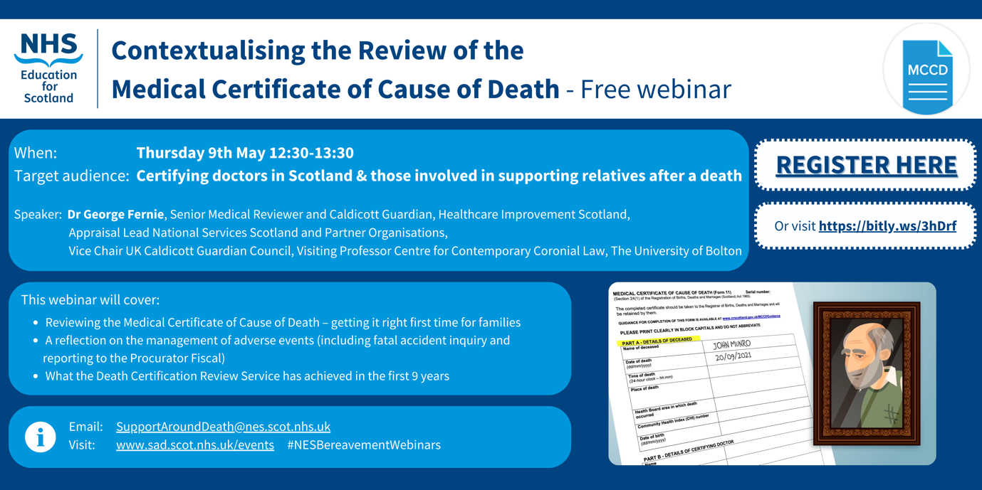

The NES Bereavement Education Programme are pleased to announce that registration is now open for their second webinar of 2024: click here to register.
Contextualising the Review of the Medical Certificate of Cause of Death

Thursday 9th May 2024, 12.30-1.30pm.

Join us to hear from speaker Dr George Fernie, Senior Medical Reviewer and Caldicott Guardian, Healthcare Improvement Scotland, Appraisal Lead National Services Scotland and Partner Organisations, Vice Chair UK Caldicott Guardian Council, Visiting Professor Centre for Contemporary Coronial Law, The University of Bolton.

This webinar is aimed at certifying doctors in Scotland and those involved in supporting relatives after a death.

The webinar will include:
  - Reviewing the Medical Certificate of Cause of Death – getting it right first time for families
  - A reflection on the management of adverse events (including fatal accident inquiry and reporting to the Procurator Fiscal)
  - What the Death Certification Review Service has achieved in the first 9 years

This webinar is being hosted on MS Teams.
Visit the NES Support Around Death website to view information and recordings from previous sessions hosted as part of the NES Bereavement Webinar series. You may also be interested in listening to the NES Talking about Bereavement podcast.

For more information contact SupportAroundDeath@nes.scot.nhs.uk and you may wish to follow @NES_Bereavement.

14. Valuing Diversity and Promoting Inclusivity

Inclusivity Poster

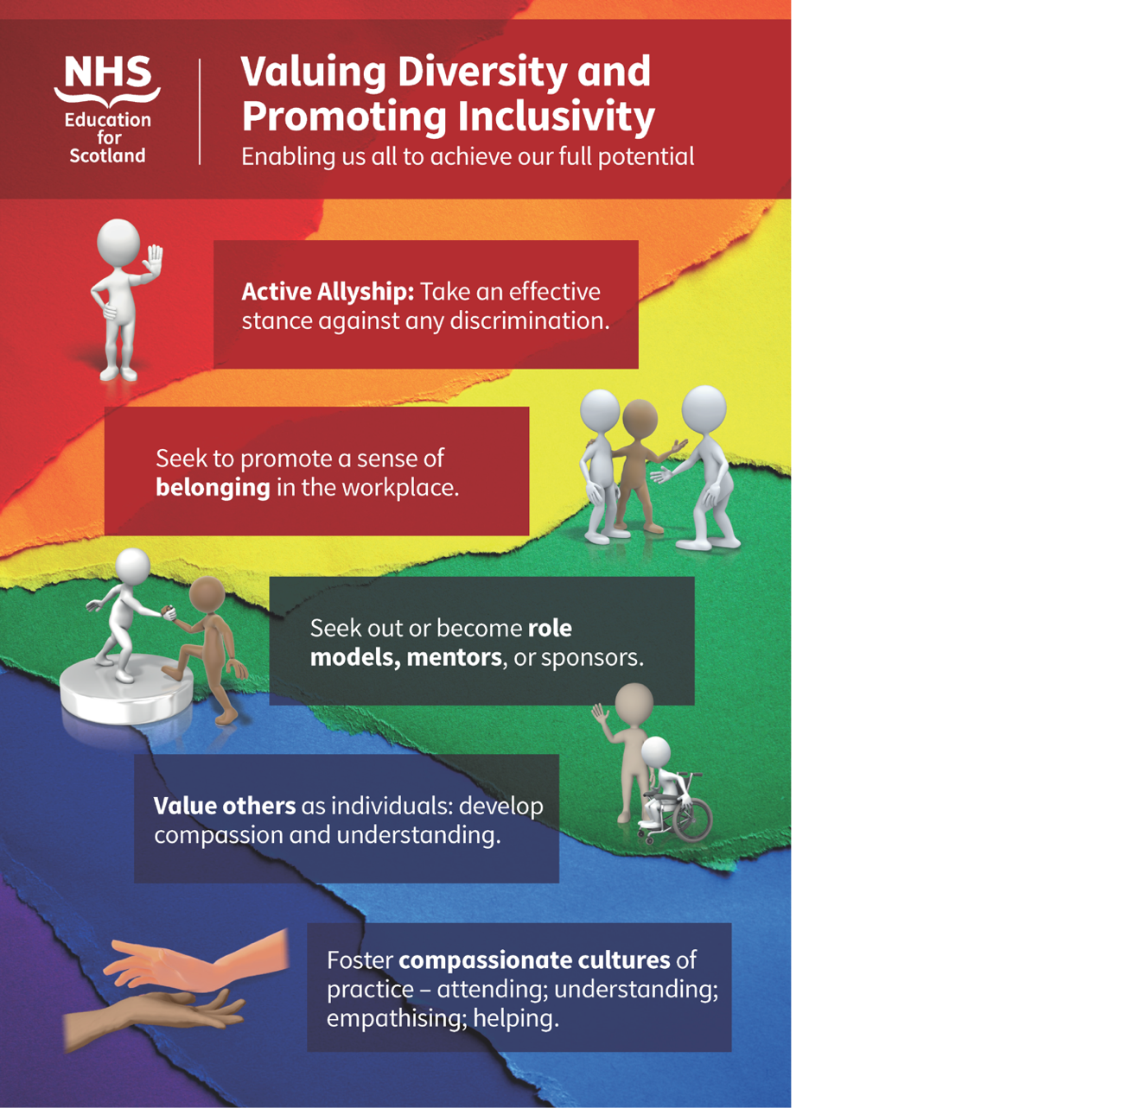

15. Please Contact Us

FAO all trainees
Please contact us with information on any initiatives and projects you are involved in that you would like to share with your colleagues across Scotland, or if you have feedback on the Deanery Newsletter or Deanery Websites.

16. NES Websites

The Scotland Deanery Website
The Scotland Deanery, along with our Local Education Providers, is responsible for managing Medical Training and Training Programmes across the four Scottish regions. Here you’ll also find details of the Deanery’s Quality Management activities, its key staff and locations plus information on Professional Development for doctors.

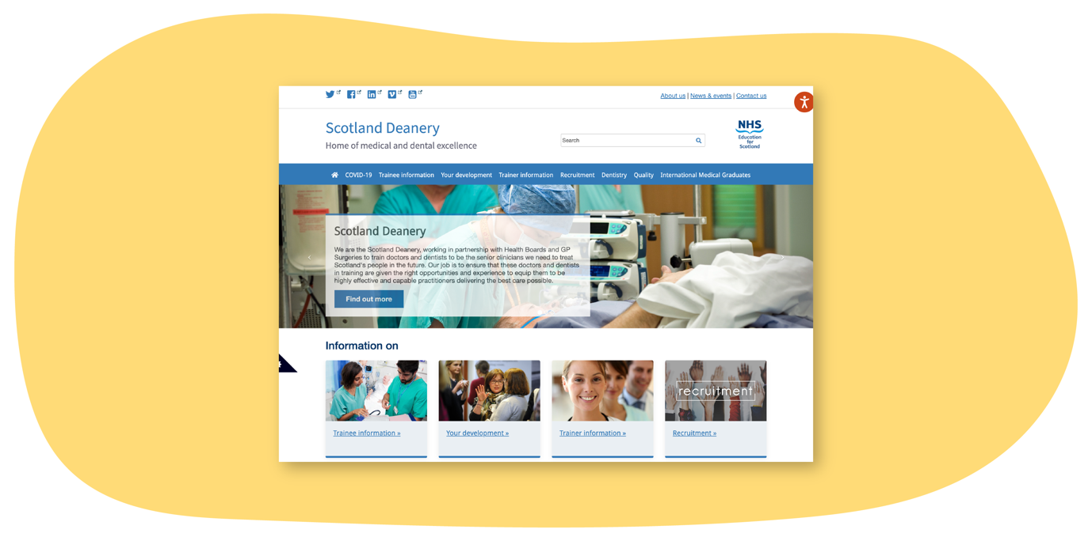
Scottish Medical Training
This site is the principal resource to learn more about how to apply for Foundation, Core and Specialty Medical Training in Scotland. Here you’ll find regularly updated information about application windows (how and when to apply), a directory of 50+ GMC-approved medical specialty programmes and first-hand accounts about training from trainees and trainers. There are also useful insights on career direction and what it’s like training and working in Scotland.

Scottish Online Appraisal Resource (SOAR)
Designed for doctors (in both Primary and Secondary Care) working and training in Scotland, for their Appraisal and Revalidation needs. SOAR is used by Appraisers and Appraisees to aid the appraisal process, and for Trainees to complete their self-declarations. Here you’ll also find a SOAR user guide, handy FAQ’s and examples of Quality Improvement Activities.

