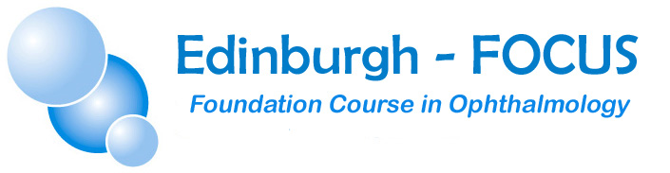

11th– 12thNovember 2022

Princess Alexandra Eye Pavilion, Edinburgh

Aiming to teach basic practical skills in ophthalmology to

Foundation Years 1&2 and Accident & Emergency trainees

Get ‘Hands – on’ experience in

Visual acuity and fields
Slit lamp examination
Ophthalmoscopy
Foreign body removal

Use of fluorescein
Pupil examination

Includes examination of patients with ocular pathology and a session covering ST1 ophthalmology applications.

Applications will open on 1stAugust via the website:
www.edinburgh-focus.com

FEE: £450 early bird fee until 15 Oct 2022, then £475 thereafter

(Includes refreshments, hot lunches and evening meal on Friday)

CONTACT

edinburghfocus@gmail.com

LIMITED PLACES!!

