
NHS Education for Scotland

GP FELLOWSHIP INFORMATION 2025
Health Inequality Fellowship – Job Information

Job Reference: EC-499

4 posts Scotland (0.5 wte)

Background

Inequality in Health and in the provision and quality of health care services is a key policy issue in Scotland. Inequalities in Health and Healthcare are both closely linked to socioeconomic deprivation. In such areas of high deprivation, the concentration of health and social problems results in levels of need and demand that place substantial and continuous pressures on GPs and Primary Healthcare Teams.

Purpose

To increase skills in General Practice and to develop specific skills related to Health Inequality which are relevant to the health needs of Scotland. The Fellowship is for doctors who have completed GP Specialty Training in the past 5 years and have some previous experience of working in a deprived area.

Structure of the Fellowship

The Fellowship has three components:

- Clinical component – There will be 2 sessions in a clinical setting linked to deprivation. This includes the provision of general medical services but with an emphasis on the general practice aspects of high deprivation.

- Academic component– this could consist of modules related to inequalities in health and healthcare.

- Project –the Fellow will undertake a project related to Health Inequalities in the community or one linked to a NES priority.

Terms and Conditions

Salary

Salary will be £39,528 pa for the half-time posts. This figure is based on the trainee base salary point 03 on the salary scale plus 45%. This arrangement reflects the unique educational nature of the post. Superannuation is payable on the base part of the salary only. Any 2025/26 salary uplift will be applied.

Each post is on a fixed term contract of 12 months duration.

If the post holder does not hold a valid UK driving licence, the ability to travel and organise suitable alternative transport will be necessary. Travel expenses incurred as a result of the need to travel will be reimbursed as per NES policy.

Study Leave

A sum of £1,000 per annum inclusive of fees for all education activities, travel and subsistence.

Disclosure

Pre-employment checks may be undertaken and appointments will be subject to satisfactory clearances.

Health Screening

All appointments will be subject to satisfactory health clearance and pre-employment health checks may be required.

Maternity/Paternity Leave and Pay

The maternity/paternity policy of the employing organisation will apply to this post.

Relocation

Any request for relocation should be discussed at interview and approved in writing by the employing organisation in advance of appointment.

Medical Defence

As a NES employee, CNORIS indemnity will cover any activities done as part of the Fellowship. Fellows need separate medical defence cover for any clinical work provided independently of the Fellowship

The Fellow will be responsible for notifying their Medical Defence body of the expected programme to ensure that there is a clear balance between CNORIS indemnity, clinical indemnity and personal indemnity cover as appropriate to cover their fellowship and other external commitments. Medical Defence subscriptions will not be reimbursed by NES.

Holidays

Annual leave and public/local holidays will be in line with the employer’s contractual terms and
conditions.

Hours of Work

Working patterns will be agreed with the Fellowship Co-ordinator.

Discipline and Grievance Procedures

The contractual employer’s policies and procedures will apply.

Sick Pay

The contractual employer’s policies and procedures will apply.

The Terms and Conditions above are for information purposes only and may be subject to variation. They do not form the basis of a legal contract.

Support and Accountability of Fellowship

It is anticipated that the Fellow will be supported in the following way:

Local Fellowship Supervisor – this individual will be responsible for the general support and progress of the Fellowship and will be appointed prior to the commencement of the Fellowship. The Supervisor will normally be based within the general practice to which the Fellow is attached and will agree the general direction of the educational component. This arrangement may vary in the different regions. An educational contract will be drawn up between the practice and the Fellow and approved by the Director of Postgraduate GP Education.

Further Information

For further information please contact the following:

Health Inequality Fellowship Co-ordinator

Iain Jamieson.
Iain.jamieson@aapct.scot.nhs.uk

and/ or discussion with current post-holder(s) could be arranged if desired

NHS Education for Scotland

Health Inequality Fellowship – Person Specification

FACTORS |  | 
 |  |  | Application | Interview
Education and Professional Qualifications | Essential | - MBChB or equivalent primary medical degree | √
 |  | - Satisfactory completion of a GP Specialty Training Programme within the last 5 years (CCT or CEGPR) prior to commencing the Fellowship | √
 |  | - Registered with GMC on the GP Register with a licence to practice | √
 |  | - Doctors from overseas wishing to be considered for these fellowships will need to achieve an overall score of 7.5 out of 9 in the International English  Language Testing System (IELTS) test. | √
 | Desirable
Experience/ Training (including research if appropriate) | Essential | - Experience of working in UK GP NHS  - Eligible to join Health Board Performers List | √  √

 | Desirable | - Other relevant Postgraduate Diplomas | √

 |  | - Experience of working in areas of deprivation
Specific aptitude and abilities | Essential | - Is able to articulate the core values of general practice and medical education.  - Some understanding of the range of problems related to Health Inequalities in Scotland.  - Evidence of personal initiative in achieving educational objectives.  - Evidence/ demonstration of self directed learning | √  √  √  √ | √  √  √  √
 | Desirable | - Insight into areas requiring further training  - Evidence of exceptional achievement personal/professional | √  √ | √  √
Interpersonal skills | Essential | - Some understanding of the range of problems facing  healthcare in Scotland  - Commitment to partnership and collaborative working  - Commitment to working in the areas of deprivation | √  √  √ | √  √  √  √
 | Desirable | - Adaptable to working in a variety of workplaces over the Fellowship period | √ | √

 |  | - Evidence of awareness of own development needs | √ | √

Leadership Behaviours
NHS
Education for Scotland

NHS Education for Scotland (NES) assesses and selects employees based on our leadership behaviours which are expected at all levels in the organisations. These leadership behaviours support the NES ways of working and NHS Scotland values.
These leadership behaviours describe how we work, and what is expected of everyone who works in NES. A number of methods may be used to assess these behaviours as part of our recruitment and selection processes. Our leadership behaviours are:


Inspiring

Empowering
(iJ

Giving our teams space and authority to deliver outcomes; investing in learning and development; expecting top performance & dealing with occasions where this is not delivered; being approachable and open to constructive challenge

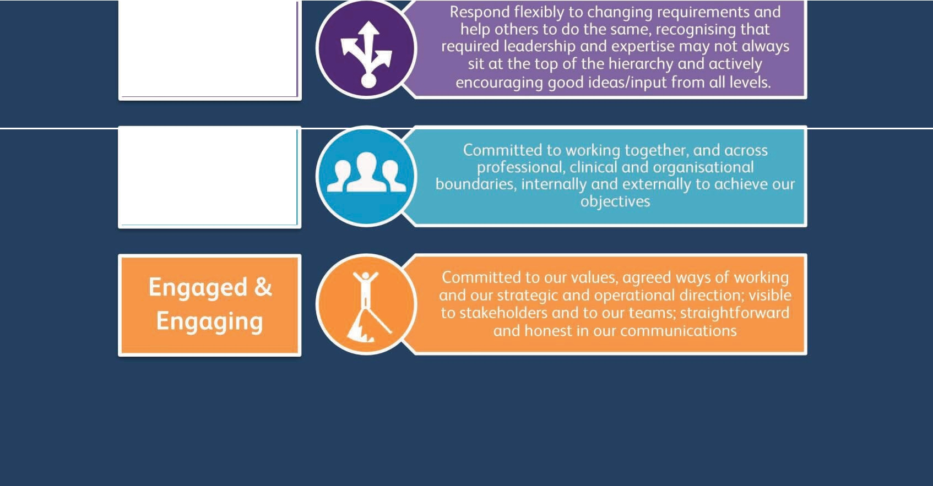
Adaptive
Collaborative



Online Application Guidance

General Guidance

- No applicant will be unfairly discriminated against. We are particularly alert to eliminating discrimination on account of age, cultural/religious/political belief, disability, ethnicity, gender, race, relationship status, sexual orientation, and/or Trade Union membership or stewardship.

You will be asked to complete the following sections:
  - Section 1: Personal Details
  - Section 2: Qualifications and Memberships o
Section 3: Career History
  - Section 4: Statement in Support of Application o Section 5: References o Section 6:
Disability o Section 7: Application Declarations o
Section 8: Equal Opportunities Monitoring

- Only Sections 2, 3 & 4 of this online form will be made available to short-listing panels. Sections 1 to 4 (inclusive) would then be used by the interviewing panel if you are selected for interview. Sections 5 to 8 will be viewed only by the HR department.

- Required questions are denoted with an asterisk (*). When you have answered the questions on a page, click the Save and continue button to continue to the next section. You can navigate to a previous section by clicking the Back button at the top of the page.

- If you wish to complete the application form later, click the Save and finish later button. It will be saved as a draft application in your Candidate Portal.

- You can retrieve saved draft forms by logging in to the Candidate Portal, selecting Dashboard from the Candidate Zone drop down menu, and then selecting Applications.

- You will have an opportunity to review and edit all sections of your application form at the end under the 'Review' Section. Click on Send my application to complete the process and submit your form.

- PLEASE NOTE: You will be unable to edit an application form once it has been submitted.

Section 1: Personal Details

- All our communications will be sent to you via email - please ensure you provide an accurate email address which you will have regular access to throughout the recruitment process. Applicants
should regularly check Junk/SPAM folders to ensure key communic ations aren’t missed. Similarly, applicants using NHS.net email accounts have reported difficulties receiving communications, with emails hitting their local firewall. Please contact your local IT if this is the case, or you may wish to consider using an alternative email address.

- Working in the UK – It is your responsibility to ensure that you have the right to work in the UK. This will be verified as part of our pre employment checks.

Section 2: Qualifications and Professional Membership

  - Please tell us about any qualifications you have or are working towards. This can include school, college or university qualifications, or work based qualifications such as SVQs or NVQs.

  - Remember to include any ‘non formal’ qualifications or certificates that you think are relevant to the job you are applying for.

  - If the post requires you to be professionally registered, please provide details of your Professional Membership e.g. GMC, NMC, GDC etc.

Section 3: Career History

  - Please tell us about your present or most recent post. This can include any voluntary work. If you have not yet worked please state this in the Job Title and Employer fields.

  - Please tell us briefly about your duties (what you do or did in your job). You could tell us your role, the main tasks, and any responsibility for supervising others.

There is a 4000-character limit (including spaces) for this question.

Page 2 of 4

If you would like to paste your response from an external document please use a keyboard shortcut: CTRL+V for Windows users, Apple+V for Mac users.

  - Please then tell us about any previous employment. If a job supports the position applied for, please say more about it in your Application Support statement.

Section 4: Statement in Support of Application

  - Please tell us your personal qualities, skills and attributes, experience and any major achievements and show how they match those needed for this job. Please refer to the Person Specification (within the Job Information Pack) when completing your statement.

There is a 4000 character limit (including spaces) for this question.
If you would like to paste your response from an external document please use a keyboard shortcut: CTRL+V for Windows users, Apple+V for Mac users.

    - Please try to remember where you heard about this job, and select the relevant option. The information you give will help us review our vacancy advertising.

Section 5: References

  - As part of pre-employment checks, if you are the preferred candidate(s) you will be asked to provide details of at least two referees, verifying a minimum of 3 years previous employment, one of which must be your current or most recent employer.

  - Our pre-employment screening also includes, where appropriate, ID and right to work in the UK, qualifications, criminal convictions and occupational health.

Section 6: Disability

    - The Equality Act 2010 defines disability as:

A physical or mental impairment that has a substantial and long-term adverse effect on a person’s ability to carry out normal day to day activities.

    - NHS Education for Scotland is a Disability Confident Employer and has made a positive commitment to the employment and retention of disabled people. In addition, we operate a Guaranteed Interview Scheme (GIS), which means that if you have a disability, and meet the minimum criteria outlined within the Person Specification, you will be guaranteed an interview.

    - Please let us know if you are a disabled candidate and would like to be considered under the GIS scheme. Please also let us know if you require any requirements you would have to enable you attend for interview or undertake a test/presentation.

Page 3 of 4

    - Please Note: this section will not be viewed by the selection panel. However, HR will use the information provided to enable us to operate the GIS and arrange reasonable adjustments.

Section 7: Declarations

    - 'Reserve candidates' may be identified by the panel where a candidate is considered 'appointable' but not the successful candidate on this occasion.

    - Please indicate if you agree to your application form being shared with NES hiring managers for similar vacancies in the future.
    - If you are offered employment, you must disclose any previous convictions either classed as 'spent' or 'unspent'. Any failure to disclose such convictions could result in dismissal or disciplinary action.

      - Any information you give will be considered only in r elation to the post for which this application form refers. Information will be verified by Disclosure Scotland for relevant posts.

    - Please read and indicate that you have understood and agree to the declaration statements.

Section 8: Equal Opportunities Monitoring

- The information you provide in this part of the form (Section 8) is confidential and is NOT used in the selection process.

Please then review and edit your application where required before selecting ‘Send my Application’ to submit it. Please note that you will not be able to amend your application once you have submitted it.

Page 4 of 4

