**Sarcoma Awareness Month July 2019**

Chance to win **funded, short- term clinical fellowships**

**Project supported by Bone cancer research Trust**

[**http://www.bcrt.org.uk/**](http://www.bcrt.org.uk/)

1. Read selected e-learning resources

2. Complete an online MCQs survey on sarcomas

3. **Receive a certificate of completion for your portfolio**

The **top scoring participants** will be given the opportunity to take part in **funded short term clinical fellowships** at a regional sarcoma centre to further their knowledge on sarcomas and to **boost their CV**

**Lumps, bumps and sarcomas** [**http://learning.bmj.com/learning/module-intro/lumps--bumps--and-sarcomas--a-guide-.html?moduleId=10050381**](http://learning.bmj.com/learning/module-intro/lumps--bumps--and-sarcomas--a-guide-.html?moduleId=10050381)

‘I’d advise any medical student to jump at an opportunity like this’ –Dr Philip Broadbent, Fellowship winner 2013, Scotland Deanery

<http://www.sarcoma.org.uk/sarcomaukfile/upload/SUKWinterConnect2013.pdf>

‘If you are interested in oncology, it is worthwhile pursuing an elective at a tertiary centre like the Royal Marsden—the National Sarcoma Awareness Week offers some annual funded fellowships, which are worth keeping an eye out for.’ –Alexandra Ho, Fellowship winner 2013

<http://student.bmj.com/student/view-article.html?id=sbmj.g1441>

Please help us increase sarcoma awareness, aid early diagnosis and save lives

**Sarcoma Awareness Month July 2019**

**Mrs Jennifer Lamb, Mr CR Chandrasekar.**

**National Sarcoma Awareness Project Team, Royal Liverpool and Broadgreen University Hospital, Liverpool**

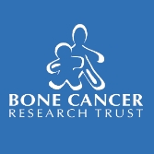

If you are interested in taking part, please contact us on

[*sarcoma.awareness@rlbuht.nhs.uk*](mailto:sarcoma.awareness@rlbuht.nhs.uk)

*Please provide your name, designation ie Final year/F1/F2, Medical School/Hospital and email contact.*

*You will receive the e-learning resources and the link to the online MCQs.*

How Much Do You Know About **Sarcomas**?

Please participate in our

National Sarcoma Awareness Project

(Open to all final year medical students and F1/F2 doctors)

What would your differential diagnoses be?

What is the ideal referral/treatment plan?

*Complete our free e-learning module*

[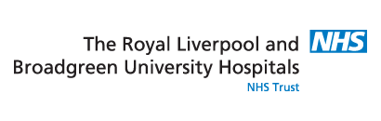](http://www.rlbuht.nhs.uk/)