Simulated Surgery: Candidate Notes

Venue
The assessment will take place at the Royal College of General Practitioners (RCGP) in London.
The address is 30 Euston Square, London, NW1 2FB.
Telephone: 020 3188 7400

Map & Directions
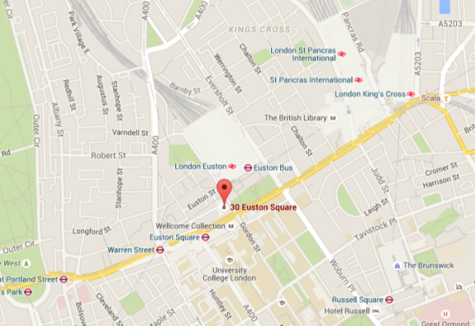
Euston: Northern line and Victoria line and mainline rail services (5min walk).
Euston Square: Circle line, Hammersmith and City line and Metropolitan line (5min walk).
Kings Cross St. Pancras: Circle line, Hammersmith and City line, Metropolitan line, Northern line, Piccadilly line and mainline/international rail services (10min walk).
Please note there are extremely limited parking facilities in the area. Please check for any planned engineering works or delays prior to making your journey.

Punctuality
Candidates are requested to arrive 15min prior to their allocated start time to ensure smooth running of the assessment. Candidates who are late may not be permitted to sit their assessment.
Please enter by the Exam entrance in Euston Road and not by the Main entrance on the corner with Melton Street, you will be asked to wait in the lobby area.
Toilets are available here.

Candidate Identification
All candidates must bring photo identification in order to proceed to the simulated surgery. Candidates will be turned away if they do not have photographic proof of identity.
- Passport or UK Photo Driving Licence

Expectations of Candidates
Candidates will have a briefing by one of the marshals and should follow all instructions and advice given.
Only the equipment specified in this document may be taken into the consultation room. Mobile phones and other electronic devices must be switched off at all times.

Equipment
Doctors should bring the following equipment:
- British National Formulary (BNF)
- Stethoscope
- Ophthalmoscope
- Auroscope
- Thermometer
- Patella hammer
- Sphygmomanometer (aneroid or electronic)
- Tape measure
- Peak flow meter and disposable mouthpieces (N.B. These must be EU standard)
It is your responsibility to ensure you have these items available. There will be no spare sets of equipment.
All BNFs must be free of hand-written notes. They may be checked before the start of the assessment and removed if they contain notes. Electronic copies on tablets or mobile devices will not be permitted.

The Assessment
This simulated surgery is not primarily a test of knowledge but that of consulting and communication skills. It is intended to be just like an everyday surgery in any general practice.
You will be given a consulting room and will remain there throughout the session. Patients will come to see you for 10min appointment slots where you will demonstrate your consulting skills to an assessor.
Refreshments will be provided halfway through the session. During this time candidates may mingle, but any discussion of cases seen will lead to immediate disqualification.

Paperwork
- In your room there will be a timetable showing the patients you will see during the course of your surgery.
- You will be given written records for each case, which will provide some background information. We advise you to read these notes.
- You can make your own notes on these records during or after the consultation for yourself. These notes will not be marked.
- Blood/x-ray forms, prescription pads and sickness certificates will be provided.
- Do NOT remove any material whatsoever by any means from the test centre. This includes paperwork or personal notes made on any material during the assessment. Removal of any paperwork will result in immediate disqualification.

Patients
- You will have 11 patients, each of whom is a role-player trained to present in a standard way, along with an assessor who will accompany the patient into the consultation.
- The cases are typical problems found in general practice.
- The role player will respond to your questions. They will tell you their story if you encourage them, not deliberately hiding any information.

Physical examination
- If you decide that a physical examination forms a part of your assessment of the case, you should examine the patient and your technique may be marked.
- The role player will not have abnormal physical signs, but you should do an appropriate examination based on the history. You may be offered a card with relevant findings.
- If a proposed examination is unnecessary, the role player will refuse an examination.

Timing
- Consultations are limited to ten minutes; the start and end of the consultation will be signalled by a buzzer.
- If you have not completed the consultation after ten minutes are up, you should allow the patient to leave.
- The assessor will leave with the patient.
- There will be a few minutes alone to look at the next patient’s notes before the next consultation starts.

Quality Assurance
- In order to ensure fairness of this assessment there are quality control measures in place
- There may be an additional assessor in the room for some of your consultations who would be evaluating the performance of the assessor, or the role player.

Marking
The assessor will be marking on five areas of consulting skills that are outlined below. Candidates are to ignore the assessor and they will not communicate or provide any further direction or information. Candidates for whom English is not their first language may have an additional language assessor present. Assessors will observe your consultation skills and make comments on a standardised schedule.

Results
The quantitative scores and qualitative personal feedback based on the consulting skills areas will be sent to candidates’ Local Education Training Board (LETB) within 10 working days. Candidates should subsequently contact their LETB for their results.
Feedback will also be available from the LETB. Candidates for whom English is not their first language will receive an additional contextualised language report.

Areas of consulting skills

Gathering medical information:
- Making use of information from the records provided
- Taking a history that elicits relevant information and excludes any potentially serious conditions
- Appropriate physical examination

Eliciting the patient’s concerns:
- Welcome and courtesy
- Helping the patient to tell their story by using listening skills and non-verbal cues
- Sensitivity to the patient’s feelings
- Discovering the patient’s concerns and expectations
- Respect for the patient’s wishes and confidentiality

Explaining the diagnosis:
- Explaining your assessment of the problem
- Explaining the choices for treatment
- Involving the patient in the management plan
- Checking the patient’s understanding

Managing the problem:
- Having a safe and effective management plan
- Acceptable prescribing, investigation and referral
- Appropriate use of time and resources

Closing the consultation:
- Making appropriate follow up arrangements
- Thinking about health promotion and advice where appropriate
- Checking that the patient’s agenda has been covered

