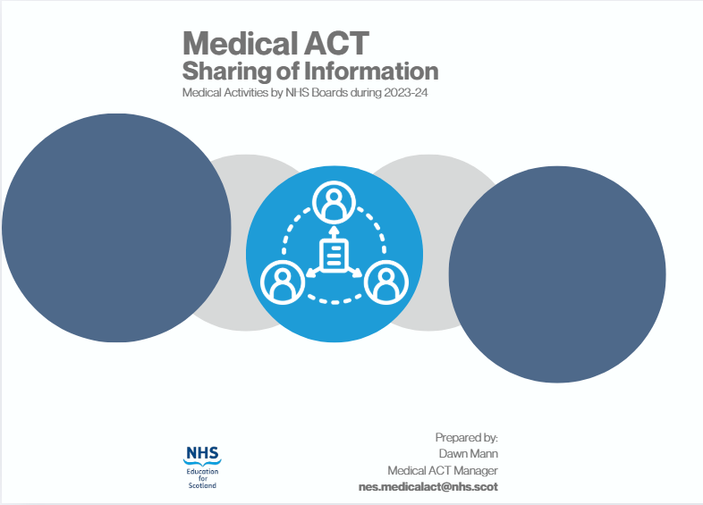

Table of Contents
Foreword 2
Executive Summary 3
Summary of Financial Information from NHS Boards 4
Allocation 4
Bids Trends 5
Slippage Data 9
Summary of Narrative Responses from NHS Boards 12
Response to Board Feedback: Medical ACT Process Changes Planned for 2024/25 18
Appendix 1: Anticipated Changes to Undergraduate Medical Teaching 21
Appendix 2: Bids Evaluation and Anticipated Benefits 25

Foreword
All Health Boards in receipt of Medical ACT funding are required to submit an annual accountability report to NES; this includes all 14 territorial Health Boards, the State Hospital, Scottish Ambulance Service, National Waiting Times Centre and National Services Scotland (NSS), which reports on activity from the Scottish National Blood Transfusion Service (SNBTS). We are grateful to all Boards for their submissions.
This paper provides an overview of activities relating to Medical ACT funding which were carried out by Health Boards between the start of April 2023 and end of March 2024.
A central aim of this paper is to share and showcase the learning, innovation and expertise that Medical ACT funding has supported in Scotland’s NHS, but also highlight the future challenges and opportunities that exist in the clinical education of students within Primary Medical Qualification programmes.
We would be pleased to receive any comments relating to the content of this summary paper, which may be submitted to the following address: nes.medicalact@nhs.scot.
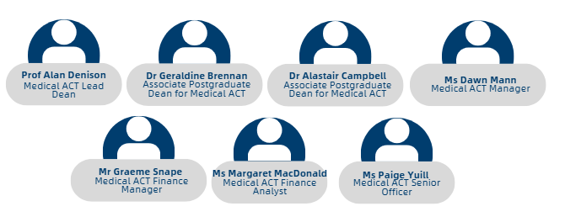

Executive Summary
The deadline for NHS Boards to submit accountability reports in this cycle was 20th September 2024. At the time of producing this paper, accountability reports were submitted by 18 of 19 Boards. As in previous years, all reports were required to be presented at the appropriate Regional ACT Working Group (RAWG) for review and discussion of their content, prior to being formally submitted to NES.
17 Boards included an organisational chart for medical education activities within their Board which is helpful for NES and other stakeholders to see.
Most Boards have a formalised local ACT working group (LAWG) or an equivalent structure to discuss Medical ACT matters, which feeds into Regional ACT Working Groups (RAWGs) and Board governance meetings.
Several Boards highlighted that collaborative conversations between Medical ACT stakeholders in their region are helpful from a planning perspective; this includes medical programmes sharing information about their curricula and preparing bids for submission to NES. Several programmes have undertaken or are planning curriculum reviews which has required Boards to respond by implementing changes to teaching delivery; the impact has also been driven by an increased number of students in the system.
Boards reported having to develop new ways of increasing capacity for both Primary and Secondary care placements during 2023/24 due to increasing student numbers. Medical ACT funding was used to support a wide-ranging set of proposals within this period to cope with this demand. Boards were invited to provide details of submitted proposals which they considered to be examples of innovative practice worthy of sharing. Further details on bids activity can be found within the report.
It is clear from the information provided that the impact of increasing student numbers remains an ongoing concern across NHS Boards which is expected to continue for the foreseeable future.

Summary of Financial Information from NHS Boards

Allocation
In 2023, the total Medical ACT budget was £119.4m (including ScotGEM and Edinburgh HCP-Med funding), which represents an increase of £15.7m from 2022/23. This uplift was primarily due to investment by the Scottish Government in additional student places, along with a continued focus on developing medical education in primary care.
Medical ACT funding | Funding 2023/24
Recurrent
ACT baseline Prior Year | £79,651,262
NES baseline inflation increase | £1,497,606
16/17 (50) Widening Access expansion | £4,875,000
21/22 (10) Widening Access expansion | £520,000
22/23 (30) Widening Access expansion | £975,000
23/24 (25) Widening Access expansion | £325,000
19/20 (60) COMET/GPEP expansion | £5,460,000
22/23 (25) GPEP expansion | £812,500
20/21 (25) HCP Med Expansion Yrs. 4-5 | £325,000
21/22 (155) General expansion | £8,060,000
22/23 (25) General expansion | £812,500
23/24 (75) General expansion | £975,000
Primary care increase | £3,515,000
Total Medical ACT Model Funding | £107,803,868
20/21 (25) HCP Med Expansion Yrs. 1-3 | £1,096,875
22/23 (5) HCP Med Expansion Yrs 1-3 | £121,875
18/19 (55) ScotGEM expansion | £4,372,500
22/23 (15) ScotGEM expansion | £592,500
Total Medical ACT recurrent Funding | £113,987,618
Non recurrent
Additional 115 non-recurrent intake 100 20/21 and 15 21/22 | £2,242,500
Total Funding for 23/24 Medical ACT model | £116,230,118

The following was highlighted through data analysis of the information provided by Health Boards in section 2 of the Accountability Reports.

Bids Trends
There were 450 bids approved by NES in 2023/24 of which 442 were reported on by Boards within Accountability Reports. Eight further bids were approved by NES with a value of approx. £247,000 but no details on the implementation of these have been reported.
The following tables highlight further information for the reported bids:

2023/24 Medical ACT Bids
Category of Spend | Number of Bids Approved | In-Year Cost
Equipment | 145 | £1,898,432
Teaching Posts | 92 | £2,132,900
Admin | 41 | £429,593
CTF | 39 | £1,317,475
Other | 36 | £326,510
GP Cost | 19 | £722,728
Additional Pay Uplift | 18 | £3,186,050
Teaching Sites | 12 | £1,736,049
Accommodation | 12 | £1,528,323
HCP Medicine | 11 | £1,218,750
Training | 9 | £93,606
Widening Access | 6 | £84,540
Travel | 2 | £5,164
Total | 442 | £14,680,120*
*Figure doesn’t include slippage.

Category of Spend | Examples of bids
Equipment | Laptops, AV equipment, furniture, medical equipment - manikins, ear examination kit etc.
Teaching Posts | Consultant post, simulation lead post, pharmacy educator
Admin/Support Staff | Usually posts - admin office support, project manager support, librarian
Clinical Teaching Fellow | CTF related costs i.e. posts, development costs (PG teaching certification, study leave budgets)
Other | Student hardship funds, increase in central costs
GP Cost | GP coordinator post, increases of GP placement block costs (increase in placement duration due to programme restructure)
Additional Pay Uplift | Additional pay uplift given to boards
Teaching Sites | Upgrade of teaching rooms, increasing capacity of teaching rooms
Accommodation | Property/accommodation purchases, refurbishment, maintenance, build projects
HCP Medicine | HCP Medicine students funding allocation to boards
Training | Supporting CPD for educators
Widening Access | Undergraduate scholarship to support WA, WA equipment & fees
Travel | Supporting Boards to attend NES Stakeholder Engagement Events

Bids not Utilised
In section 2b we provide Boards with a breakdown of all approved Medical ACT bids in 2023/24 and ask Boards to confirm if the funding was fully utilised and if not, what barriers there were to implementation.
It was reported that 27% of bids were not fully implemented which is an increase of 10% from 2022/23 reporting. The breakdown of reasons is detailed below, with an additional 16 not stating the reason and 5 with other reasons including an error on the bid submitted, delivery delays and cost savings on purchase price or within the Project.
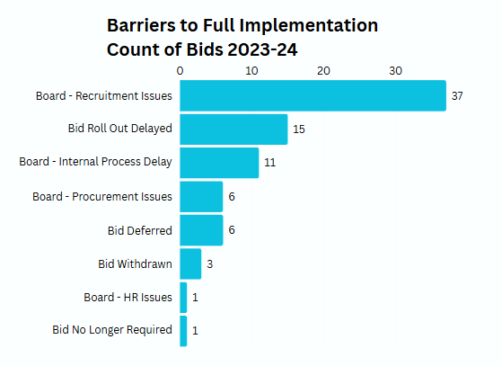
Section 2b also allows Boards an opportunity to provide any available results from bid evaluation and detail the anticipated benefits of the bid, for information sharing purposes detail provided for these can be found in Appendix 2.
Boards were asked if the anticipated benefits were achieved:
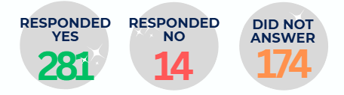

Slippage Data

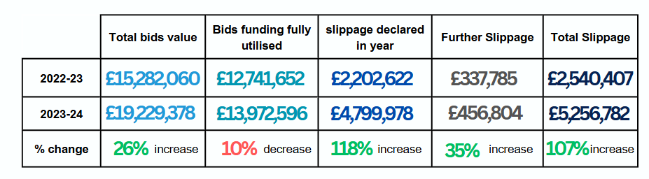
We appreciate that a degree of slippage is inevitable however we would encourage all Boards to monitor slippage for reporting to NES at an early stage, to support the wider Medical ACT budget. This will become more important in future years when less growth in the budget is anticipated.
Capital Bids
There were 17 capital bids with a total value of £1,808,681. NES received 1 request to facilitate a Revenue to Capital transfer, the remaining 16 transfers were carried out within Boards.
Clinical Teaching Fellows
The use of Clinical Teaching Fellows within Boards has greatly increased in recent years, Many Boards provided positive feedback on how these roles are an integral part of increasing their teaching capacity and how post-holders acted as role models for students. See below for examples of submitted information:
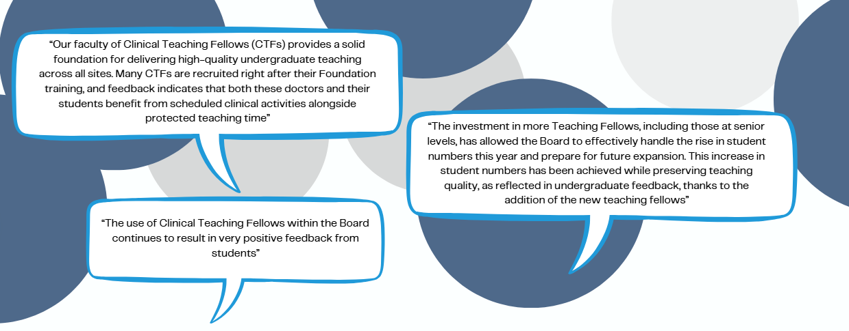

We asked Boards to provide details of how many Clinical Teaching Fellows (or equivalent) were working within their Board and the ratio breakdown. Details were:
Medical ACT: Board Ratio | Number of Posts advised in 2022/23 | Number of Posts Advised in 2023/24
20:80 | 5 | 4
40:60 | 4 | 2
50:50 | 9 | 2
60:40 | 27 | 28
80:20 | 37 | 37
100:00 | 20 | 32
Total | 102 | 105

Summary of Narrative Responses from NHS Boards
Local Governance Arrangements
In last year’s Sharing Information paper (available on the Medical ACT website: Medical ACT Sharing Information 2022-23) we detailed the full information provided by Boards regarding their local Governance Arrangements for Medical ACT. This year in section 4A Boards were asked to provide any in year changes to the Medical ACT Governance arrangements they have in place, including details of the interface between local groups, regional Medical ACT groups and up to Board level. Areas of note included:
- We were advised by a Board they have agreed a different recruitment approval pathway for Medical ACT funded posts to help streamline the process. We are aware that following Scottish Government guidance on cost savings most Boards have to present posts through a panel and evidence of external funding could be helpful.
- Boards highlighted the necessity of being flexible and dynamic to meet the needs of their local area following the introduction of the NES monthly bids cycle and submission of bids through the Medical ACT App. Some Boards have introduced local meetings to discuss time or content sensitive bids outwith the RAWG meetings, some have ad hoc meetings, and the use of email communication is now key to enable Boards to submit bids on a more regular basis and prevent delays to projects.
- As detailed bids discussions have been reduced at RAWG meetings it was felt that more time was available for strategic Medical ACT discussions to take place, which was felt to be helpful.
- Boards indicated that Medical ACT conversations are now taking place with a broader range of stakeholders to allow collaboration at an earlier stage of planning.
Sharing Intelligence around Medical ACT
In section 4B Health Boards were asked to provide details of any innovative Medical ACT funded activities and initiatives which have been beneficial and which they felt could be beneficial and potentially transferrable to other Boards. Themes and examples are detailed below.

Simulation
Board | Bid Name | Bid Purpose
NHS Fife | GP Simulation Tutor | Working in the Simulation Centre, the post holder has developed and delivered sessions to help students develop their clinical skills and judgement in a primary care setting
NHS Grampian | Anatomage Table | Allows virtual dissection, sectioning and observation of individual systems, as well as correlation to imaging across 5 different cadavers. It is life size, moveable and can be used for direct, tutor-led, small group teaching and also for self-directed student learning using tutor-created preset learning tasks
NHS Grampian | Simulation Room | Creation of a dedicated teaching and simulation room within the Critical Care unit in ARI. This allows for insitu SIM training and IPL learning.
NHS Greater Glasgow & Clyde | Baby manikins | allow access to a wide range of conditions, some of which will be rare conditions, through simulation.
NHS Greater Glasgow & Clyde | DECT Phones | DECT phones for use within simulated environment have helped to augment the immersive experience of our UG escalation simulation scenarios which are designed to allow and enable students to reach the ceiling of their competence and recognise the point at which they require to escalate to a more senior colleague.
NHS Tayside | Ophthalmology simulators and Otoscope simulators | 4 Ophthalmology simulators and 2 Otoscope simulators were purchased for teaching of Ophthalmology and ENT students respectively. They have become a mainstay of our teaching repertoire and may be used for potential research projects in future.
NHS Tayside | Audio Visual Equipment | Purchase of cutting-edge audio-visual equipment for use in Pathology where demonstrations could be live streamed to classrooms or recorded and viewed later.
NHS Fife | Simulation Day | The Patient Journey Urgent Care (PJUC) Block Lead developed an emergency sim day in preparation for the increase in student numbers heading into year 2.
Creation of Additional Space
Board | Bid Name | Bid Purpose
NHS Greater Glasgow & Clyde | Creation of additional teaching space | Current non-clinical space was renovated and updated, thereby creating a functional and comfortable learning / teaching environment which allows key educational staff to work with increasing numbers of undergraduate medical students.

Accommodation
Board | Bid Name | Bid Purpose
NHS Dumfries & Galloway | Nithbank refurbishment | Refurbishment of flats for 8 more students on the Nithbank site. This has been necessary because of the year-on-year increase in students requiring accommodation.

Capacity Building
Board | Bid Name | Bid Purpose
NHS Grampian | Clinical placement review project | Appointed to assess all clinical placements across NHSG, identify gaps and maximise capacity. This non-recurring role was vitally important in helping to target Services and departments where UG education opportunities could be increased or changed.
NHS Grampian | Additional PAs | 50 PAs distributed across departments to allow for significant increase in students. Along with above role has allowed us to target specific areas whilst keeping additional teaching relevant to curriculum. The other benefit of this approach has been that clear connection between teaching and funding – hopefully this will allow for succession planning and will encourage departmental responsibility for teaching going forward.
NHS Highland | Project Manager and Project Officer for educational capacity. | Recruitment of these roles has allowed a structured approach to assessment of potential capacity across our Board area and support ongoing work to create additional capacity through review of placements in collaboration with university partners.
NHS Lothian | WTE Consultant Appointments | We tested a model of expanding the WTE Consultant/SAS number in 7 clinical areas to allow sessions to be taken for UG clinical supervision in those teams. The initiative has proven successful and supported some real innovation in the teams involved with OP consultations, virtual ward rounds and increased number of F2F bedside teaching sessions being some examples. The funding for appointments is accompanied by a SLA signed by the CD, Service manager and site UG lead Community.
NHS Lothian | Outpatient Consultations & NearMe | A challenge of capacity for UG students in OP settings led us to review the model of NearMe use by the University of Aberdeen in their medical programme. Following appropriate governance checks locally we have tested the model with groups of 8 students in a meta-debrief room, observing a clinician/patient interaction with a student in the consultation room. We have been using sessional rate GP colleagues to host the observation room. Feedback from students, faculty and the patients themselves has been overwhelmingly positive.
NHS Grampian | Dr Gray’s Clinical Skills Centre | The setting up of this clinical skills centre which is under the auspice of clinical skills in Aberdeen has allowed us to increase student capacity in Dr Gray’s and along with the very motivated ACT funded role holders in DGH has allowed UG education to continue satisfactorily despite significant challenges facing Dr Gray’s clinical services and this has been vitally important for overall capacity across NHSG. It also allows for local IPL and postgraduate training.

Widening Participation
Board | Bid Name | Bid Purpose
NHS Lothian | UG Scholars | Supporting UG medical students who identify as WP with paid opportunities to join our Lothian MED team on an advisory/project based/student connection basis. These roles are competitively appointed and run on an annual cycle with a better than minimum wage hourly rate for 250hrs of work over the full calendar year.
NHS Tayside | Widening Participation | Medical ACT funding was also used to support Widening Access students attend conferences and also in the provision of equipment for them.
NHS Orkney | Mentoring | The creation of a service level agreement to a local GP practice. This use of ACT funds was to help encourage and mentor school pupils hoping to become doctors. The GP practice visits schools, arranges placements within NHS Orkney, and assists in the applications to medical school.
Faculty Development
Board | Bid Name | Bid Purpose
NHS Orkney | LiTLe FDA Course | Run a 2 day LiTLe FDA course on the island. This was for both primary and secondary care educators to receive face to face training without having to travel off island. The training was based around leadership, effective relationships with trainees, trainees in difficulty and workplace culture.

New Ways of Working
Board | Bid Name | Bid Purpose
NHS Shetland | Primary Care redesign | Redesign of the medical student primary care placements in Shetland with a hybrid model of delivery involving a teaching week – this week was designed to take the pressure of the primary care team and facilitate longitudinal learning for all of the medical students. The medical students hosted by primary care now are split between a larger practice and a more rural practice. Feedback from the students on the new hybrid primary care block and focused teaching week have been very positive and indeed the GP Richardson Prize winner spent her GP placement time in NHS Shetland.
ScotGEM | SOP Development | At a time of stabilising the programme as it transitions to steady state, the focus has been on ensuring core delivery. A key activity started in year which relates to programme stability has been the development of a ScotGEM partner boards Standard Operating Procedure (SOP) related to ACT funded activities to support programme delivery. This will continue to be refined, as altered programme numbers progress through to a new steady state.
Student Wellbeing
Board | Bid Name | Bid Purpose
NHS Dumfries & Galloway | Bicycles | Our Active Travel Officer supervises the maintenance of 16 bicycles and the induction/training to ensure their safe use. Bicycles are necessary as some accommodation is off the main DGRI site and public transport in a rural area is often not optimal.
NHS Dumfries & Galloway | Doctors’ Mess contribution | An annual contribution to the Doctors’ Mess, which ensures a comforting supply of  coffee, tea and snacks during breaks and the opportunity to spend some down time with the resident doctors.

Factors Affecting Use of Medical ACT in Boards
In section 4C Health Boards were asked to provide details of any challenges which impacted the delivery of Undergraduate Medical Education in the Board and an overview of any issues that prevented them using their full Medical ACT allocation. Many Boards reported they had utilised all Medical ACT Funding and encountered no barriers.

We have used the answers provided to produce the below common themes:
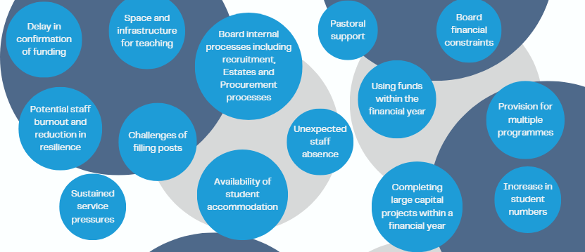

Anticipated Changes to Undergraduate Teaching
In section 4D Health Boards were asked to provide details of any confirmed and considered changes to Undergraduate teaching or curriculum which could impact Medical ACT. We thank Boards for the information provided which gives us an awareness of change and allows us to think of any implications to Medical ACT processes and policies. Full details can be found in Appendix 1.

Response to Board Feedback: Medical ACT Process Changes Planned for 2024/25
Following Board feedback from previous years’ accountability reports, NES introduced changes during 2024/25 for to try and overcome barriers to Boards using their Medical ACT funding including:
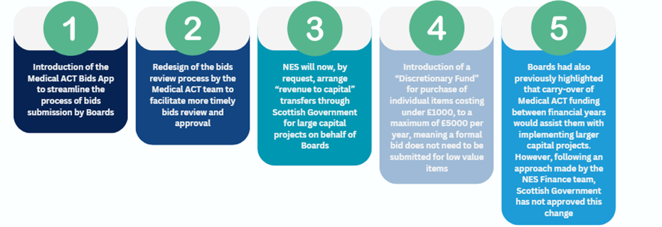
NES Medical ACT Team also heard:
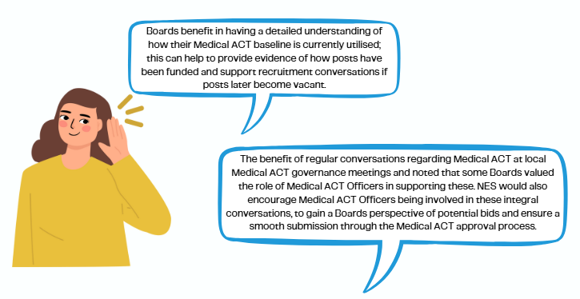
Proposed Adjustments to the 2024/25 Accountability Report Template
Based on the lessons learned from the 2023/24 accountability reports, the following changes are proposed for the 2024/25 reporting process:
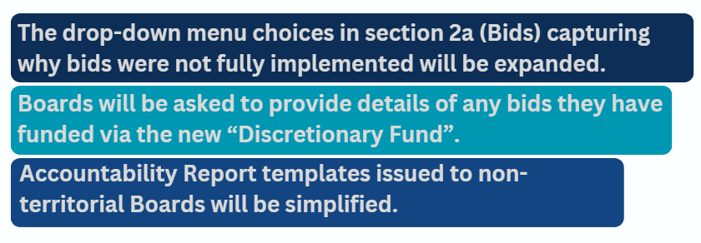

Appendices

Appendix 1: Anticipated Changes to Undergraduate Medical Teaching
Health Board | Confirmed Changes | Review/Considered changes
NHS Ayrshire & Arran | There has been a reconfiguration of critical care services in NHS Ayrshire and Arran with all level 3 beds moving to University Hospital Crosshouse leaving a Level 2 High Dependency Unit at University Hospital Ayr. This has the potential to impact on the Critical Care week for Year 4 students on their medical block. The investment in a Critical Care CTF has ensured that Crosshouse site can manage an increased throughput of students. Increased travel costs may be incurred by students which could lead to an increase in travel expenses paid through ACT. | Further service reconfiguration changes are not planned but increasingly over the last few years more acute services (Critical Care and Trauma) have moved to Crosshouse site with more elective activity at Ayr. Potentially we may need to look increasingly at cross-site teaching programmes which could incur additional travel costs – this already happens for MSK block. Further investment in digital technologies to support remote teaching may also need to be considered.
NHS Dumfries & Galloway | As per last year, there is a general feeling that  we are nearing capacity for teaching and  supervision, and a worry that quality will fall if we  take on many more, without protecting time in  consultant job plans and/or appointing more  CTFs. | We are exploring the possibility of appointing  more CTFs.
NHS Fife | Introduction and planning for the ScotCOM programme - Currently, St Andrews BSc students attract only a pre-clinical payment of ACT which is 17% of the full ACT funding per annum.  Students undertaking the new MBChB course will attract full ACT funding for the 5-year duration of the course. We anticipate at steady state that this will result in £5.36m of ACT funding per annum for ScotCOM based on 55 students undertaking the course each year. Of this £4.82m is new funding. This will not all come to NHS Fife as there is delivery within the two partner health boards and travel/accommodation and primary care costs will be top sliced from the budget.  In 2024/25, the focus is to recruit to the Hub Lead positions and on leadership across the DME team and senior administrative team. The Senior Project Manager and Undergraduate Administrator are shared resources across NHS Fife, NHS Borders & NHS Forth Valley.
NHS Forth Valley | - Unanticipated changes: 3 additional students from Edinburgh university in O and G, medicine and Paediatrics.  - Retirement of our Undergraduate Administrator.  - Re-banding of the Undergraduate Administrator post.  - ScotCOM course planning with ADME post for primary care and additional clinical teaching fellow.
NHS Grampian | Significant increase in student numbers  reaching Year 3 in 2024/25 academic year  Significant increase in student numbers  reaching clinical years in 2025/26 and 2026/27  academic year. | Several ACT proposals in 2024/25 to support  impact on GP clinical teaching in Year 3  UoA & NHSG educational teams considering  capacity issues; several 2024/25 ACT proposals to  develop and upgrade clinical teaching space.  Continued development and increase of  simulation teaching and training Employment of recently retired colleagues to assist hard-pressed services with clinical teaching (mainly the increased number of 3rd year students.
NHS Greater Glasgow & Clyde | Regional Group has approved 3 non-recurring bids in 2024/25 financial year relating to GP ACT. These cover Vocational Studies and OSCE examining. When Regional Group review any changes to the level of GP ACT for 2025/26, these are known impacts. | The impact from increasing student numbers and potential curriculum changes could impact on use of Medical ACT. The use of new areas to expand teaching capacity, as well as different teaching approaches, are being discussed between UoG and NHSGGC, but are still at early stages. Increased support for clinical teaching in oncology has been agreed, while more exposure to multimorbidity and frailty remains under consideration.
NHS Highland | Significant increase for undergraduate students in AY 25.26 so for FY24.25 priority is the infrastructure - both residential and teaching accommodation and faculty requirements. | Redesign of placement structure to support combination of ward experiences and more structured teaching activities in non-clinical areas.
NHS Lanarkshire | - Increased numbers embedded in many departments with further planning for 24-25.  - Increased UG in primary care in NHS Lanarkshire.  - Completed Next gen pilot and return to offering experience in clinical space, intending to further expand.  - Commenced Year 3 student initial Clinical contact / clinical placement for Glasgow University at UHH, supported as per Glasgow model with CTFs.  - Pilot of Professionalism simulation 40 students. | - Addition of GP OOH to Year 3 after successful pilot (GGC) for Glasgow university.  - Addition of GP sim still being considered for all Glasgow students but will be delivered for NHS L UG.  - Working with ENT and Ophthalmology to expand number of places for UG students.  - Exploring Specialty doctors for CTF role.
NHS Lothian | As per the attached Programme document  (appendix 1) there are significant planned  changes to the Programme length and clinical  year components beginning in 25/26.  We (NHS Lothian) will be spending much of this  academic year aligning our current  infrastructure (teaching faculty, administration  support, educational opportunities and  innovations to build capacity) to this new  model esp. for clinical year 4 commencing in  25/26  This new model will require:  - 10 extra teaching weeks annually across the 10 modules  - Administration (Local) capacity in many more clinical services in Lothian  - A realignment and expansion of the teaching faculty in the ward based clinical services  - An expansion of the teaching faculty in the non-ward based/Outpatient services eg Diabetes and Endocrinology. | In addition to the confirmed changes outlined we  will be considering and testing a model of hybrid  clinical fellow posts to support ward based UG  education. A current small-scale test of hybrid  (clinical and education) fellow posts in Paediatrics,  Psychiatry and Oncology has been very successful.
NHS Shetland | A change to the structure of Medical Education Governance into two groups in order to help facilitate better overall governance requirements of being a Local Education Provider:  - Teaching and Training Group – looking at over all teaching opportunities for the team including medical students.  - Strategic and Operational Group – that has overall organisational oversight of all aspects of being a LEP such as having enough Trainers and how ACT resources are best utilised.
NHS Western Isles | General Practices have been changed to 2CBoard run services, which will alter the  administration and educational governance  pathway for medical students on placement at  these locations. | Consideration underway as to possible change in  provision of undergraduate mental-health  teaching programme in Western Isles, potentially  to be revised to incorporate general practice  placement.
ScotGEM | Fife - Increase in student numbers going into  Y2. Curriculum changes to accommodate the  increased student numbers in Y2. Movement  of additional Y1 GCM to become a Y2 GCM to  accommodate the increased student numbers  in Y2. | Awareness of requirement to consider  modification of placement/alternative models of  LIC delivery if capacity challenged.  Fife – A new ScotGEM Business Manager post is  being considered to line manage Fife GCMs –  funding being released from Fife Lead GCM role.  Development of SOP to provide an accurate  overview of ScotGEM funding. Review of  secondary care faculty.
NSS SNSTS | As highlighted in the 2022/23 monitoring report there were some changes to teaching programmes  - Glasgow - MBChB Year 3 Consultant presentation on ‘Introduction to Blood Transfusion’ - new session added to the clinical laboratory block in 2023 and planned annually.  - Edinburgh - Year 5 - SNBTS Consultant & TP led session on 'Transfusion Simulation increasing from 6 to 12 sessions (2.5 hours) due to increased number of students in 2023/2024.  - Dundee - New annual Year 4 session in 2023 (approx. 4 hours). | Teaching content and method will be continually reviewed based on the agreed curriculum, student numbers and appropriate method of delivery.  The Scottish Government Infected Blood Oversight and Assurance Group are presently looking at the IBI recommendations. Recommendation 7. Patient Safety: Blood Transfusions covers ‘bodies concerned with undergraduate and postgraduate training of people who intend to be working in the NHS’. The recommendation relates to the adequacy of training, the measurement and definition of standards, and defined accountability. This may in time lead to changes within the training activities currently delivered by SNBTS.

Appendix 2: Bids Evaluation and Anticipated Benefits
Board | Proposal/Item Description | Detail Results of Evaluation | Anticipated Benefits | Achieved  (Y/N)
Dumfries & Galloway | CTF for psych | Better organisation and delivery of teaching. Helped with capacity issues in the department. | Test of change as to how psychiatry undergraduate teaching is supported and delivered. Department and students felt this had been successful and plan is to submit bid for recurrent funding moving forwards. | Y
Dumfries & Galloway | ADME Undergraduate Medical Education | ADME Undergraduate postholder has dedicated time to support and develop medical student teaching | Senior consultant in post providied with dedicated time to offer more support to medical student teaching. Feedback has demonstrated that the students have benefited from this. | Y
Dumfries & Galloway | Anaesthetic Specialty Dr Session | Students rate their anaesthetics and ICU experience highly. | Will allow planning and delivery of teaching to be job planned to support the specialty dr who is essentially doing this in his own time. Supported time should ensure ongoing quality in the delivery of this placement. | Y
Dumfries & Galloway | Active Travel Officer | Many students do not have any means of transport when they arrive for placement, so appreciate the loan of bikes to allow them to travel in the region. They understand the need for a comprehensive induction and the ability to use the equipment safely. | Supports students to participate in active travel while on placement. This supports mental and physical wellbeing and also offers alternative transport in a rural area where public transport options are often limited. | Y
Dumfries & Galloway | CTF Medicine | Student feedback indicates that they receive an excellent experience while on placement with D&G - Glasgow 3rd and 4th year medicine placements rank as the best in the WoS. | Allow postholder appropriate time to plan and deliver undergrad curriculum | Y
Dumfries & Galloway | Undergraduate admin assistant | Students appreciate the pre-arrival information and induction programme delivered by the admin assistant. | Allows sufficient time to provide quality administrative support across UG medical education. | Y
Dumfries & Galloway | Doctors Mess Contribution | Students have reported that they appreciate being able to use the facilities and supplies in the mess | Allows students to spend time with the medical staff outwith clinical areas. Provides access to refreshments and snacks when they are working in the library or the education centre. | Y
Dumfries & Galloway | Catheter Trainer | Student feedback indicates that they receive an excellent experience while on placement with D&G. | Ensure appropriate equipment is available to deliver teaching. | Y
Dumfries & Galloway | Ophthalmoscope/Otoscope | Student feedback indicates that they receive an excellent experience while on placement with D&G. | Ensure appropriate equipment is available to deliver teaching. | Y
Dumfries & Galloway | Laparoscopic Trainer | Student feedback indicates that they receive an excellent experience while on placement with D&G. | Allow students to opportunity to experience laparoscopic surgery via the trainer. | Y
Dumfries & Galloway | Ipad | Student feedback indicates that they receive an excellent experience while on placement with D&G. | More opportunities for in situ teaching | Y
Dumfries & Galloway | Consumables | Student feedback indicates that they receive an excellent experience while on placement with D&G. | Additional equipment required to support teaching delivery. | Y
Dumfries & Galloway | Property maintenance | Student feedback indicates that accommodation is of a high quality and this is appreciated by them. Wifi can sometimes be less than optimal and IT continue to try to find a long term solution to this. | High quality, fit for purpose, accommodation for students on placement with NHS D&G | Y
Dumfries & Galloway | 2023/24 HCP Medicine Funding | Funding has ensured the HCP Med students in the region are able to follow their curriculum and achieved learning outcomes. | It is hoped that by supporting the HCP Med programme, this will result in the students returning to the region as qualified drs. | Y
Dumfries & Galloway | Additional student accommodation Nithbank | Funding was allocated to the Board over two financial years. For 2023/24, £40k was allocated and this funded initial costs such as planning, fees and some materials. The remaining £358,886 was allocated to the Board in 2024/25 to support the build and finish of the work. The project was completed in August 2024 and students are now benefitting from new accommodation. | The new accommodation will be used to house increased student numbers. | N
Fife | NHS Fife Edinburgh Lead 2PA | N/A | Successful leadership in:  Leading on the HCP-Med Course  Leading on the University of Edinburgh Assistantship Programme  Providing general medicine teaching sessions for the year 4 medical students  Leading on Research for NHS Fife Medical Education  Supervising of MD Medical Education Fellow  Delivering simulation teaching for final year medical students  Supporting the DME team to embed future curriculum change in Edinburgh University programmes | Y
Fife | Additional clinical placement in year 1 | N/A | To increase the positive representation of primary care within the undergraduate clinical curriculum, in line with governement strategy and Gillies report recommendations. An additional community based placement in year one of the BSc Hons would reach (circa) the 25% primary care content target. The overarching aim is to promote General Practice as a positive career destination. | Y
Fife | Simulation Centre Manager | N/A | Leadership and organisation for the Simulation Centre - post required to coordinate simulated teaching sessions. | Y
Fife | Year 3 modules - Ophthalmology, Breast Surgery, Sexual Health, Sim | N/A | Year 3 modules allowed for increased student numbers and will continue as a permanent addition to the timetable | Y
Fife | GP Sim Tutor | N/A | Post holder carrys out teaching at the Queen Margaret Simulation Centre and supports Y2 St Andrews teaching. | Y
Fife | Senior Clinical Educator (Lead Nurse for Medical Education) | N/A | Post holder leads the clinical skills and simulation team and has been appointed to look at overall teaching and find areas requiring additional teaching. | Y
Fife | Sim Tech Assistant | N/A | Post holder assists in teaching sessions being held at the Queen Margaret Simulation Centre. Teaching could not happen without his expertise on the use of the equipment. | Y
Fife | Med Ed Development Officer | N/A | HR delays in evaluating new job description | N
Fife | Allied Health Professions - Respiratory Physiologist / Echo Physiologist | N/A | Weekly session run for year 2 St Andrews students - allows students to get hands on experience | Y
Fife | Edinburgh Lead | N/A | Same as row 9 | Y
Fife | Year 3 Module - ICU | N/A | Carries out teaching for St Andrews Y3 on Thursdays | Y
Fife | Occupational Health costs and vaccination of St Andrews students should have been recurrent | N/A | To ensure St Andrews students are properly vaccinated for placements | Y
Fife | Undergraduate Administrator | N/A | Successful administrative support by:  . helping to meet increasing demands for additional placements  . building resilience in the team, particularly around annual leave and other absences  . providing additional capacity in team to make adjustments to new/additional/unexpected demands | Y
Fife | Maternity cover - Clinical Lecturer (Siobhan McGaw) | N/A | This bid is to cover the maternity pay costs of an ACT Funded lecturer to ensure continuity of teaching delivery. | Y
Fife | Maternity cover - Clinical Lecturer (Linnie Pinto) | N/A | This bid is to cover the maternity pay costs of an ACT Funded lecturer to ensure continuity of teaching delivery. | Y
Fife | Cameron Hospital Development (ScotCOM) | N/A | Developed as an education hub for ScotCOM - whole building has been refurbished and will be ready to welcome students from academic year 24-25 | Y
Fife | Simulation Centre Manager (additional hours) | N/A | Same as row 11 | Y
Fife | ScotCOM - Director of Medical Education | N/A | Additional time taken up by DME and ADME for ScotCOM development time | Y
Fife | 2023/24 HCP Medicine Funding | N/A | Requirement to run HCP course | Y
Fife | ACT Officer (if recruited to this FY then in-year baseline slippage will be used) | N/A | Essential for the Board to have an ACT Officer who works at the University. Post holder is an expert in ACT funding and works as a liaison between NHS Fife's Medical Education and Finance department, and the University | Y
Fife | Cedar House Residential Accommodation | N/A | Initial funding allowed for existing residents of building to be moved out and we await further funding in 24.-25 to finish the renovation | Y
Fife | Stratheden Accommodation Upgrades | N/A | Accommodation had not been upgraded for many years - now looking much fresher. | Y
Fife | IT equipment replacement | N/A | Required by National VC Services to allow remote teaching to continue | Y
Fife | Additional Pay uplift | N/A | Per NES instruction of 25 September 2023. Additional 4% pay uplift (on top of original 2% pay uplift) to align with doctor's pay inflation of 6% | Y
Grampian | 2 wte Physician Associates (spread 0.2 wte over 10 posts) to be distributed across departments to allow for significant increase in students and clinical placements and Category A teaching |  | Unable to appoint during 23/24 but post holders started in July 2024 | N
Grampian | Clinical Histopathologist |  | unable to appoint so far but continuing recruitment | N
Grampian | Innovation Fund |  | Fund was advertised but as no applications were received, was fully released back in-year. | N
Grampian | Year 4, Pilot of Cluster Leads for 3 Grampian GP Practices |  | GP team advertised this but failed to recruit. Re-advertised into expected project time, hoping to recruit with a delay at least, but also unsuccessful. At that stage, no point of trying again as remaining time would be too short. Notified NES 11.04.24 and that 24/25 impact not required. | N
Grampian | GP Clinical Teaching Hub (Forest Grove House lease) |  | Delay in processing lease, in part due to internal discussions around best strategic direction for teaching hub. Notified NES on 12.02.24 that full 23/24 amount slippage. 24/25 start date yet to be confirmed. | N
Highland | Project Manager for capacity development |  | partial achievement, but work ongoing - structued approach to evaluation fo capacity and response to try to increase capacity across board area | Y
Highland | Clinical placement review admin support |  | partial achievement, but work ongoing - structued approach to evaluation fo capacity and response to try to increase capacity across board area | Y
Highland | GP Teaching in UoA Year 4 Long Terms Conditions block |  | meeting core curricular requirements | Y
Highland | 0.5 consultant PA for Sustainable Medicine Lead (fixed term 24 months) |  | significant progress achieved in development of curricular resources and embedding sustainability into core curriculum. ongoing work therefore propose further recrurrent bid | Y
Highland | Simulation / clinical skills acting resources |  | Too early to provide detail of anticipated benefits, was just set up in March 2024, will start to be utilised in academic year 24.25 and will monitor how it's utilised | Y
Highland | Additional Deputy Director of Medical Education sessions (2 PA) |  | enhanced resilience and capacity of core team | Y
Lanarkshire | Updating / replacement of Equipment more than 5 years old - moved to recurring |  | This provideds funding for rolling replacement of simulaton and clinical skills across the Health Board, both in the medical Education and Training centre, as well as the various sites. As a result equipment, Modeks and simulators are kept in good working order, allowing courses and teaching and learning to be delivered, with a low cancellation rate due to equipment concerns, whilst supporting new courses and developments. | Y
Lanarkshire | Smartboards - METC |  | Additional Smartboard purchased and deployed in METC, this has facilitated additonal courses and simulation sessions, particualrly new sessions such as GP sim and Psych. | Y
Lanarkshire | Smart Boards - Upgrades to Seminar Rooms |  | Additional Smartboard purchased and deployed in acute site seminar rooms, this has facilitated additional current l courses and simulation sessions, including new sessions such as GP sim and Psych. As well as new professionalism and active bystander simulation | Y
Lanarkshire | VR Licence Renewal - moved to recurring | The course that this equipment contributes to is regularly evaluated and undergraduate feedback is reviewed and used to inform improvements to the course | This was a bid to move to recurring VR licence for our existing undergraduate programme from previous bids. This allows this work to be supported and delivered on an ongoing basis | Y
Lanarkshire | Clinical Teaching Fellow - UHH | Whilst not individually evaluated, all of our CTF posts contribute directly to the delivery of UG teaching and learning across the Board. The students report per block and annually on their experience which provided quantitative and free text feedback teaching, for which the CTFs are partly responsible. The feedback for this site / post remains high quality. Like all CTF posts the fellow has a internal supervisor and appraiser to support and monitor performance in post | This was an additional post to allow us to deliver UG teaching for the increased number of medical students undertaking attachments in secondary care. All CTFs are whole time medical education, with no service element, and are offered a PG certificate in medical education as per separate item. | Y
Lanarkshire | Obs & Gyn Clinical skills Equipment | The course that this equipment contributes to is regularly evaluated and undergraduate feedback is reviewed and used to inform improvements to the course | This bid allowed the replacement and purchase of additional Obstetric t task trainers enabling undergraduate medical students to undertake obstetric Skills in a simulated safe environment, as part of their undergraduate attachment. | Y
Lanarkshire | Teaching quality Improvement |  | This was a bid to move to recurring a previous pilot / non-recurring bid for a Quality improvement advisor post to support QI for Undergraduate teaching and PG SMART objectives. The post is now permanent with the team. The post has been highly valuable for ensuring QI cycle on improvements in block by block feedback from our partner university. The post has contributed significantly to supporting department gathering and collating the evidence for PG SMART objective Quality Action plans. The plans / evidence have been commended by visiting panels | Y
Lanarkshire | DDME for Primary care (Undergraduate) | The post holder meets regularly and is responsible to the DME and the AMD from primary care. This allows evaluation of the post, which is proving highly valuable. | The post has been recruited and is providing support for existing and the development of new attachments in Primary care directly. We have seen an increase in the number of both UG and PG attachments available across Lanarkshire. The post is facilitating innovative proposals such as UG teaching hubs, Out of Hours attachments and GP, all on going and exciting proposals. | Y
Lanarkshire | PG Certificate in Medical Education |  | Linked to UHH CTF | Y
Lanarkshire | Suture Practice Kit for Medical Students | The course that this equipment contributes to is regularly evaluated and undergraduate feedback is reviewed and used to inform improvements to the course | This bid has allowed undergraduates the opportunity within our surgical skills program to practice safely with constructive critique, to gain competencies in the simulated environment prior to further skill development in clinical practice | Y
Lanarkshire | Suture and Stapling Practice Trainer | The course that this equipment contributes to is regularly evaluated and undergraduate feedback is reviewed and used to inform improvements to the course | This bid has allowed the addition to our surgical skills program for undergraduate medical students the opportunity to practice safely with constructive critique , preparing them for the next stage of competency acquisition in clinical practice | Y
Lanarkshire | Arterial Puncture Wrist | The course that this equipment contributes to is regularly evaluated and undergraduate feedback is reviewed and used to inform improvements to the course | This bid facilitated the replacement and upgrading of this part task trainers enabling medical students to practice arterial blood gas sampling, which is a core skill in curriculum , and essential to allow undergraduates to gain competency in the simulated environment | Y
Lanarkshire | Colles' Fracture Reduction Trainer (Light Skin Tone) | The course that this equipment contributes to is regularly evaluated and undergraduate feedback is reviewed and used to inform improvements to the course | This bid and item is used as part of orthopaedic undergraduate simulation course giving practical opportunity to manipulate fracture, which is a safe simulated environment, laying foundation for potential future clinical skill acquisition | Y
Lanarkshire | MamaNatalie Complete - Light Skin | The course that this equipment contributes to is regularly evaluated and undergraduate feedback is reviewed and used to inform improvements to the course | This bid and equipment have facilitated aspects and components of the obstetrics skills emergency simulation course giving undergraduate medical student opportunity to experience obstetric emergencies in a safe simulated environment. | Y
Lanarkshire | Birth Model Set | The course that this equipment contributes to is regularly evaluated and undergraduate feedback is reviewed and used to inform improvements to the course | This bid and equipment has facilitated aspects and components of the obstetrics skills emergency simulation course giving undergraduate medical student opportunity to experience obstetric emergencies in a safe simulated environment. | Y
Lanarkshire | Newborn Anne |  | In order to ensure that the equipment is fit for intended use, in undergraduate programs, we evaluated the use, prior to purchase, in this case, this showed that the high-fidelity equipment, specifically bid for, was not fully fit for purpose in this undergraduate course. As a result, the funding was used to fund low(er) fidelity models, to enable the resuscitation training and simulation courses, the equipment was intended for. The purchase value used the allocated funding | Y
Lanarkshire | PROMPT Flex Birthing Simulator - Standard | The course that this equipment contributes to is regularly evaluated and undergraduate feedback is reviewed and used to inform improvements to the course | This bid and purchased equipment has afforded undergraduate medical students the opportunity to practice and gain foundation competencies of examination, assessment, this is delivered as part of clinical skills workshops for medical students during both obstetric and some ED blocks
Lanarkshire | 2023/24 HCP Medicine Funding |  | This directly supports HCP teaching provided for appropriate yrs as students, centrally allocated. Internally we support supervisors, block lead, and a component of CTF time | Y
Lanarkshire | Increase in Central Costs slippage bid |  | Central bid item | Y
Lanarkshire | Increasing Clinical Teaching capacity in NHS Lanarkshire slippage bid |  | This is fixed term post that has been appointed and in progress. The post is supporting a secondment of a Project manager to scope, plan and assist in delivery of increased undergraduate placement in the board. In addition to expanding current placement, we are working with our main partner university to understand opportunities and requirements for curriculum redesign | Y
Lanarkshire | Publication of Professionalism Research in Medical Education slippage bid |  | This bid item supported the publishing of papers on professionalism, which have been written, submitted and accepted by peer reviewed journals | Y
Lanarkshire | Publication of Professionalism Research in Medical Education slippage bid |  | This bid item supported the publishing of papers on professionalism, which have been written, submitted and accepted by peer reviewed journals | Y
Lanarkshire | Furniture for METC slippage bid |  | The furniture has been purchased and is supporting the delivery of existing and new courses at METC, the tables reduce the need for movement during set up and breakdown, improving efficiency and staff safety of course delivery | Y
Lanarkshire | Arms slippage bid | The course that this equipment contributes to is regularly evaluated and undergraduate feedback is reviewed and used to inform improvements to the course | This bid has allowed the renewal replacement of arm models regularly (and heavily) used for cannulation / venepuncture as part of Management of deteriorating patient simulation course | Y
Lanarkshire | Touchscreen / smart board slippage bid |  | Additional screen purchased and deployed for seminar rooms, this has facilitated additional current l courses and simulation sessions, including new sessions such as GP sim and Psych. As well as new professionalism and active bystander simulation | Y
Lanarkshire | Additional Pay uplift |  | Central funded and planned item | Y
Lanarkshire | GP ACT Slippage |  | Central funded and planned item | Y
Lanarkshire | T/F to T&S TopSlice |  | Central funded and planned item | Y
Orkney | Clinical Teaching Fellow |  | Did not recruit during 23-24. Post holder started in May 2023. Has allowed us to take more students. | N
Orkney | PGCert Medical Education |  | Post holder not taken up this opportunity | N
Orkney | Admin support for Medical Education |  | Did not recruit during 23-24. Post holder started in April 2024. Student placements are now highly organised | N
Orkney | Clinical Skills Resources - clinicalskills.net |  | Used extensively by clinical skills facilitator in teaching | Y
Orkney | Software licensing - Docman |  | Issues with GP Practices | N
Orkney | Faculty Development Alliance |  | Helped support trainers / educators on the island - Funding received from July 2024 | Y
Orkney | Introduction of shared, secure social area for students & clinical staff |  | Students and junior doctors have now have a private rest room | Y
Orkney | GP coordinator |  | Working well now up and running | Y
Orkney | Full cost of shared, secure social area for students & clinical staff. See bid O9 (using slippage to cover) |  | Students and junior doctors have now have a private rest room | Y
Shetland | Clinical Development Fellow (CDF) 1 Support | The CDF posts has been instrumental in hosting increased numbers of medical students in 23/24. The feedback from the medical students on the standard of teaching provided in Shetland as being consistently of high quality. The CDF post has been central to NHS Shetland being able to host increased numbers of medical students in surgery, medicine and general practice. The ability of NHS Shetland to host increased numbers of students in Shetland fits with NHS Educations for Scotland ethos of increased exposure of medical students to remote and rural practice. | On going high quality education delivery for medical students by NHS Shetland. | Y
Shetland | Clinical Development Fellow 2 Support | The CDF posts has been instrumental in hosting increased numbers of medical students in 23/24. The feedback from the medical students on the standard of teaching provided in Shetland as being consistently of high quality. The CDF post has been central to NHS Shetland being able to host increased numbers of medical students in surgery, medicine and general practice. The ability of NHS Shetland to host increased numbers of students in Shetland fits with NHS Educations for Scotland ethos of increased exposure of medical students to remote and rural practice. | On going high quality education delivery for medical students by NHS Shetland. | Y
Shetland | Increase Study Budget | In order to attract high quality CDFs we understand the need to ensure that they also have teaching and training opportunities- the study budget allows them to part fund an education qualification or advanced life support course. Each study application is reviewed by the DME. | To attract high quality CDFs, who in turn help with medical student teaching and training. | Y
Shetland | 5th year MBChB GP Placement Fee adjustment | A NES requirement | To allow ongoing GP teaching | Y
Shetland | Increase of GP Placements | NHS Shetland has been able to host increased numbers of medical students across primary care in Shetland - the number of practices able to host blocks has increased with a good split between larger practices and more remote practices. The students split their time between practices, and this allows them to see how health care is delivered in a more urban practice as well as single handed Island practice. | To allow ongoing GP teaching | Y
Shetland | Obs & Gyne Consultant - Half a session a week (increased to 1PA September) | The O&G team have hosted students that come to do their surgical block - the students get time in theatre 1:! With a O&G consultant as well as the opportunity to attend maternity and clinics. The O&G consultants have also been part of the teaching week - formal didactic teaching sessions as well as simulation sessions. | To allow for more medical students to be hosted by the Gilbert Bain Surgical team - surgical students can spend time with O&G team in theatre and observing procedural skills | Y
Shetland | Paediatric Consultant - Half a session a week | Medical Students have time with the paediatrician - ward reviews of sick children as well as the chance to sit in on clinics | In Shetland the medical team looks after all ages - time with the paediatric consultant allows for more direct learning for medical students on the assessment of an unwell child as well as an opportunity to sit in on clinics | Y
Shetland | Hospitality - Patient Partners (mileage and lunch vouchers) | In order to run examination sessions, simulation and OSCE session we have brought in patient volunteer partners. Each partner is vetted via the NHS Shetland Volunteering process. The patient partners help with the teaching week | This has allowed us to use patients in teaching. With small clinical teams this has freed clinical staff up from role playing scenarios etc. This allows the staff to be more involved in teaching and feedback. | Y
Shetland | Moulage Sim Kit | Used in teaching and training sessions and simulation | Allows for high quality simulation sessions | Y
Shetland | Testicular Exam Kit | Used in teaching and training sessions and simulation | Allows for high quality simulation sessions | Y
Shetland | Surgical Wounds Infection | Used in teaching and training sessions and simulation | Allows for high quality simulation sessions | Y
Shetland | Venous Blood | Used in teaching and training sessions and simulation | Allows for high quality simulation sessions | Y
Shetland | Ear Examination Kit | Used in teaching and training sessions and simulation | Allows for high quality simulation sessions | Y
Shetland | Rectal Examination Kit | Used in teaching and training sessions and simulation | Allows for high quality simulation sessions | Y
Shetland | Ultrasound Venous Access Trainer | Used in teaching and training sessions and simulation | Allows for high quality simulation sessions | Y
Shetland | Otoscope and ophthalmoscope | Used in teaching and training sessions and simulation | Allows for high quality simulation sessions | Y
Shetland | Suture Training Kits | Used in teaching and training sessions and simulation | Allows for high quality simulation sessions | Y
Shetland | Breast Examination | Used in teaching and training sessions and simulation | Allows for high quality simulation sessions | Y
Shetland | Kitchen Equipment & Utensils | In the teaching and training centre there is a kitchen that the students have use of - microwave, kettle and fridge. | Wellbeing of the students- access to kitchen | Y
Shetland | Undergraduate Laptop | Used for teaching and training as well as by the students for things like prescribing exam | Students use for prescribing exam and other study | Y
Shetland | Trupicc IV Training Arm | Used in teaching and training sessions and simulation | Allows for high quality simulation sessions | Y
Shetland | Lumbar Puncture Training Kit | Used in teaching and training sessions and simulation | Allows for high quality simulation sessions | Y
Shetland | Smart Board GX065 | Used in teaching and training sessions. | Allows for high quality teaching sessions | Y
Shetland | 6 Part Female Pelvis Model | Used in teaching and training sessions and simulation | Allows for high quality simulation sessions | Y
Shetland | OSCE Books | In the medical education library for student use | Students wanted this book for personal study | Y
Shetland | Teaching Display Equipment | Used in teaching and training sessions. | Allows for high quality simulation sessions | Y
Shetland | 3 EZIO Power Driver Maroon for training only | Used in teaching and training sessions and simulation | Allows for high quality simulation sessions | Y
Shetland | 3 EZ-IO 45mm Training Needle | Used in teaching and training sessions and simulation | Allows for high quality simulation sessions | Y
Shetland | 3 EZ-IO 25mm Training Needle | Used in teaching and training sessions and simulation | Allows for high quality simulation sessions | Y
Shetland | 3 EZ-IO 15mm Training Needle | Used in teaching and training sessions and simulation | Allows for high quality simulation sessions | Y
Shetland | 6 EZ-IO Training Bone & skin patch Adult Humeral Head | Used in teaching and training sessions and simulation | Allows for high quality simulation sessions | Y
Shetland | 6 EZ-IO Training Bone & skin patch Adult Distal Tibia (ankle) | Used in teaching and training sessions and simulation | Allows for high quality simulation sessions | Y
Shetland | 6 EZ-IO Training Bone & skin patch Adult Tibia | Used in teaching and training sessions and simulation | Allows for high quality simulation sessions | Y
Shetland | Additional Pay uplift | As per requirement | Good governance of funds | Y
Tayside | Simulation Teaching Fellow - Clinical Skills | The postholder delivered teaching for Y1-3 Clinical Skills receiving excellent feedback from her peers and from students. As well as supporting the delivery of the Final Year Ward Simulation Exercise she took on responsibility for reviewing the existing scenarios and updating them appropriately and also ensured all clinical resources were up to date and relevant. | The postholder also completed a literature review and a proposal around the use of gamification in teaching Clinical Skills. | Y
Tayside | Teaching Fellow - ENT/Plastic Surgery/Ophthalmology | This has not been formally evaluated. | The benefits have been to UG teaching and support to the increasing number of students in the ENT department mainly. The postholder has also helped with Plastic Surgery teaching. The post is needed to maintain the amount and quality of teaching in future. | Y
Tayside | Teaching Fellows - Anaesthesia | All 4 CTFs delivered teaching and achieved their PGCME qualifications | UG Anaesthesia teaching delivered in PRI | Y
Tayside | Educational Guidance & Support Tutor - Widening Access | Since October 2023 there has been over 250 individual contacts with Y1 students (the most in any year of study) with 15% of all contact with student support known to be Widening Access. | Improved provision for Widening Access support. | Y
Tayside | Maternity Cover - GP Teaching | Continuity of cover provided | Teaching continuity | Y
Tayside | Unicol Avecta AV Trolley | Trolley being used | Increased flexibility for delivery of teaching | Y
Tayside | Admin Team Leads | No evaluation was undertaken | Increased support for administrators will provide better support for staff and lead to better outcomes for students and teaching staff. | Y
Tayside | Operator chairs | Chairs in use | Improved teaching facilities | Y
Tayside | Furniture for Demo Room Ward 24/25 NW | Furniture in use | Improved teaching facilities | Y
Tayside | AV equipment - Pathology | Equipment has been successfully installed and tested. | Teaching scheduled next year for timetabled sessions as well as within SSCs. | Y
Tayside | Attendance at AMEE conference | 20 staff attended | Experiential learning from a worldwide educational conference held in Scotland. | Y
Tayside | Global Health UG Teacher | There have been multiple deliverables centred on Global Health with examples including "Case Report: Mitigating social inequalities impact on health assignment ". Also, curriculum planning for 2024/25. | Enhanced teaching for students; portfolio assessment contributions which align with GMC outcomes for graduates. | Y
Tayside | GP UG Teacher | Posts have supported 13 Med Ed research projects in 2023/24; 12 EVS projects being curated, with a feedback session in October. | There have been multiple project outcomes eg exploring service learning in SSCS; use of student assistants in AMU; impact of value-based learning training on FY doctors. | Y
Tayside | Simulation Teaching Fellow (moved to recurrent) | The postholder has delivered teaching in Y1-5 Clinical Skills for procedural, examination, consultation skills along with participating in delivery of the Final Year Ward Simulation Exercise and again has received excellent feedback from both her peers, other faculty, students and professional services staff. | The postholder has also designed and introduced a fluid balance workshop for Y4, which following a successful pilot, will now be introduced into the curriculum. She has also provided support to the Bridges Ward Simulation Exercise for refugee doctors which has included reviewing all the scenarios and resources and participating as faculty to deliver this component of the national Bridges programme. | Y
Tayside | Upgrade of Demo Room Ward 42, NW | Equipment installed and in use, we will monitor the annual student feedback once received. | An updated AV/IT presentation setup for users when delivering teaching. The setup also allows for hybrid delivery. | Y
Tayside | Room refurbishment plus furniture | Room being used for teaching | Enhanced teaching facilities | Y
Tayside | Simulation Teacher (Nursing) | This appointment has enabled Clinical Skills to deliver the Final Year Ward Simulation Exercise for 228 Final Year in this academic year. | The postholders have set up an IPE Working Group for the Medical School UG programme to research ways in which IPE can be developed and introduced into Clinical Skills UG programmes. | Y
Tayside | Earsi Otoscope simulator | The ear simulators have been a very useful teaching tool for the medical students and department as a whole. They are accessible and easy to use allowing the students to see some common pathology and practise the technique of looking in an ear. The ability for the trainer to see the image the student is viewing is a game changer to enable specific and accurate teaching. | Overall, the simulators are a great addition to the tools used to teach ENT. | Y
Tayside | Long Term Sickness Cover - Y4 Surgery Convenor | This leadership across the Y4 Surgical block ensured timely delivery of end of block feedback and written case discussion feedback, attendance and contribution to several MBChB committees including clinical teaching forum, away days, exam board etc. | This role ensured continuity of leadership and teaching. | Y
Tayside | Emergency Medicine Seminar room | Completion of the seminar room refurbishments has led to enhanced teaching facilities and the ability to split the room into two teaching rooms. | Improved teaching facilities, and improved flexibility to deliver teaching | Y
Tayside | Ophthalmoscopy simulators (deferred from 22/23) | The simulators were implemented in our Y4 teaching – grossly enhancing our recent development of a bespoke teaching clinic. This has proved highly satisfactory from a tutor and student perspective, but we have no metrics on this. The simulators were heavily used during our Y2 block in March 2024, and again this revolutionised our teaching in this area. Students were confident using the ophthalmoscopes and tutors were aware of faster skills acquisition this year compared to previous year groups. Informal feedback from students was highly positive. | This has become a mainstay of our teaching repertoire now and we will continue to use this in the future. We are also investigating potential for research projects using this equipment. | Y
Tayside | Medicine CTF (moved to recurrent) | The postholder delivered 5PA of Medicine teaching per week, 3x Final Year Ward simulation exercises, 5x patient shadowing assessments, supporting 4 x Respiratory SSC students, 10x Y4 Medicine Mini-CEX, 6x OSCE, 4x MMI, 5x portfolio students. He received positive feedback. | There have been benefits to UG teaching and support to the increasing number of students in the Medicine department. | Y
Tayside | Vascular Surgery CTF (moved to recurrent) | These posts have not been formally evaluated. One postholder delivered 5PA Vascular surgery teaching and supported 5x portfolio students. | There have been benefits to UG teaching and support to the increasing number of students in the ENT department mainly. One postholder has helped with Plastic Surgery teaching. The posts are needed to maintain the amount and quality of teaching in future. | Y
Tayside | Psychiatry CTF (moved to recurrent) | The postholder delivered 5PA of Psychiatry teaching per week, 12x Final Year Ward simulation exercises, 5x MMI, 5x portfolio students. They received positive feedback. | There have been benefits to UG teaching and support to the increasing number of students in the Psychiatry department. | Y
Tayside | Simulation Teaching Fellow - Surgical Skills (moved to recurrent) | The postholder has been a key member of faculty for delivery of UG Basic Surgical Skills teaching in Y4 delivered to over 200 students. She has also assisted ENT to deliver the Y2 Otolaryngology Clinical Skills block. She has also delivered Clinical Skills sessions in Y1-3 and participated in the Final Year Ward Simulation Exercise. | The postholder has been working with colleagues in Media, Arts and Culture at UOD to develop video resource materials to support this teaching and has led on this project. | Y
Tayside | Trauma & Orthopaedics CTF (moved to recurrent) | The postholder delivered 5PA of T&O teaching per week, 16x End of Block assessments, 20x written CBD, 1x MMI, 5x portfolio students, 5x patient shadowing assessments, 2x OSCE, 2x poster presentations at NES Conference and Scottish CF Conference, 1x seminar hosted, 1x paper accepted for publication by BMJ. | There have been benefits to UG teaching and support to the increasing number of students in the T&O department. | Y
Tayside | AMU CTF (moved to recurrent) | The postholder delivered 5PA of AMU teaching per week, 9x Ward simulation exercises, 8x MMI, 5x portfolio students, 7x clerking workshops, 5x OSCE, 1 abstract submitted. They received positive feedback. | There have been benefits to UG teaching and support to the increasing number of students in the AMU department. | Y
Tayside | Healthcare Improvement CTF (moved to recurrent) | Several new workshops relating to Leadership and QI were created and delivered to students with really positive feedback. Delivery of ongoing sessions were updated and revamped. Creation of several staff development sessions e.g. Teaching Innovation Lab and an escape room session. Evaluation of the impact of HI teaching blocks. Presentation of two posters at NES Education conference April 2024. Creation of OSCE stations and exam questions. | The postholder has been a great addition to the HI team, bringing a fresh ward-based focus which helped develop teaching. He also completed a project to improve induction to IT systems for all new doctors to NHS Tayside. | Y
Tayside | Palliative Medicine CTF (moved to recurrent) | The postholder delivered 5PA of Palliative Medicine teaching per week, 9x Y2 Essay marking, 2x ward clerking, 7x MMI, 5x portfolio students, 1x OSCE station written, 7x OSCE, 1 poster presentations at NES Conference. They received positive feedback. | There have been benefits to UG teaching and support to the increasing number of students in the Palliative Medicine department. | Y
Tayside | Y4 Clinical Placement Support | Evaluation due in June 2025 |  | N
Tayside | Storage boxes for Otoscopes | Boxes are being used | Secure storage for fragile equipment | Y
Tayside | Educational Guidance & Support Lead (Increased sessions) | With increasing student numbers, increasingly complex student needs and team growth, this role has evolved significantly. The postholder is now taking forward projects on development of inclusive teaching practice as part of a drive towards developing an inclusive curriculum and also working with disability services and others to develop the support for students throughout the MBChB with increased focus upon the clinical years. | A coordinated and equitable approach across all years is important and this role leads the student support team to ensure this while continuing to be student facing in support provision. | Y
Tayside | Nutrition UG Teacher | Postholder will address the gaps in service and ensure all aspects of the teaching programme and commitments required are fulfilled. | This appointment will allow our team to address gaps in nutrition teaching in the MBChB undergraduate programme in Y1-5. | Y
Tayside | Teaching equipment | Yearly consumables used in teaching | Consumables used in weekly teaching sessions to teach practical skills | Y
Tayside | Laptops | Laptops being used | Improved facilities for delivery of teaching | Y
Tayside | Digital Signage | AV equipment installed, but cabling still required to enable full functionality |  | N
Tayside | Wired keyboards | Keyboards being used |  | Y
Tayside | Upgrade of Dermatology teaching rooms | Equipment installed and in use, we will monitor the annual student feedback once received. | An updated AV/IT presentation setup for users when delivering teaching. The setup also allows for hybrid delivery. | Y
Tayside | Upgrade of Medical Physics teaching rooms | Equipment installed and in use, we will monitor the annual student feedback once received. | An updated AV/IT presentation setup for users when delivering teaching. The setup also allows for hybrid delivery. | Y
Tayside | K2 PTP Subscription (Perinatal Training Programme) | Positive feedback from students | The K2 package enables students further study in maternal and foetal physiology and CTG interpretation. | Y
Tayside | Long Term Sickness Cover - Y4 Breast Surgery Specialty Lead | There was no evaluation undertaken. | Without this cover there would be no teaching or assessment in Breast Surgery blocks. | Y
Tayside | CTF Study Leave Budget | Various training and development opportunities were taken up ranging from ATLS course, exam fees, Surgical Skills course, online courses. | Improved knowledge and understanding for CTFs, which can then be cascaded down to students. | Y
Tayside | 2023/24 HCP Medicine Funding | The student received 160 hours of hospital placement teaching at Ninewells across the following specialties: Cardiology, Medicine for the Elderly, Acute Medical Unit, Respiratory, Stroke, Neurology, Gastroenterology. They provided positive verbal feedback. | High quality hospital teaching for HCP Med students. | Y
Tayside | NHS Orkney T&A Uplift | Funding used to settle Orkney's historic T&A debts with UOD | Outstanding debts cleared. | Y
Tayside | Cannulation arms x 2 | Equipment to be used in next academic year | Equipment to be used to make sim sessions more realistic | Y
Tayside | Transfer cohort practice OSCE | A 3-station OSCE practice for organised for 35 students, covering clinical examination and patient consultation skills. Students were graded and feedback provided. | Students appreciated its value towards overcoming cultural barriers and significantly enhancing their confidence and competence in professional clinical practice across different contexts. As a consequence of this, transfer student performance in the Y3 OSCE exam has been remarkably better than the previous years with only two students needing to resit. However, students did express that three stations are not enough to cover the vast majority of scenarios, and they would appreciate more stations going forward. | Y
Tayside | Final Year Ward Simulation Exercise | Delivery to 220 students both in Tayside with outreach support provided for delivery to students in D&G. | The exercise provided strategic leadership in the development of a new simulation structure, and the faculty development of new observers. | Y
Tayside | Teaching equipment - Pleural manikin | Manikin relatively new and still being familiarised with by teaching staff | Pleural sessions for clinical/anatomical education at PRI will be undertaken using a manikin rather than having to arrange sessions with patients | Y
Tayside | GP Patient Journey Recruiter further | Already 21 additional patients recruited to the Patient Journey bank with further plans to recruit ongoing. | Increased Patient Journey bank, providing more support to students | Y
Tayside | Early Years Clinical Teaching | Medicine teaching is underway, other specialties still to be involved | Improved provision of clinical teaching to Y1-3, improving students’ knowledge and experience | Y
Tayside | Scottish DME Conference costs | Meeting was hosted by NHST in Dundee. | The meetings rotate between centres, and they are an important face to face session for DoME team members across Scotland to discuss issues and highlight areas of success and good practice. | Y
Tayside | IT Equipment upgrade | Laptops, screens and chairs in use | Improved facilities for delivery of teaching | Y
Tayside | ENT Simulation Actors | This has been implemented. The actors have been very useful, freeing up the tutors to run the sessions and provide guidance to students. | More time for tutors to support students, improved student experience. | Y
Tayside | Widening Access Equipment & Fees | Roll out deferred until 2024/25 academic year | Provision of stethoscopes and Lab coats to widening access students, making them equivalent to their peers with less expenses incurred | N
Tayside | Widening Access Mentor | Additional staff member allocated to supported students | Cohort of WA students needing support continues in alignment with WA activities from UOD. | Y
Tayside | Breast simulation models x 4 | These teaching models have been used in the Y3 Reproduction & Sexual Health block to teach breast examination. | The models will be used for assessment purposes in the upcoming Y4 OSCE diet in June 2024 and thereafter. | Y
Tayside | Widening Access Conference costs | Students and staff were able to attend local conference in Dundee | Multiple good practice points and policy were noted that will be taken forward at SMED; UOD staff showcased good working practices at UOD Medical school. | Y
Tayside | Additional Pay uplift | Uplift applied |  | Y
ScotGEM | SCOTGEM-Teaching & consulting rooms upgrade, Rothes Practice (NHS Fife premises) | Works now completed. Open day 17/9/24. | Improved teaching facilities - safe and effective learning environment. | Y
ScotGEM | SCOTGEM-Fife Lead GCM | The Scotgem ACT funded Lead GCM post comes to an end 31 July 2024. The individual in this post will change job labels to Fife Link GCM. The post will be 4 sessions Scotgem ACT funded (+ 1 clinical session). | The two sessions released will be used to create a new Scotgem Business Manager post which will take online management of Fife GCMs. | Y
ScotGEM | SCOTGEM-Wellbeing Resource Fife | Funding was utilised for Aug 23 – Jul 24. We are not intending to continue with this role and funding was not included in the 24/25 SOP. | Slippage last year of £700 was incorporated into forecasts and year end programme underspend. | Y
ScotGEM | SCOTGEM-Acute Care block teaching Tayside | All ScotGEM students take part in the Acute Care Block in Tayside, so this is a proportional contribution to funding so they can be accommodated. The bid was implemented to fund further development in UG teaching of Acute Care, predominantly in Emergency Medicine. | Improved feedback from students | Y
ScotGEM | SCOTGEM - Fife CTF | This post was a great success and has been re-recruited for AY2024-25. We have never had funding for more than one CTF for Scotgem. | The post has been re-recruited for AY 24/25. Building on provision of formal teaching and support for Y3 and Y4 Regional Residents. | Y
ScotGEM | SCOTGEM-Fife Lead GCM | The Scotgem ACT funded Lead GCM post comes to an end 31 July 2024. The individual in this post will change job labels to Fife Link GCM. The post will be 4 sessions Scotgem ACT funded (+ 1 clinical session). | The two sessions released will be used to create a new Scotgem Business Manager post which will take online management of Fife GCMs. | Y
ScotGEM | SCOTGEM - Fife Year 1 GCM | This was a temporary post to cope with extra student numbers. The postholder agreed to move to Y2 GCM and will stay for a further year to cope with extra numbers moving into Y2. Contract will be extended to July 2025 (bid approved). | Slippage of £5k in 23/24. This post allows us to keep an appropriate student group size per GCM. | Y
ScotGEM | SCOTGEM New GCM practice AV equipment D&G | Y2 students have made use of the equipment each week on their GCM days. This has allowed GCMs to deliver teaching using appropriate AV technology to support learning. Students have fed back informally that they appreciate the facilities. | Improved teaching facilities. | Y
ScotGEM | SCOTGEM New GCM practice AV equipment D&G | Y2 students have made use of the equipment each week on their GCM days. This has allowed GCMs to deliver teaching using appropriate AV technology to support learning. Students have fed back informally that they appreciate the facilities. | Improved teaching facilities. | Y
ScotGEM | SCOTGEM New GCM practice AV equipment D&G | Y2 students have made use of the equipment each week on their GCM days. This has allowed GCMs to deliver teaching using appropriate AV technology to support learning. Students have fed back informally that they appreciate the facilities. | Improved teaching facilities. | Y
ScotGEM | SCOTGEM New GCM practice AV equipment D&G | Y2 students have made use of the equipment each week on their GCM days. This has allowed GCMs to deliver teaching using appropriate AV technology to support learning. Students have fed back informally that they appreciate the facilities. | Improved teaching facilities. | Y
ScotGEM | SCOTGEM New GCM practice - creation of dedicated teaching room D&G | Work was required in the new GCM practice to create a dedicated teaching space for Y2 students on their GCM days. The project was completed in November 2023 and costings were as per the quote. | Students had previously been having to share space for their teaching and they and the GCM have reported a much-improved learning environment since the new room has been created. | Y
ScotGEM | SCOTGEM Private taxi for wheelchair user - Highland | Implemented. The student came to NHS Highland on placement and claimed for associated transport costs via St Andrews University, recharging approved costs back to NHS Highland. | Improved accessibility for students | Y
ScotGEM | SCOTGEM Accommodation refurbishment - Highland | The refurbishment is complete, and feedback will be evaluated from students. | Improved accommodation facilities | Y
ScotGEM | SCOTGEM PJUC Lead (Interim cover 6 months) Highland | This is a programme wide bid and role to provide interim cover. St Andrews University appointed a NHS Highland member of staff, who has been covering this role since 1/11/23. | Provision of PJUC leadership to the programme | Y
ScotGEM | SCOTGEM Examination couch for student using wheelchair - Fife | Couch was purchased and practice reimbursed. | Cost was £500 less than bid for and slippage was incorporated into forecasts and slippage for year-end programme underspend. Expanded our practice accessibility in line with Equality, Diversity and Inclusion. | Y
ScotGEM | SCOTGEM Clinical Skills models - Fife | Equipment purchased and in use | This is the minimum requirement to meet the teaching needs of the increased MD3101 cohort of students. This would allow teaching in 6 groups when the new GCMs are onboarded. The models sought will also increase the diversity of the available models for student teaching. | Y
ScotGEM | SCOTGEM ACT Officer - UOSA | ACT Officer in post | Dedicated resource for Scotgem | Y

