**Returning to Work**

Returning to work after a period of absence can be a challenging time for both learners and educators. Trainees can feel “rusty” and have reduced confidence that their knowledge and skills are at the level they were prior to absence. When returning from a period of ill health, trainees may also have specific needs which require adjustments to clinical work and training activity. Good communication between employer and training team is crucial to ensure training not adversely impacted and to ease the trainee back into the workplace and training.

This guidance does not supersede the employer’s responsibility of managing the return to work but is to ensure that educational needs and curriculum requirements are being met.

For more info click [HERE](http://www.scotlanddeanery.nhs.scot/trainer-information/programme-director-handbook/return-to-clinical-practice/)

**Thriving in Medicine**

Training in Medicine, in any speciality, can be extremely positive and rewarding. Medicine is stimulating and challenging. We can positively impact on our patients lives and those of their families. We are entrusted with people’s bodies and health and wellbeing: this can be a big responsibility, but also helps to serve our sense of personal value.

There will be many positive times in life in medicine, but it is likely that everyone at some point will be challenged and stressed by their experiences. There is now much evidence that working to improve our personal resilience can benefit us, as well as our workplace. We can all do better for our patients when we are taking care of ourselves.

For more info click [HERE](http://www.scotlanddeanery.nhs.scot/trainee-information/thriving-in-medicine/)

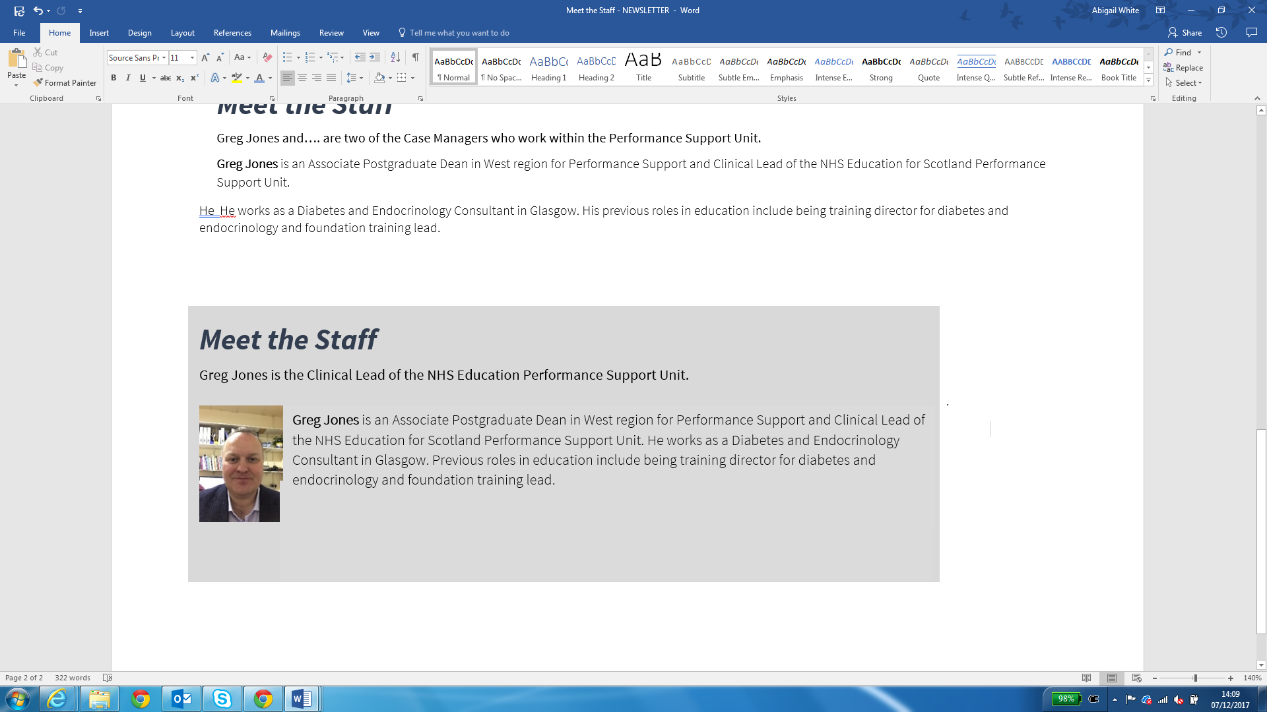

**Performance News**

Performance Support Unit

**Title**

Sub-title