Guidance on conduct of educational and clinical supervisor meetings

Meetings with a trainee are a fundamental part of the educational and support process.
Whilst most meetings are perceived as going well by both trainee and trainer sometimes meetings can go wrong.
This note is meant as general guidance on usual practice and to advise on the framework of meetings between trainees and named supervisors.

To view the document please clink on the link below –
Meeting Guidance
Exam Failure

In medical training failure to progress in programme due to failure in mandatory examinations is a common reason for delayed training progress. Examination failure is stressful for the trainee as there are potentially high stakes of longer time in or release from training. Examination failure can also be expensive for NHS Scotland when training time needs to be extended. Examination success is a readily measured metric of educational performance which can be compared between programmes, regions and deaneries and UK nations. For more information click here.

Performance News
Performance Support Unit

Title
Sub-title

Meet the Staff
Alastair Leckie and Joseph McConnell are two of the Case Managers who work within the Performance Support Unit.
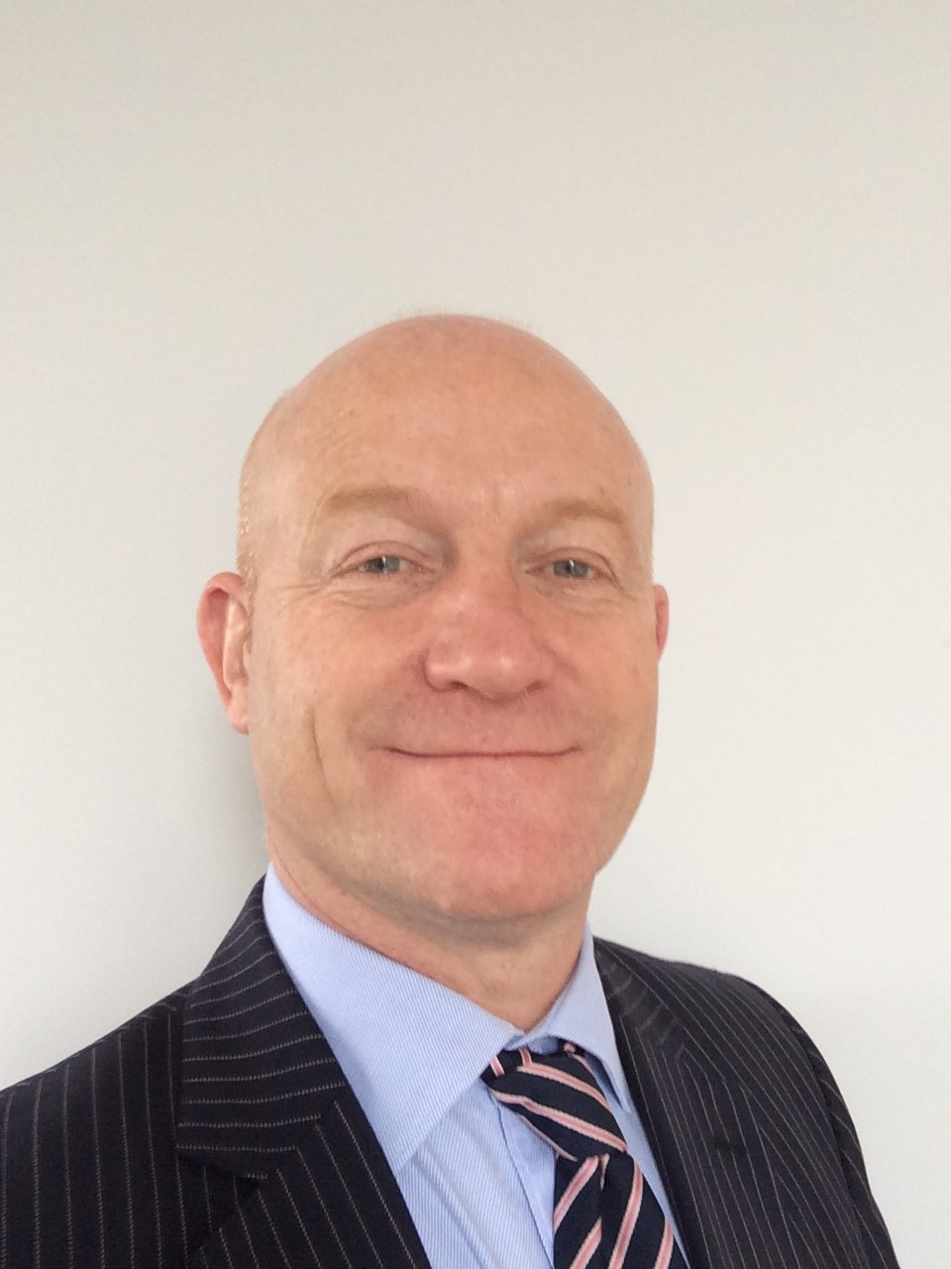
Alastair Leckie is one of the associate postgraduate deans based in the SE region and has responsibility for less than full-time training and performance support. He is a consultant in occupational medicine and director of NHS Lothian Occupational Health and Safety Service. He has been an educational and clinical supervisor since 2004 and was TPD for occupational medicine’s national programme from 2008-2015. Away from work and family escape to the golf course helps maintain the balance.

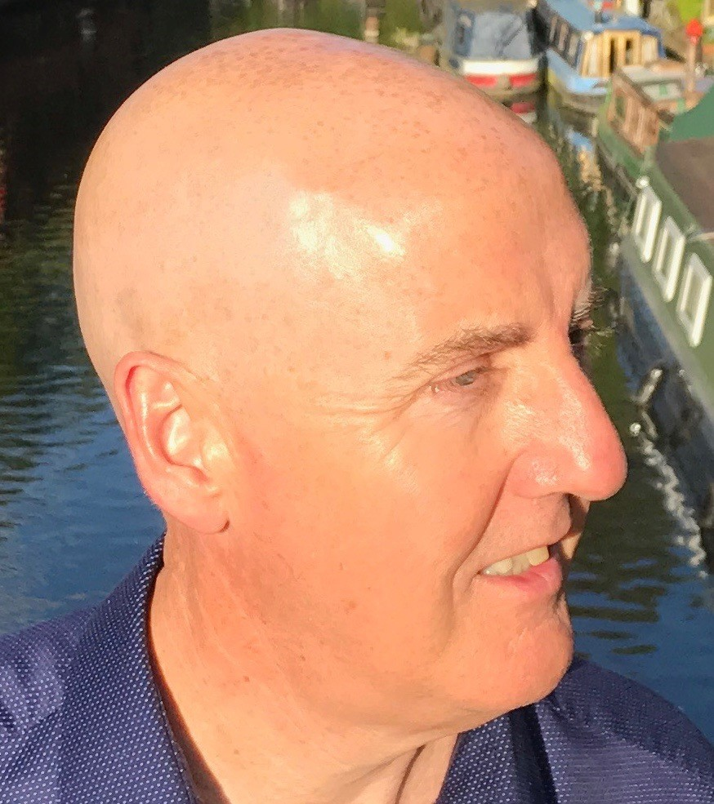
Joseph McConnell is a Case Manager for the Performance Support Unit -he is a GP in West Glasgow and a Training Programme Director providing support for trainees in difficulty in GP-West of Scotland. He is an Examiner for the Clinical Skills component(CSA) of the RCGP exam.

