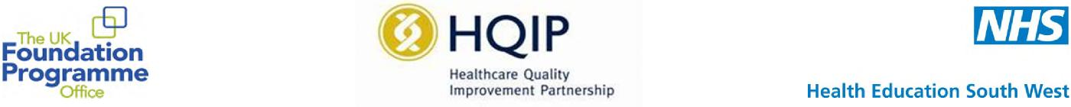

National Foundation Doctors Presentation Day
- Quality Improvement
- Education
- Sustainability
- Research/ Original Work
- Case report
Categories
10 minute oral
presentation
or
A2 Poster
12th January 2018
All Foundation Doctors and Trainers are warmly invited to a day of presentations by F1 and F2 doctors.
Judges to include representatives of the UKFPO, GMC and HQIP.
WANTED:
Presentations for work completed during your foundation training.
To enter, please return the form by November 17th 2017 to Eloise.Ambrose@hee.nhs.uk
Mercure Bristol Holland House Hotel & Spa Redcliffe Hill,
BS1 6SQ

