GP STEP

Communication Skills Workshop
Post-Session Activity
In our Communication Skills workshop we considered the range of factors that make communication complicated (you can refer back to the slides to remind yourself.
This is an exercise to be carried out in pairs or small groups. It is an opportunity for you to practice communicating common procedures to patients in multiple ways.
The exercise:
How easy is it to explain what we know? The scenario: you need to explain a basic procedure to a patient. But they don’t quite understand the first explanation, and ask you to explain it again. Can you explain it another way? If they still don’t understand, could you explain it a third way?
- A 50-year old man received a bowel screening kit. What exactly is he supposed to do with this?
- Your 70 year old (male) patient requires a urine test. Explain to him how to provide a urine sample.
- A reluctant 25-year-old woman thinks she might book an appointment for her cervical smear, but wants you to explain what is going to happen before she decides.
- A 15-year-old girl needs to do a chlamydia self-swab (see image) -- please describe this procedure to her.
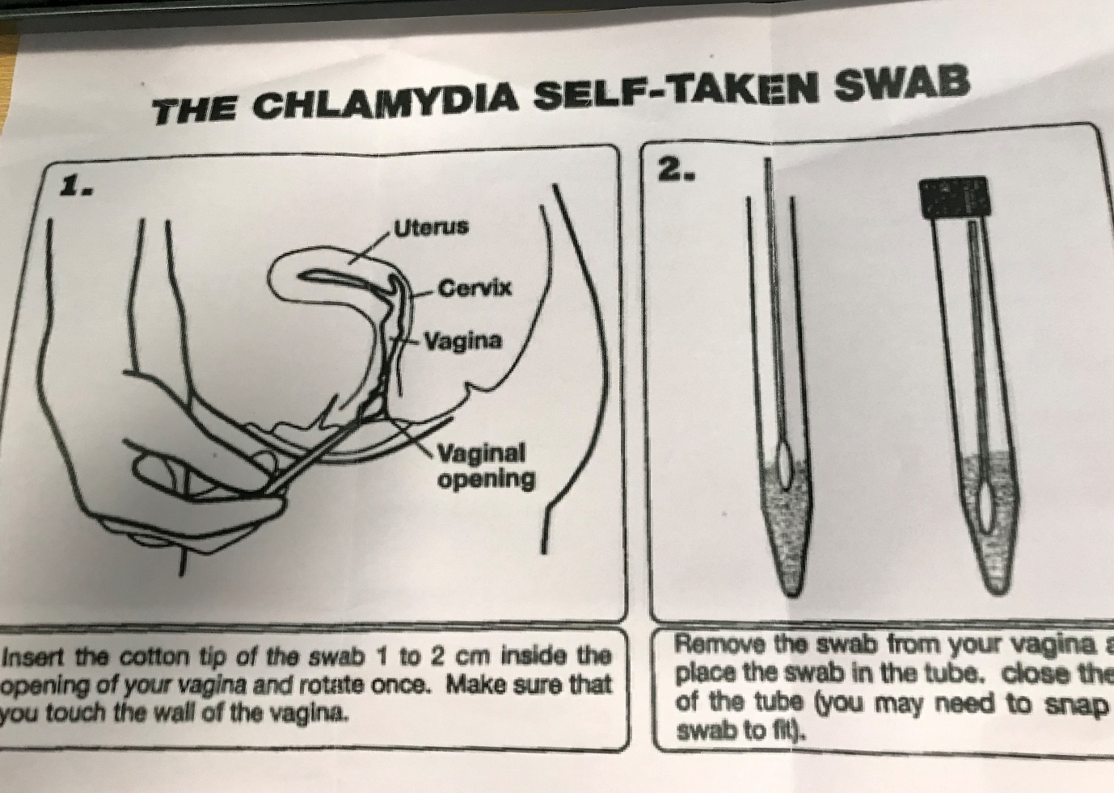
You and your ES can extend this activity by devising other example procedures and patients.
The reflection:
For the reflection you will want to consider your experience of completing the activity, your own assessment of how it went, and also any feedback you received on your attempts. There are many models of reflection; use the one that is right for you. These questions are prompts which you might find useful, but feel free to develop your own reflections.
- How easy did you find it to explain the procedures so that the patient would understand and be able to carry it out?​
- If you are not able to use your preferred terms or way of explaining, how easy is it to come up with an alternative?​
- How do you feel when you experience a communication barrier?​
- Think back to the different facets of communication we discussed – cultural expectations, language complexity, personal factors, situational factors. Did any of these come into play?​
- What does the feedback you received from others suggest about your communication strengths and development areas?

