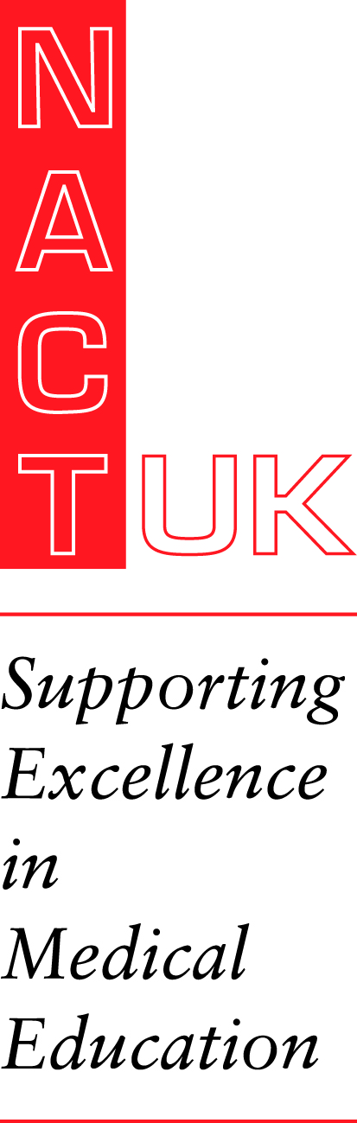
Your Future in Medical Education
Tuesday 14th June 2022
Macdonald Burlington Hotel, Birmingham New Street

PROGRAMME
The future of medical education: educational leadership through times of transition
For trainees considering a future in educational leadership

Objectives:
- to increase knowledge of educational leadership roles, structures and future direction of travel
- to be inspired by role models
- to learn about a topic that supports personal well-being and impact on the way doctors work and train
- to present their own work to like-minded peers
- to meet and network with trainees and trainers with similar interests
- to learn about a key topical area of interest for all

09.00 Registration and Coffee

09.35 Welcome & Overview of the day Dr Shirley Remington/Dr Marwan Bukhari

THE FUTURE OF EDUCATION
09.45 Fatigue, Dr Emma Plunkett, RCoA TBC
10.05 Using Social Media, Dr Jonny Guckian
10.25
10.45 Q & As

11.00 COFFEE and Poster Viewing
11.25 Diversity. Dr Nazir Lone, Public Health Scotland
12.05 Title TBC, Professor Geeta Menon, PG Dean, South London
12.45 Q & As

13.00 LUNCH and Poster judging
13.45
14.00
14.15
14.30 Q & As

14.45 TEA
15.10 Rota Management, Dr Mark Johnson, Bucks Healthcare
15.40 Q and As
16.00 CLOSE

