Scottish Trainee Enhanced Programme
Induction Event
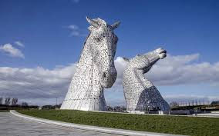

Stirling Highland Hotel
Thursday 8th November 2018

Thursday 8th November 2018
0945 | Registration with coffee on arrival
1000 | Session 1 - Introduction to the STEP  - Background to Differential Attainment  - Exam pass rates and context  - GMC/RCGP interventions
1030 | Session 2 - Culture and Transition  - IMG presentation on Culture, Culture Shock, barriers and how to integrate in local culture  - Small groups- Individual Journeys and the importance  - Cultural Competence
1145 | Session 3 – Positive Factors  - Success factors- what helps  - Video- experiences from previous IMG’s
1215 | Lunch
1300 | Session 4 – Communication  - Linguistics and communication  - Communication barriers  - CSA and Communication
1415 | Session 5 – Reflective Practice  - E-portfolio and reflection  - Self-regulated learning  - Learning logs- how to make the most of them
1530 | Tea & Coffee
1545 | Plenary and Evaluation
1615 | End Of day

Facilitators
East Region
Gordon McLeay: Assistant Director for GP Education
North Region
Monica Milne : TPD for GP Education
Eleanor Ragg: Associate Adviser for GP Education
South East Region
Amjad Khan: Director for GP Education
Nitin Gambhir: Assistant Director for GP Education/CSA examiner
Kristi Long: Equality and Diversity Adviser- NES
West Region
Joe McConnell: TPD Performance Support/CSA examiner
Graeme Hay: CSA examiner

