Area  Scottish Deanery Requirements for Paediatric ARCP 2019  The following document is a guide for Trainees, Trainers and ARCP panelists as to the requirements for the 2019 Paediatric ARCPs in Scotland | Description (and Source) | Requirement
Supervision | Educational Supervisor’s Trainers Report(s) –Trainee led preferably  (Kaizen)  Report must clearly comment on trainees readiness to progress through training at each level  i.e.  For trainees completing ST3/LAT 3  Report covers completion of the full RCPCH membership exam and level one mandatory capabilities with a clear indication of whether progression to level 2 training can be made.  For trainees completing ST5/LAT 5:  Report covering General Paediatrics, Neonates and CCH experience and commenting on appropriate completion level 2 key capabilities with a clear indication of whether progression to level 3 training can be made.  CSAC progression form – this should be completed by CSAC allocated representative and indicate whether appropriate progression against Subspecialty goals is being made for the level of training. A second ARCP outcome is given for Grid training in addition to that for the generic capabilities. |   Mandatory  Minimum of one yearly Educational Supervisor Trainers Report –  Please note  - An optimal report is in the second half of a training year and a panel will expect that an early report highlighting any concern will always be followed by a later report to follow up on progress against PDP goals.  - a clinical supervisors report is not equivalent and will not be accepted in Lieu  CSAC progression form- mandatory for all subspecialty Grid trainees submitted prior to ARCP
SLEs | All Workplace Assessments: CBD, DOPs, Mini-CEX, DOCs since last ARCP review or start of training as per the college guidelines  (Kaizen) | Please review minimum requirements and notes on appropriate engagement Appendix1 and 2 and RCPCH guidance material†
Feedback | Summary MSF as per RCPCH process  (Kaizen) | Mandatory  One per training year minimum.  1 per post is desirable when changing units and a second is mandatory where there are development needs identified in a preceding MSF
MRCPCH Exam | For trainees completing ST2/LAT 2:  Foundation of practice (FOP)  Theory and Science (TAS)  Applied Knowledge in practice (AKP)  (Kaizen-Upload as a document to eportfolio if not already populated by the RCPCH in the exam section)  For trainees completing ST3/LAT 3:  MRCPCH Clinical Exam  (Kaizen-Upload as a document to eportfolio if not already populated by the RCPCH in exam section) | Mandatory  2 out of 3 MRPCH written exams in place by end ST2  (any order)  Mandatory  All parts of MRCPCH exam must be completed in order to progress to level 2 training
Safeguarding | Evidence of Child Protection training  As per agreed Scottish CP training guideline (appendix 4 and 5)  (Kaizen-Upload clearly identified certificates and evidence of on line/face to face training to DOCS .  Undertake mandatory Safeguarding CBD’s  Reflective logs on CP cases  Peer review meetings- reflective log)  Mapped Against ‘Progress Key Capabilities’ | Mandatory  Level 2 CP training by beginning of ST3  Level 3 CP training  Majority of competencies by end ST5 and all by ST8  One Safeguarding CBD per year for all trainees
Teaching | Evidence of attendance at Postgraduate Teaching Sessions  (Kaizen upload) | Minimum of 50% desirable  mapped against key capabilities
Life Support Courses | Evidence of completion Neonatal and Paediatric Life Support course(s)  Paediatrics –one of  APLS/PALS/PILS/EPLS  Neonatal – one of  NLS/SMMDP  (Kaizen- upload clearly labeled certificates to DOCS) | Mandatory  All levels  Desirable as early as possible in ST1  Ensure 4 year updates in place at time of ARCP
START Assessment | Completion of START assessment for level 3 trainees with appropriate reflection and PDP goals | Mandatory  by end ST7  Desirable at end ST6/beginning ST7
Absence Declaration Form | Supplied by Deanery managers and emailed separately  All trainees must submit including those OOP, LTFT and on M/L. Trainee must clearly state dates e.g. 03.11.18 – 07.12.18 | Mandatory  for yearly progression all levels
SOAR Declaration | Appropriate declaration of Health/Probity or involvement in complaints procedure  Completed by Trainee and signed by the Educational Supervisor through online SOAR platform | Mandatory  for yearly progression all levels

Appendix 1 RCPCH Table of Assessments
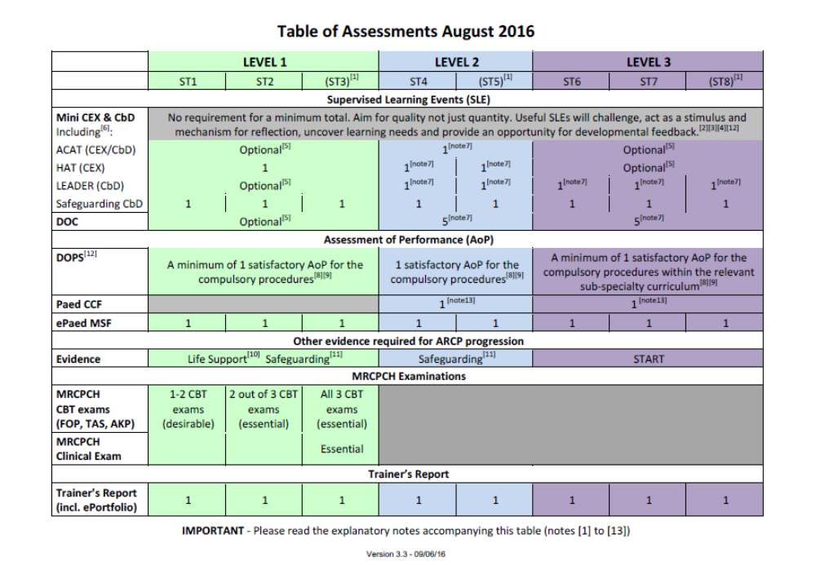
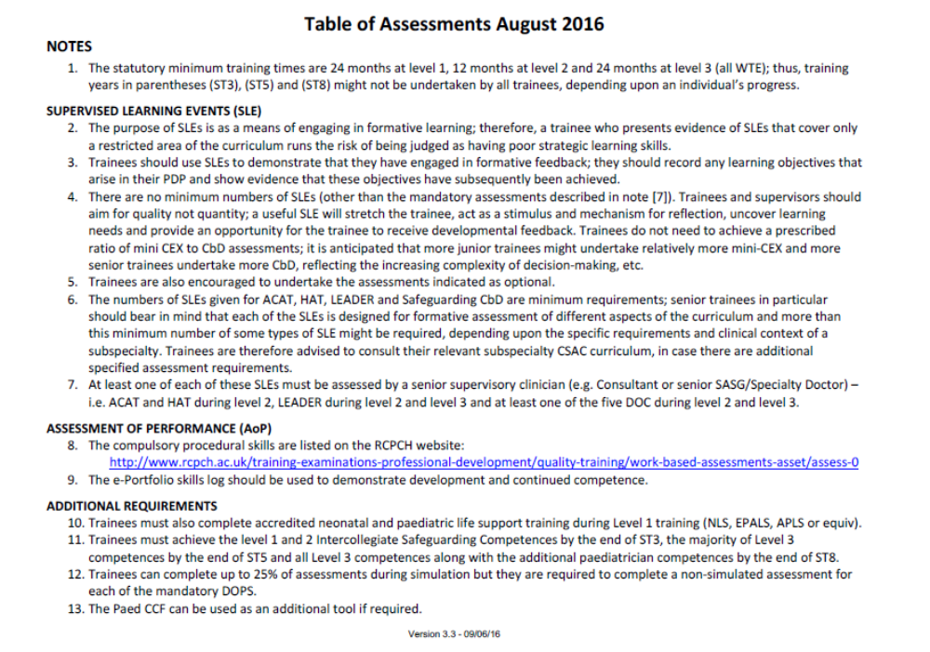
Appendix 2
Appropriate Engagement with eportfolio and the Progress Curriculum for ARCP

Appendix one outlines the mandatory and desirable requirements to demonstrate adequate progression at ARCP for Paediatric programmes in Scotland. From August 2016 the minimum number of Supervised Learning Events (SLE’s) has been removed from the college table of assessments. The purpose of this is to encourage the appropriate use of SLE’s. These should be used as a tool to support progression against competencies along with other appropriately linked evidence.
Please note that the ARCP panel will assess the use of SLE’s and evidence against the domains of the progress curriculum using the detailed RCPCH guide which delineates appropriate progress at each level . Please ensure you read this document and discuss with your supervisor when reviewing your training goals. You can access this with the following link-
ARCP Progression standards RCPCH 2018†
Table 1- Approach to assessment of SLE's at ARCP
Poor/Unacceptable | Only compulsory SLEs undertaken  No evidence reflection  No evidence of how feedback informed practice  No evidence of mapping against curriculum/competencies
Acceptable/Good | Undertaking SLE’s in a variety of clinical situations, with a range of assessors  Evidence of reflection and/or feedback informing practice  Good mapping of SLE’s against curriculum/competencies
Very good/Excellent | In addition to above-  Using SLE’s in a novel and innovative manner  Evidence of self-challenge , using SLE’s to gain insight or challenge weaker areas of practice  Mature reflection with consideration of how practice has been informed  Evidence of completion of Action plans/learning objectives arising from SLE feedback.

In practice, the decision as to whether an overall satisfactory outcome is achieved will be based on the totality of the eportfolio evidence presented as outlined above. The Educational Supervisors Trainers Report will play a key role in this assessment by the panel. If you are unsure as to the detail of the process please discuss with your educational supervisor in the first instance and involve your TPD/deanery manager if your query cannot be resolved.
Appendix 3 Compulsory DOPS Procedures

Compulsory DOPS
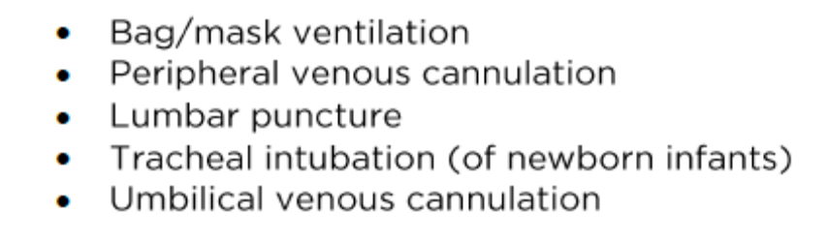
Optional DOPS
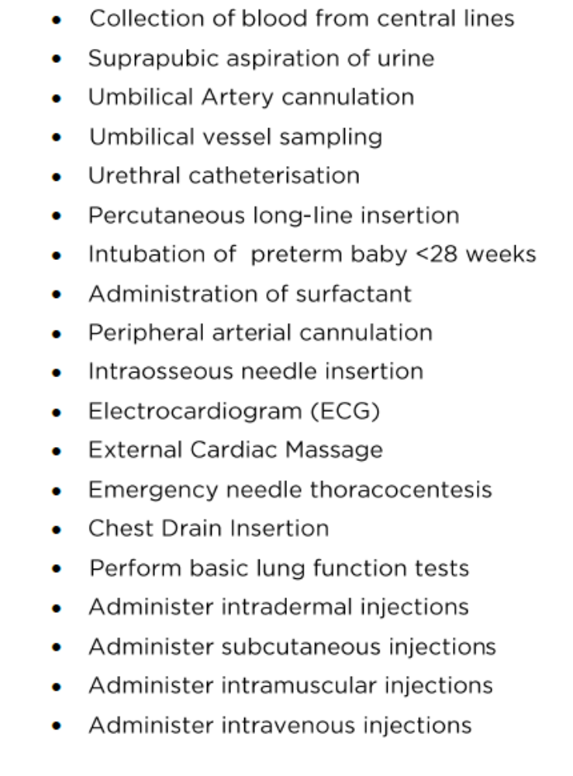

Appendix 4 Further contacts

 | TPD | Programme Manager
North | Shyla Kishore  shyla.kishore@nhs.net | Carol Leiper  carol.leiper@nes.scot.nhs.uk
East | Alice Jollands  alice.jollands@nhs.net | Carol Elliot  carol.elliot@nes.scot.nhs.uk
South East | Laura Jones  Laura.jones@luht.scot.nhs.uk  Ailsa Mclennan  Ailsa.McLellan@nhslothian.scot.nhs.uk | Emma McFadyen  Emma.McFadyen@nes.scot.nhs.uk
West | Chris Lilley  chris.lilley@ggc.scot.nhs.uk  Ben Smith  ben.smith@ggc.scot.nhs.uk | Laura Armstrong  laura.armstrong@nes.scot.nhs.uk

Appendix 5 - Child Protection Guidelines Scottish Deanery 2017/ Summary of Level 2 Intercollegiate Competencies
This summary recognises that in Scotland many paediatric trainees at ST3 grade will be working as middle grade cover in district general hospitals. It therefore suggests that all paediatric trainees should have reached Level 2 intercollegiate safeguarding competencies as a minimum by the beginning of ST3. The Level 3 competencies are outlined in another document.

The college recognises that both the intercollegiate and general paediatric curriculum should be better integrated and a definitive policy for trainees identified. A review is currently taking place (initiated in late 2013) although there is no information currently about when it will be completed.
The table below attempts to start this process in a Scottish context by summarising the Level 2 intercollegiate guidance and providing examples that trainees might use as evidence. It is envisaged this can be used as a “log book” or educational passport to demonstrate to supervisors their ongoing attainment of competencies. It is not expected that trainees undertake all the courses or work based assessments suggested.
The RCPCH (Scotland) CP Training subcommittee urge that all supervisors and employers recognise the time commitment required of trainees who participate in e-learning modules. Each module is expected to represent 2 hours of time. Please note that one module might cover several competencies.

 | Stage of Training | Key Skill | Competency summary | Examples of Evidence | Evidence provided
 | ST1-2 | Clinical Skill | Use professional and clinical knowledge of what constitutes child maltreatment to identify signs of child abuse or neglect | - eLearning for health “Recognition” module (secondary care)  - Safeguarding CbD
 |  |  | Able to seek appropriate advice and report concerns and feel confident they have been listened to | - Safeguarding CbD  - eLearning for health “Response” module  - CPRR – Recognition & Response ALSG course
 |  |  | Demonstrate understanding of referral processes and multi-agency working | - eLearning for health “Response in secondary care” module  - CPRR – Recognition & Response ALSG course  - Safeguarding CbD
 | ST1-2 | Information Sharing and Documentation | Document child protection concerns and maintain best practice record keeping | - eLearning for health “Record in secondary care” Level 2 module  - DoC or safeguarding MiniCex
 |  |  | Share appropriate and relevant information | - eLearning for health “Record in secondary care” Level 2 module
 | ST1-2 | Multi-agency working | Know how to refer to social care if a safeguarding concern is identified as appropriate to role. | - Safeguarding CbD  eLearning for health  - eLearning for health “Response in secondary care” module  - CPRR – Recognition & Response ALSG course
 |  |  | Aware of local policies and procedures, who to contact and where to receive additional advice. | - eLearning for health “Response in secondary care” module  - CPRR – Recognition & Response ALSG course
 | ST1-2 | Legislation and Guidelines | Know what is meant by “looked after” or fostered and understand legislations surrounding this | - RCPCH course in health in looked after children  - CbD around looked after child
 |  |  | Clear about own responsibilities and legislation including UN Convention on Rights of the Child and Human rights. | - eLearning for health “Recognition” module (secondary care)  - CPRR – Recognition & Response ALSG course
 |  |  | Understand the purpose and guidance around conducting a significant case review. | - eLearning for health “Recognition” module (secondary care)  - CPRR – Recognition & Response ALSG course
 | ST1-2 | Risk Factors and Prognosis | Understand the public health consequences of child maltreatment | - eLearning for health “Recognition” module (secondary care)  - CPRR – Recognition & Response ALSG course
 |  |  | Able to identify and refer a child suspected of being a victim of trafficking, sexual exploitation or FGM | - eLearning for health modules “FGM”  - CPRR – Recognition & Response ALSG course

Suggested Courses
CPRR – Recognition and Response ALSG course: Face to face one day course covering basic diagnosis and communication in child protection. Very few courses currently running in east of Scotland – this has been raised and addressed through RCPCH (Scotland) Child Protection Committee meeting on 16th December 2015 (chair – Dr J Mok). It is anticipated that a CPRR course will run in the east of Scotland at the end of 2016.
eLearning for Health: Accessible and free to all qualified doctors through RCPCH website. Specific Modules for Level 2 competencies split into three areas – Recognition, Response and Recording in secondary care. There is also a module relating specifically to FGM. Certificate provided by website on completion of course.
Local Courses: Within Lothian these would be Learn-Pro safeguarding courses available through intranet or courses advertised through the local child protection committees. Within Lothian there is also a new mandatory child protection induction module that will include video e-learning and face to face teaching (SCORM). Any of these might be used as supporting evidence for the attainment of competencies.

Appendix 6 - Child Protection Guidelines Scottish Deanery 2017/ Summary of Level 3 Intercollegiate Competencies
This summary recognises that in Scotland many paediatric trainees at ST3 grade will be working as middle grade cover in district general hospitals. It therefore suggests that all paediatric trainees should have reached Level 2 intercollegiate safeguarding competencies as a minimum by the beginning of ST3. The Level 2 competencies are outlined in another document.
The college recognises that both the intercollegiate and general paediatric curriculum should be better integrated and a definitive policy for trainees identified. A review is currently taking place (initiated in late 2013) although there is no information currently about when it will be completed.
The table below attempts to start this process in a Scottish context by summarising the Level 3 intercollegiate guidance and providing examples that trainees might use as evidence. It is envisaged this can be used as a “log book” or educational passport to demonstrate to supervisors their ongoing attainment of competencies. The examples of evidence given are examples only and are not suggesting that all trainees must attend expensive courses to achieve competencies.
The RCPCH (Scotland) CP Training subcommittee urge that all supervisors and employers recognise the time commitment required of trainees who participate in e-learning modules. Each module is expected to represent 2 hours of time. Please note that one module might cover several competencies

Stage of Training | Key Skill | Competency summary | Examples of Evidence | Evidence provided
ST3 | Clinical | Identify signs and symptoms of child maltreatment and be aware of differential diagnosis. Also identify associated co-morbidities and provide clear management plan | - eLearning for health: “unexplained injuries” and “disability & neglect” modules  - Safeguarding CbD demonstrating clinical skills
 |  | Ability to write effective chronologies | - DoC example
 |  | Knowledge of the effects of poor parental mental health and domestic violence on children | - eLearning for health modules level 3  - Local multi-agency courses advertised through Child protection committee

ST3 – 5 | Clinical | Able to support or refer in situations requiring further expertise | - Safeguarding Reflective event or CbD
 | Information Sharing | Advise others on information sharing and understand confidentiality, consent and data protection | - Local course eg Lothian Learn-pro information governance course  - Reflective event  - Local information sharing eLearning modules
 | Multi-Agency Working | Evidence of working with other agencies including health contribution to risk assessment – eg advice / report / attendance at CPCC  Role of voluntary sector | - Covered in community paediatric attachment: CbD and/or DoC  - Attendance at local multi-agency training
 |  | Awareness of importance of follow up of failure to attend appointments | - Discussion of community and general paediatric OPD work
 |  | Understanding of Children and Young People (Scotland) Act 2014 and importance of GIRFEC child planning process | - Evidence of local training / attendance at child planning meeting during community training
 | Risk Factors and Prognosis | Understand the effects of parental behaviour and family factors on children, including their cultural & religious background | - eLearning for health “Parental Risk Factors”
ST3 – 8  All trainees | Clinical Skills | Undertake examination for suspected child abuse with adequate documentation and report if required | - CbD, DoC or minicex  - Reflective event or discussion with trainee  - CPEC course
 |  | Understanding of Fabricated and Induced Illness | - eLearning for health module  - CPIP course  - CPEC course
 |  | Aware of the importance of peer review and regular scrutiny of safeguarding practice including learning from Significant Case Reviews | - CPIP course  - eLearning for health “attaining and maintaining safeguarding competencies module”  - RCPCH course “Peer review in practice”  - Evidence of attendance at peer review
 | Multi-agency working | Recognition of appropriate action if insufficient response from other agencies | - CbD  - Reflective event  - CPIP course  - CPEC course
 | Legislation and Guidelines | Aware of local and national SUDI procedures and child death review process | - eLearning for health “Management of sudden unexpected death of a child”  - Reflective event  - CbD

ST6 – 8 Community Trainees | Legislation and Guidelines | Aware of legislation and national guidelines including remit of local child protection committee and multi-agency inspection process | - Local training events  - Evidence of attendance at Public Protection Committee meetings  - SPIN module
 |  | Contribute / involvement in a Significant Case Review | - CPIP course  - SPIN module  - Reflective event
 |  | Core knowledge of court and criminal justice system | - CPEC course  - Local court skills course  - CPIP course
 | Forensic Examination | Competent in child protection examination, use of colposcope and taking of appropriate samples including the concept of chain of evidence | - Child sexual abuse examination course  - eLearning for health “adolescent presenting with intoxication” module  - DoC
 |  | Able to present child protection concerns and examinations verbally and in writing | - DoC for child protection report  - RCPCH course in safeguarding “Statement and report writing”  - CPEC course  - Court skills course
Prior to ST8 | Clinical Skills | Understand the importance of audit in child protection practice | - Evidence of one audit relating to child protection theme

Suggested Courses

CPiP course: Child protection in practice. A nationally recognised two year online educational programme for speciality trainees, run through ALSG.
Modules include:
Epidemiology
Underpinning principles
Legislative frameworks
Clinical topics
Special circumstances
Communication
The course has recently been re-launched and costs £50 per online module. Reports from trainees are that there are still problems with accessing modules.

CPEC course: Child protection: examination to court. A 2-day face-to-face Level 3 course delivered by RCPCH in London. It is hoped that this can be adapted for and delivered in Scotland. The first day provides an excellent update on all aspects of child maltreatment and also a Report writing workshop. Delegates are given a case on which to base a report which has to be submitted before the course. The second day covers multi-agency working and ends with the delegates going into groups for ‘mock trial training’ based on their reports. Barristers conduct examinations-in-chief and cross-examinations.

SPIN Module: special interest module in child protection – this has been revised and is available on the RCPCH website. On completion of this, the candidate is recognised as a paediatrician with special expertise in child protection at Level 4.

eLearning for Health: Accessible and free to all qualified doctors through RCPCH website covering levels 1 to 3 of the intercollegiate safeguarding competencies. Certificate provided by website on completion of course.

Local Training: Trainees can use local training attended as evidence if meets competency requirement, eg Lothian – Learn-pro courses, development of mandatory child protection induction, rolling ST training programmed covering safeguarding topics.

